Command Reference: SetOutputYearType()
Set the output year type for time series
Version 09.05.02, 2009-11-02

The SetOutputYearType() command sets the global output year type for output reports and files. The default for most operations is calendar year (January through December); alternate year definitions may be useful. The global output year type is recognized by some common tools and commands that create output. Many write commands also allow the year type to be specified for the command. Internally, all data are managed using calendar years and are converted to different year types during output or display. The ChangeInterval() command also allows time series to be converted to annual values where the value corresponds to a year type.

The following dialog is used to edit the command and illustrates the command syntax.

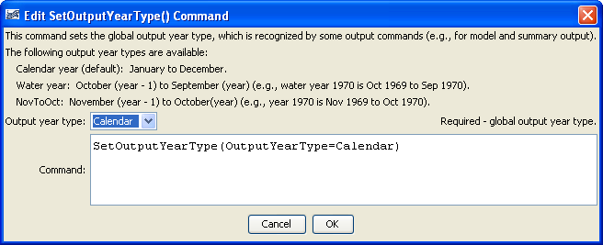
SetOutputYearType
SetOutputYearType() Command Editor

The command syntax is as follows:

SetOutputYearType(Parameter=Value,…)

Command Parameters

Parameter | Description | Default
OutputYearType | The output year type, one of:  - Calendar – January through December.  - NovToOct – November of the previous calendar year to October of the current calendar year. For example, year 1970 spans Nov 1969 to Oct 1970.  - Water – October of the previous calendar year through September of the current calendar year (and water year). For example, water year 1970 spans Oct 1969 to Sep 1970.  In the future, more generic types like NovToOct may be implemented. | If this command is not specified, Calendar is the default.

A sample commands file is as follows:

SetOutputYearType(OutputYearType=Calendar)

