Command Reference: CopyEnsemble()
Create a new ensemble as a copy of an ensemble
Version 08.15.00, 2008-05-04

The CopyEnsemble() command creates a copy of an ensemble, copying all time series in the ensemble and assigning a new identifier to the result. The copy is an exact copy except that the ensemble identifier is different (the TSIDs for each ensemble time series should also specified to be unique).

The following dialog is used to edit the command and illustrates the syntax for the command.

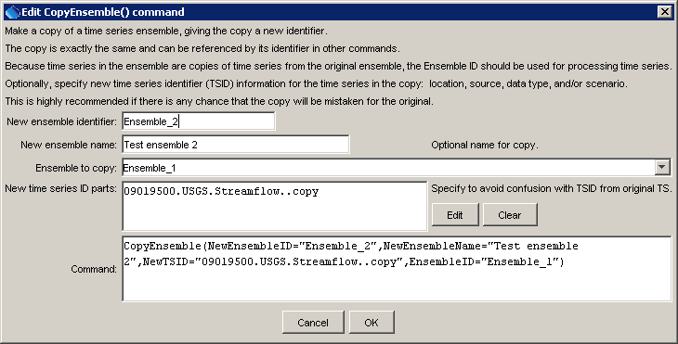
CopyEnsemble
CopyEnsemble() Command Editor

The command syntax is as follows:

CopyEnsemble(Parameter=Value,…)

Command Parameters

Parameter | Description | Default
EnsembleID | The ensemble to copy. | None – must be specified.
NewEnsembleID | The ensemble identifier for the new ensemble | None – must be specified.
NewEnsembleName | The name for the new ensemble. | Blank.
NewTSID | A new time series identifier to assign to time series in the new ensemble. This is useful to avoid confusion with the original time series. Use the Edit button to edit the time series identifier parts. The data interval and sequence number will be determined from the original time series. | Copy the original time series TSID.

A sample commands file to read a time series from the State of Colorado’s HydroBase, create an ensemble from the time series, and make a copy is as follows:

# 09019500 - COLORADO RIVER NEAR GRANBY
09019500.USGS.Streamflow.Day~HydroBase
CreateEnsemble(TSID="09019500.USGS.Streamflow.Day",
TraceLength=1Year,EnsembleID="Ensemble_1",EnsembleName="Test Ensemble",ReferenceDate="2008-01-01",ShiftDataHow=ShiftToReference)
CopyEnsemble(NewEnsembleID="Ensemble_2",
NewEnsembleName="Test ensemble 2",
NewTSID="09019500.USGS.Streamflow..copy",EnsembleID="Ensemble_1")

