Command Reference: TS Alias = NewStatisticTimeSeriesFromEnsemble()
Create a time series containing a statistic determined from a time series ensemble
Version 08.15.00, 2008-05-04

The TS Alias = NewStatisticTimeSeriesFromEnsemble() command uses data from a time series ensemble to calculate a statistic for each interval in the ensemble, and assigns the statistic value to each corresponding interval for the full period. For example, for a statistic of Mean applied to a daily time series, all January 1, 1970 values will be averaged and the output time series will be set to the mean value for the date. Because the ensemble has overlapping time series that have the same period, leap year will be included if it is in the period of the ensemble.

The following dialog is used to edit the command and illustrates the syntax for the command.

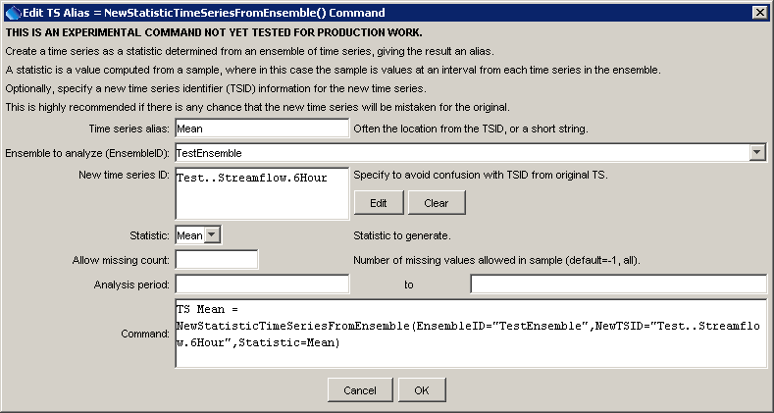
NewStatisticTimeSeriesFromEnsemble
TS Alias = NewStatisticTimeSeriesFromEnsemble() Command Editor

The command syntax is as follows:

TS Alias = NewStatisticTimeSeriesFromEnsemble(Parameter=Value,…)

Command Parameters

Parameter | Description | Default
Alias | The alias of the new time series, which can be used instead of the TSID in other commands. | None – must be specified.
EnsembleID | The ensemble identifier to analyze. | None – must be specified.
NewTSID | The time series identifier to be assigned to the new time series, which is useful to avoid confusion with the original time series. | None – use the same identifier as the original time series.
Statistic | See the Available Statistics table below. | None – must be specified.
Allow  Missing  Count | The number of missing values allowed in the source interval(s) in order to produce a result. This capability should be used with care because it may result in data that are not representative of actual conditions. | -1 – allow any number of missing values
AnalysisStart | The date/time for the analysis start, using a precision that matches the original time series. | Analyze the full period.
AnalysisEnd | The date/time for the analysis start, using a precision that matches the original time series. | Analyze the full period.

Available Statistics

Statistic | Description | Limitations
Mean | Mean of all values on an interval. | None.

Examples

The following example command file illustrates how to generate test data and a corresponding statistics time series:

TS ts1 = NewPatternTimeSeries(NewTSID="ts1..MAP.6Hour",
Description="test data 1",SetStart="2000-01-01 00",
SetEnd="2007-05-13 18",Units="IN",PatternValues="1,2,4,3,5,6,25,10,8,5,1")
CreateEnsemble(TSID="ts1",TraceLength=1Year,
EnsembleID="TestEnsemble",ReferenceDate="2000-01-01 00",
ShiftDataHow=ShiftToReference)
TS Mean = NewStatisticTimeSeriesFromEnsemble(EnsembleID="TestEnsemble",
NewTSID="Test..Streamflow.6Hour",Statistic=Mean)
WriteDateValue(
OutputFile="Results/Test_NewStatisticTimeSeriesFromEnsemble_1_out.dv")

