Command Reference: AnalyzePattern()
Determine historical average patterns for monthly time series
Version 08.15.00, 2008-05-04

The AnalyzePattern() command creates the pattern file for use with the FillPattern() command (see also SetPatternFile()). Each time series to be processed is analyzed as follows:

- Create a time series to contain the pattern identifiers for each month.
- For each month, determine the monthly values for the time series being analyzed (e.g., find all of the January values).
- Rank the values in ascending order.
- Evaluate the percentile rank information and assign in the pattern time series an appropriate pattern identifier. For example, if the percentile values are .25 and .75, assign the first pattern identifier to values < 25% of the total count, assign the second pattern identifier to values >= 25% and < 75%, and assign the third identifier to the values > 75%.

The resulting pattern time series list is then written to a file. This command is enabled for monthly data only. See below for an example of a fill pattern file. One or more patterns can be included in each pattern file, similar to StateMod time series files (see the StateMod Input Type Appendix), and multiple pattern files can be used, if appropriate.

# Years Shown = Water Years
# Missing monthly data filled by the Mixed Station Method, USGS 1989
# Time series identifier = 09034500.CRDSS_USGS.QME.MONTH.1
# Description = COLORADO RIVER AT HOT SULPHUR SPRINGS, CO.
# -e-b----------eb------eb------eb------eb------eb------eb------eb------eb------eb------eb------eb------eb------eb--------e
10/1908 - 9/1996 ACFT WYR
1909 09034500 AVG AVG AVG WET WET AVG AVG AVG WET WET WET WET
1910 09034500 WET WET WET WET WET WET AVG AVG AVG AVG AVG AVG
1911 09034500 AVG AVG WET AVG AVG AVG AVG WET WET WET AVG WET
1912 09034500 WET WET WET WET WET AVG AVG WET WET WET WET WET
...ommitted...

The pattern file will by default contain all available data for the overlapping period and will be written in calendar year. The output period can be set with the SetOutputPeriod() command and the output year type can be set with the SetOutputYearType() command.

The following dialog is used to edit the AnalyzePattern() command and illustrates the syntax of the command.

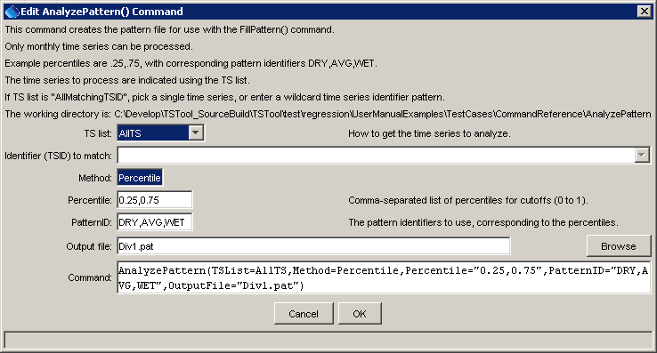
AnalyzePattern
AnalyzePattern() Command Editor

The command syntax is as follows:

AnalyzePattern(Parameter=Value,…)

Command Parameters

Parameter | Description | Default
TSList | Indicate how the list of time series to process should be determined, one of:  - AllTS – all time series  - AllMatchingTSID – all time series that have identifiers matching the given TSID parameter.  - SelectedTS – all time series that have been selected with selectTimeSeries() commands. | None – must be specified.
TSID | The time series identifier or alias for the time series to be analyzed. A pattern containing the * wildcard character can be used to process multiple time series (e.g., * or 29*). | Must be specified if the TSList parameter has a value of AllMatchingTSID.
Method | Method used to determine the patterns. Currently only Percentile is recognized. | Percentile
Percentile | A comma-separated list of percentiles for cutoffs, used when Method=Percentile. Values should be 0 to 1 (e.g., .25, .75) | None – must be specified.
PatternID | The pattern identifiers to use, corresponding to the percentiles. Specify one more than the number of percentiles (e.g., DRY,AVG,WET). | None – must be specified.
OutputFile | Output file to write, which will contain the pattern information. Currently only the StateMod pattern file format is supported. | None – must be specified.

A sample command file to analyze streamflow data from the State of Colorado’s HydroBase is as follows:

# 06720500 - SOUTH PLATTE RIVER AT HENDERSON
06720500.DWR.Streamflow.Month~HydroBase
# 06754000 - SOUTH PLATTE RIVER NEAR KERSEY
06754000.DWR.Streamflow.Month~HydroBase
analyzePattern(TSList=AllTS,Method=Percentile,
Percentile="0.25,0.75",PatternID="DRY,AVG,WET",OutputFile="Div1.pat")

This page is intentionally blank.

