Command Reference: PrintTextFile()
Print a text file
Version 10.00.03, 2011-06-26

The PrintTextFile() command prints a text file to a physical or virtual (e.g., PDF file) printer. This command is used in testing to verify print features but also can be used in production.

Printing is highly dependent on the features available from a printer. The command attempts to list printer options to configure command parameters. However, some options are listed based on what a printer can do, but this may require changing/selecting paper trays, using manual feed, etc. The command will be enhanced in the future to specify features including tray selection but currently it is intended for use with common printer settings. If advanced settings are needed, use ShowDialog=True.

The following dialog is used to edit the command and illustrates the syntax for the command.

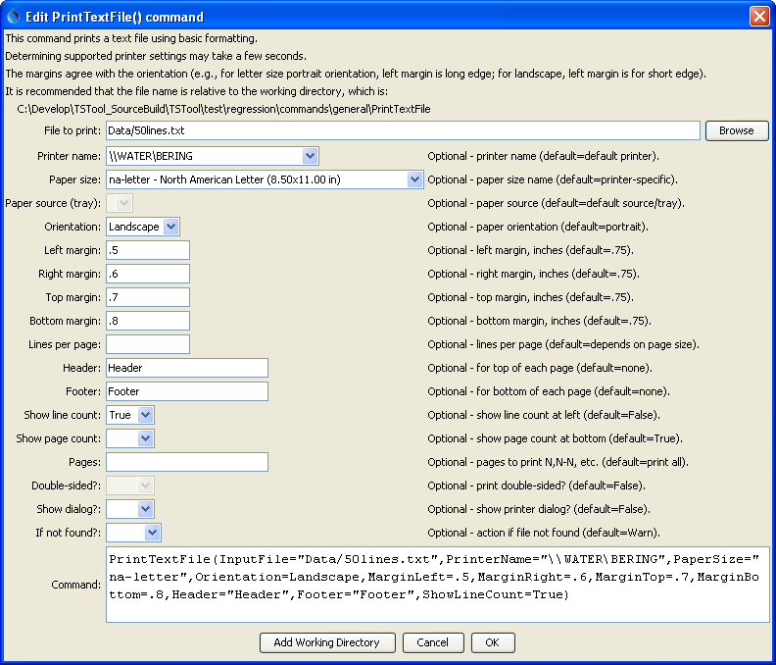
PrintTextFile
PrintTextFile() Command Editor
The command syntax is as follows:

PrintTextFile(Parameter=Value,…)

Command Parameters

Parameter | Description | Default
InputFile | The name of the text file to print. | None – must be specified.
PrinterName | The name of the printer to use (e.g., \\MyComputer\MyPrinter or Adobe PDF) | The default printer will be used.
PaperSize | The paper size to print. Because there are a number of standards for paper, the size is specified as standard-sizename (e.g., na-letter for North American Lettter). For information on paper sizes, see: http://en.wikipedia.org/wiki/Paper_size. | The default for the printer will be used.
PaperSource | The tray for the paper – currently not enabled. Use ShowDialog=True to select. | The PaperSize is used.
Orientation | The paper orientation. | The default for the printer and paper size will be used.
MarginLeft | The left margin for the orientation, inches. | See above.
MarginRight | The right margin for the orientation, inches. | See above.
MarginTop | The top margin for the orientation, inches. | See above.
MarginBottom | The bottom margin for the orientation, inches. | See above.
LinesPerPage | The number of lines per page to print. The font size is chosen accordingly. | An even number is chosen with font size between 7 and 12 points.
Header | String included in the top left of every page. | No header is shown.
Footer | String included in the bottom left of every page. | No footer is shown.
ShowLineCount | Indicate whether the line count should be shown to the left of each line. | False
ShowPageCount | Indicate whether the page count should be shown in the center of the footer. | True
DoubleSided | Indicate whether printing should be double-sided, currently not enabled. Use ShowDialog=True to select. | False
ShowDialog | Indicate whether to show the printer dialog, which allows review and editing of printer parameters. This is useful for testing and for selecting advanced printer features not handled in batch mode by this command. | False
IfNotFound | Indicate action if the file is not found, one of:  - Ignore – ignore the missing file (do not warn).  - Warn – generate a warning (use this if the file truly is expected and a missing file is a cause for concern).  - Fail – generate a failure (use this if the file truly is expected and a missing file is a cause for concern). | Ignore

