Command Reference: TableToTimeSeries()
Create time series from a table
Version 10.21.00, 2013-06-27

Note: This command may be split into two separate commands (one for single column data values and one for multiple column data values) if editing the command parameters becomes confusing.

The TableToTimeSeries() command creates time series from a table. This command can be used when a command to read time series from a specific file format or datastore has not been implemented. The table typically is read using one of the following commands:

- ReadTableFromDataStore() – for example, define an ODBC DSN connection to a database and query time series using an SQL statement.
- ReadTableFromDelimitedFile() – for example, read time series from a comma-separated-value (CSV) file.
- ReadTableFromExcel() – for example, read time series from a comma-separated-value (CSV) file
- ReadTableFromHTML() – envisioned for the future.

TSTool internally represents tables as a collection of columns, where a column contains values of a consistent data type (e.g., integer, string, double). A time series table requires at a minimum a date/time column (or separate date and time columns), at least one data value column, and optionally one or more columns for data flags. Data represented in one of two table designs are handled by this command:

- Data for multiple locations/series stored in a single column (common in a database or stream of data from a data logger) – specify the LocationColumn command parameter.
- Data for multiple locations/series stored in multiple columns (common in spreadsheets and CSV files) – do not specify the LocationColumn command parameter but instead specify the ValueColumn and optionally LocationID parameters.

The command provides flexibility to specify time series metadata (e.g., data source, units) as command parameters, or read from the file. However, this flexibility is limited by practical considerations in supporting likely data formats. One current limitation of the command is that TSTool does not determine table column names during discovery mode (discover mode is a partial command run that allows data such as time series and table identifiers to be provided to later commands for editing). Consequently, although this command will create time series when run, it does not produce time series information in discovery mode and the time series will not be listed in later command editors. This limitation will be addressed in future TSTool updates.

An example of a table with single data value column with flags is shown in the following figure (note that a column is used for the location identifier and that the location is different for the topmost and bottommost records).

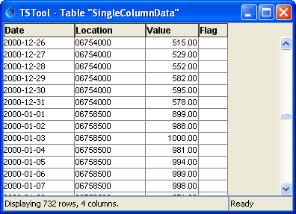
TableToTimeSeries_Single_Data
Simple Table with Data Values in a Single Column

In the above example, the list of unique time series is determined by examining the location column contents. Other time series metadata such as data source and units can be assigned using the DataSource, Units, and similar parameters. The following dialog is used to edit the command and illustrates the command syntax when processing single-column data from the above example. Note that time series metadata are specified with command parameters.

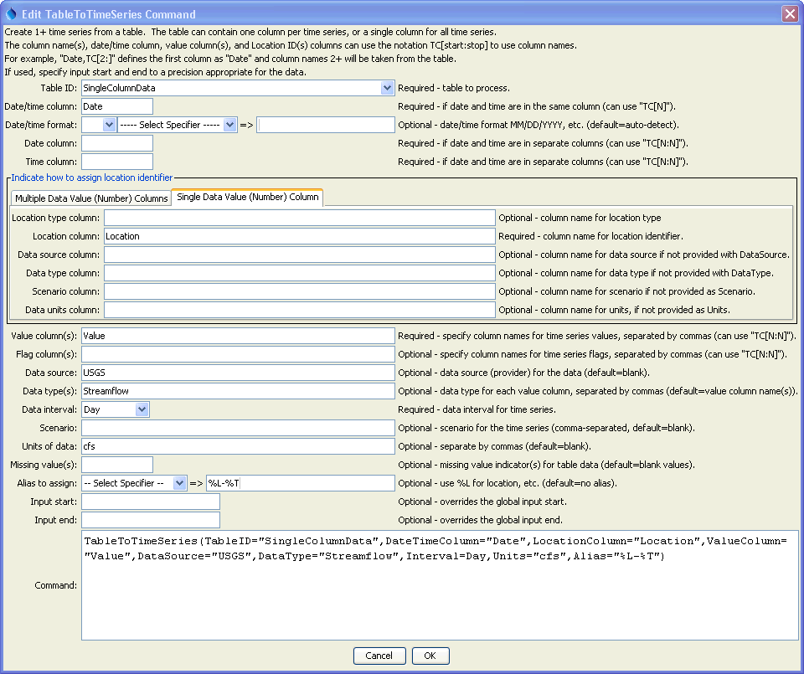
TableToTimeSeries_Single
TableToTimeSeries() Command Editor for Table with Data in a Single Column

The following example is also treated as single-column because a single column of data values is present. However, metadata are taken from other columns. This data format is consistent with a database query where several tables have been joined together. Although not efficient because time series metadata is repeated for every row, the format is convenient for data translation. Use the DataSourceColumn, UnitsColumn and similar parameters to specify metadata. The unique list of time series will be determined from the combinations of location identifier and other metadata..

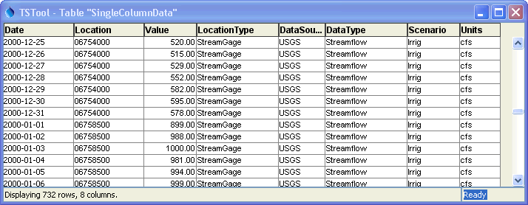
TableToTimeSeries_SingleMeta_Data
Table with Data Values in a Single Column and Metadata Provided in Other Columns

The following dialog is used to edit the command and illustrates the command syntax when processing single-column data from the above example. Note that time series metadata are specified with command parameters.

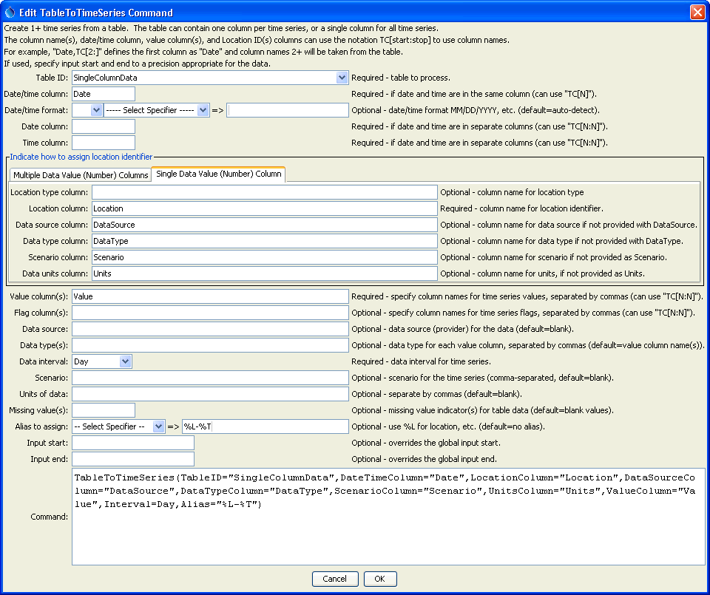
TableToTimeSeries_SingleMeta
TableToTimeSeries() Command Editor for Table with Single Data Column and Metadata Columns

An example of multi-column data with flags is shown in the following figure, where each time series has its own data and flag columns:

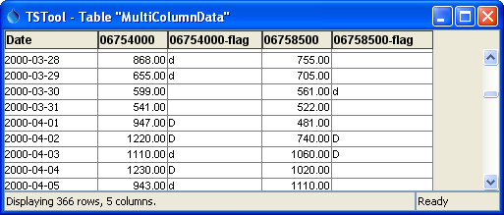
TableToTimeSeries_Multiple_Data
Table with Multiple Data Columns
The following dialog is used to edit the command and illustrates the syntax for the command when processing multi-column data from the above table.

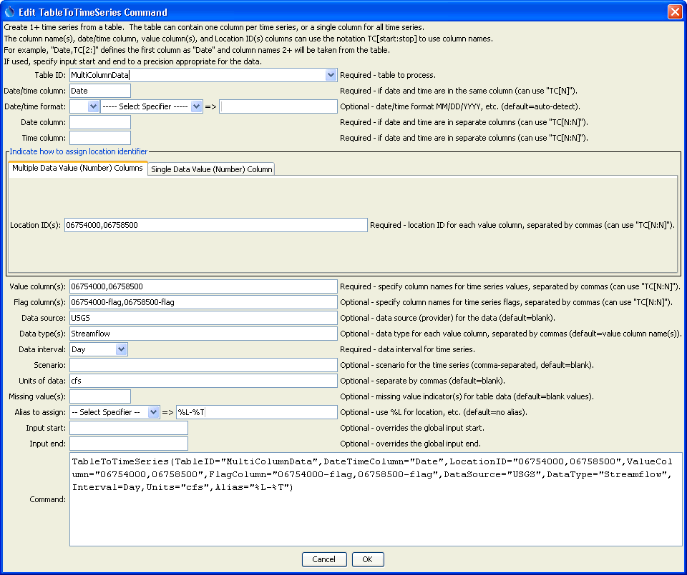
TableToTimeSeries_Multiple
TableToTimeSeries() Command Editor For Table with Data in a Single Column

The command syntax is as follows:

TableToTimeSeries(Parameter=Value,…)

Command Parameters

Parameter | Description | Default
TableID | The identifier for the table to read. | None – must be specified.
DateTime  Column | The column for date/time, when date and time are in one column. If the table was read in a way that the column type is “date/time”, then the values are used directly. If the table was read in a way that the column type is “string”, then the string is parsed using default logic or the DateTimeFormat parameter if specified. | Required if DateColumn is not specified.
DateTime  Format | The format for date/time strings in the date/time column, if strings are being parsed. If blank, common formats such as YYYY-MM-DD hh:mm and MM/DD/YYYY will automatically be detected. However, it may be necessary to specify the format to ensure proper parsing. This format will be used to parse date/times from the DateTimeColumn or the merged string from the DateColumn and TimeColumn (if specified). The format string will depend on the formatter type. Currently, only the “C” formatter is available, which uses C programming language specifiers. The resulting format includes the formatter and specifiers (e.g., C:%m%d%y). | Will automatically be determined by examining date/time strings.
DateColumn | The name of column that includes the date, used when date and time are in separate columns. | Required if DateTimeColumn is not specified.
TimeColumn | The name of column that includes the time, used when date and time are in separate columns. If both DateColumn and TimeColumn are specified, their contents are merged with a joining colon character and are then treated as if DateTimeColumn had been specified. | Required if DateColumn is specified and the interval requires time.
LocationID | Used with multiple data column table. The location identifier(s) to assign to time series, separated by columns if more than one column is read from the table. Column names can be specified as literal strings or as TC[start:stop] to match table column names, where start is 1+ and stop is blank to read all columns or a negative number to indicate the offset from the end column. | None – must be specified for multiple column data tables.
LocationType  Column | Used with single data column table. The name of the column containing the location type. | Do not assign a location type.
LocationColumn | Used with single data column table. The name of the column containing the location identifier. | None – must be specified for single column data tables.
DataSource  Column | Used with single data column table. The name of the column containing the data source. | Use the DataSource parameter, which can be blank.
DataType  Column | Used with single data column table. The name of the column containing the data type. | Use the DataType parameter, which can be blank.
ScenarioColumn | Used with single data column table. The name of the column containing the scenario. | Use the Scenario parameter, which can be blank.
UnitsColumn | Used with single data column table. The name of the column containing the data units. | Use the Units parameter, which can be blank.
ValueColumn | The name(s) of column(s) containing data values. Separate column names with commas. The TC[start:stop] notation discussed for LocationID can be used. Only one column should be specified for single data column table. | None – must be specified.
FlagColumn | The name(s) of column(s) containing the data flag. Separate column names with commas. The TC[start:stop] notation discussed for LocationID can be used. If specified, the number of columns must match the ValueColumn parameter, although specifying blank column names is allowed to indicate that a value column does not have a corresponding flag column.. | Flags are not read.
DataSource | The data source (provider) identifier to assign to time series for each of the value columns (or specify one value to apply to all columns). | No provider will be assigned.
DataType | The data type to assign to time series for each of the value columns (or specify one value to apply to all columns). | Use the value column names for the data types.
Interval | The interval for the time series. Only one interval is recognized for all the time series in the table. Interval choices are provided when editing the command. If it is possible that the date/times are not evenly spaced, then use the Irregular interval (this is difficult to do for multiple data column tables). | None – must be specified.
Scenario | The scenario to assign to time series for each of the value columns (or specify one value to apply to all columns). | No scenario will be assigned.
Units | The data units to assign to time series for each of the value columns (or specify one value to apply to all columns). | No units will be assigned.
Missing | Strings that indicate missing data in the table (e.g., “m”), separated by commas. | Interpret empty column values as missing data.
Alias | The alias to assign to time series, as a literal string or using the special formatting characters listed by the command editor. The alias is a short identifier used by other commands to locate time series for processing. | No alias will be assigned.
InputStart | The date/time to start reading data. | All data or global input start.
InputEnd | The date/time to end reading data. | All data or global input end.

