Command Reference: ReadUsgsNwisInstantaneous()
Read 1+ time series from the USGS NWIS Instantaneous Values web service
Version 10.13.00, 2012-10-30

The ReadUsgsNwisInstantaneous() command reads one or more time series from the United States Geological Survey (USGS) National Water Information System (NWIS) Instantaneous Values web service (see the UsgsNwisInstantaneous Datastore Appendix). The command provides parameters to constrain the web service query and also allows the result to be saved as an output file. For example, if WaterML is chosen as the time series format, a WaterML file can be saved and can be read later using the ReadWaterML() command. See also the WebGet() command, which also can be used to retrieve data files from the USGS website.

The USGS NWIS web service allows station and time series data type information to be filtered, both as a convenience and to maintain reasonable web service performance. Many of the choices that are available for limiting queries allow 0+ values to be provided. For example, specifying no requested parameter will return all available parameters for a location. Specifying a list of parameters (separated by commas) will return only the requested parameters.

The data interval for returned time series is set to 15Min. A check is performed to ensure that data line up with this interval. If the data do not line up, values are set by rounding time and warnings will be generated. Another option is to save the time series as a WaterML file and then use ReadWaterML() command, which allows the time series interval to be specified.

USGS codes are used in order to generate a unique time series identifier (TSID). For example, the TSID data type is formed from the parameter code. The numerical codes currently are used to ensure uniqueness but in the future the string name may be allowed as an option. In order to have more human-friendly identifiers for time series, one strategy is to request only a specific parameter and then use the alias to specify a text equivalent to the numeric codes. For example, specify Parameters=00060 (for streamflow discharge) and and assign the alias with Alias=%L.Streamflow.

The following dialog is used to edit the command and illustrates the syntax. Note that some choices are provided as a convenience. However, full listing of choices (such as all the thousands of streamflow stations that are available) is not provided due to performance issues. Additional query features will be enabled as web service integration is enhanced.

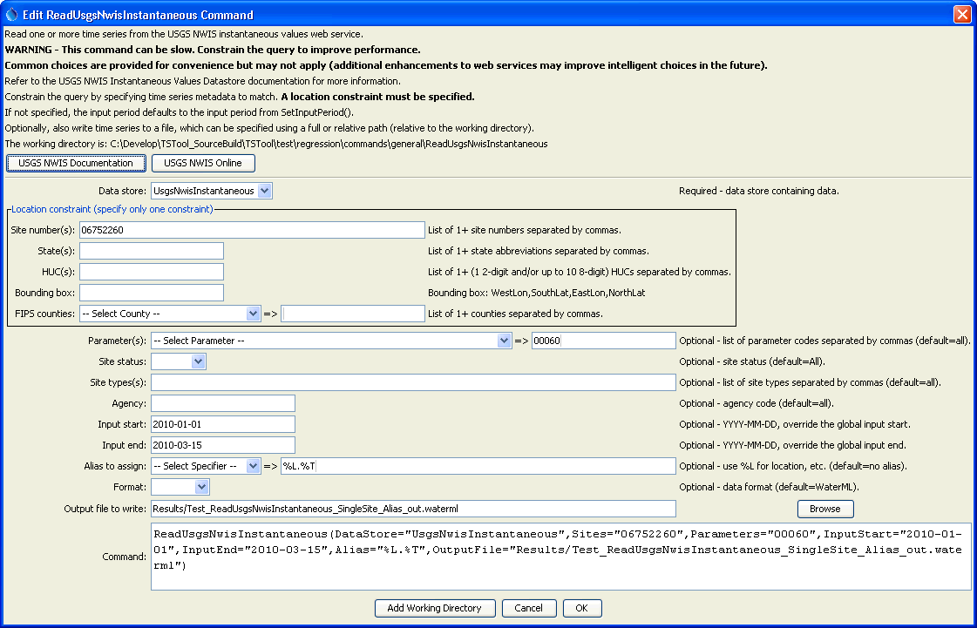
ReadUsgsNwisInstantaneous
ReadUsgsNwisInstantaneous() Command Editor

The command syntax is as follows:

ReadUsgsNwisInstantaneous(Parameter=Value,…)

Command Parameters

Parameter | Description | Default
Sites | A list of site numbers to read, separated by commas. | None – one of the locational parameters must be provided to constrain the query.
States | A list of state codes (e.g., AL), separated by commas. | None – see above.
HUCs | A list of hydrologic unit codes, separated by commas. See the limitations on the NWIS site for more information. | None – see above.
BoundingBox | A bounding box consisting of west longitude, south latitude, east longitude, and north latitude, separated by spaces. Longitudes in the western hemisphere are negative. | None – see above.
Counties | A list of Federal Information Processing Standards (FIPS) county codes, separated by commas. | None – see above.
Parameters | Data parameter codes for the stations (e.g., 00060 for stream discharge), separated by commas. | All available parameters for the sites are returned.
SiteStatus | Filter for stations, one of:  - All – all stations are returned  - Active – only active stations are returned  - Inactive – only inactive stations are returned | All
SiteTypes | Site types to return, separated by commas. | All available site types are returned.
Agency | Agency code to return (e.g., USGS). | All available agencies are returned.
InputStart | The start of the period to read data to 15-minute precision – specify if the period should be different from the global query period. | Use the global query period.
InputEnd | The end of the period to read data to 15-minute precision – specify if the period should be different from the global query period. | Use the global query period.
Alias | The alias to assign to the time series, as a literal string or using the special formatting characters listed by the command editor. The alias is a short identifier used by other commands to locate time series for processing, as an alternative to the time series identifier (TSID). | None – must be specified.
Format | The data format for output, one of:  - JSON – JavaScript Object Notation (currently used only for downloads but will not result in time series in TSTool)  - RDB – tab-delimited format (also see ReadUsgsNwisRDB() command; currently used only for downloads but will not result in time series in TSTool).  - WaterML – XML format (also see the ReadWaterML() command). | WaterML
OutputFile | The name of the output file to create. The path to the file can be absolute or relative to the working directory. | No output file will be created.

