Command Reference: WriteStateCU()
Write time series to a StateCU format file
Version 08.16.04, 2008-09-04

The WriteStateCU() command writes time series to the specified StateCU frost dates format file. Currently only the frost dates file can be written with this command. See the WriteStateMod() command to write StateMod format files (e.g., for the precipitation, temperature, and diversion time series files used with the StateCU model). See the StateCU Input Type Appendix for more information about the file format. All time series matching the data types FrostDateL28S, FrostDateL32S, FrostDateF32F, and FrostDateF28F will be written (all other time series will be ignored). Other StateCU files may be supported in the future. See also the StateDMI software, which processes other StateCU files.

The following dialog is used to edit the command and illustrates the syntax of the command.

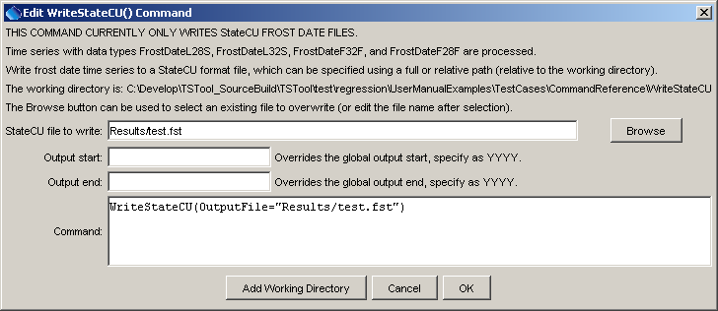
WriteStateCU
WriteStateCU() Command Editor

The command syntax is as follows:

WriteStateCU(Parameter=Value,…)

Command Parameters

Parameter | Description | Default
OutputFile | The StateCU frost dates output file. The path to the file can be absolute or relative to the working directory. | None – must be specified.
OutputStart | The date/time for the start of the output. | Use the global output period.
OutputEnd | The date/time for the end of the output. | Use the global output period.

A sample command file is as follows, using data from the State of Colorado’s HydroBase database:

# 0109 - AKRON 4 E
0109.NOAA.FrostDateL28S.Year~HydroBase
0109.NOAA.FrostDateL32S.Year~HydroBase
0109.NOAA.FrostDateF32F.Year~HydroBase
0109.NOAA.FrostDateF28F.Year~HydroBase
WriteStateCU(OutputFile="test.stm")

