Command Reference: WriteDateValue()
Write time series to a DateValue format file
Version 10.01.00, 2011-11-15

The WriteDateValue() command writes time series to the specified DateValue format file. See the DateValue Input Type Appendix for more information about the file format. The time series being written must have the same data interval – use the TSList parameter to select appropriate time series.

The following dialog is used to edit the command and illustrates the syntax of the command.

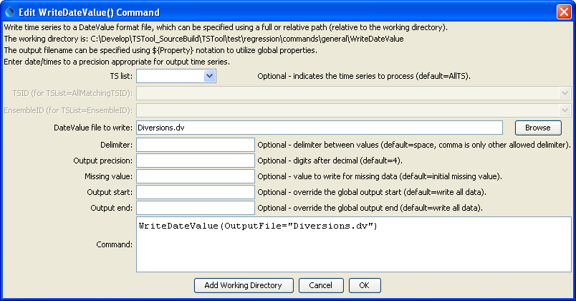
WriteDateValue
WriteDateValue() Command Editor

The command syntax is as follows:

WriteDateValue(Parameter=Value,…)

Command Parameters

Parameter | Description | Default
OutputFile | The DateValue output file. The path to the file can be absolute or relative to the working directory (command file location). Global properties can be used to specify the filename, using the ${Property} syntax. | None – must be specified.
Delimiter | The delimiter character to use between data values. Comma is the only other allowed value other than the default space. | Space.
Precision | The number of digits after the decimal for numerical output. | 4 (in the future may default based on data type)
MissingValue | The value to write to the file to indicate a missing value in the time series. | As initialized when reading the time series or creating a new time series, typically -999, NaN, or another value that is not expected in data.
OutputStart | The date/time for the start of the output. | Use the global output period.
OutputEnd | The date/time for the end of the output. | Use the global output period.
TSList | Indicates the list of time series to be processed, one of:  - AllMatchingTSID – all time series that match the TSID (single TSID or TSID with wildcards) will be processed.  - AllTS – all time series before the command.  - EnsembleID – all time series in the ensemble will be processed.  - FirstMatchingTSID – the first time series that matches the TSID (single TSID or TSID with wildcards) will be processed.  - LastMatchingTSID – the last time series that matches the TSID (single TSID or TSID with wildcards) will be processed.  - SelectedTS – the time series are those selected with the SelectTimeSeries() command. | AllTS
TSID | The time series identifier or alias for the time series to be processed, using the * wildcard character to match multiple time series. | Required if TSList=*TSID.
EnsembleID | The ensemble to be processed, if processing an ensemble. | Required if TSList= EnsembleID.

A sample command file to process data from the State of Colorado’s HydroBase database is as follows:

# 0100501 - EMPIRE DITCH
0100501.DWR.DivTotal.Month~HydroBase
# 0100503 - RIVERSIDE CANAL
0100503.DWR.DivTotal.Month~HydroBase
WriteDateValue(OutputFile="Diversions.dv")

