Command Reference: WriteReclamationHDB()
Write a time series to a Reclamation HDB database
Version 10.19.00, 2013-03-15

The WriteReclamationHDB() command writes time series to a Reclamation HDB database:

- a single time series (which can be part of an ensemble), indicated by its time series identifier
- all time series in an ensemble, indicated by its ensemble identifier

See the Reclamation HDB Data Store Appendix for more information about the database features and limitations. The command will not define a new time series but will update the data records for an existing time series. The time series interval is used to determine the time series table to write, with irregular data being written as instantaneous data with date/time precision to minute. The time series is written to a model time series table if model parameters are specified. The HDB “write_to_hdb” stored procedure is used to write the data. Limitations of this command are as follows:

- Missing data currently are not written. By convention missing values in HDB are simply not included in the database. Currently the command will not delete previous records if the new value at a date/time is missing.
- Data units in the time series are not checked against data units in the database because the units in TSTool data may originally have come from various sources that do not use the same units abbreviations as HDB. It is the user’s responsibility to ensure that time series that are being written have units that are compatible with HDB.
- Time zone can be indicated in TSTool time series by including in the start and end date/time information; however, time zones are difficult to standardize when data comes from different sources. The default time zone for HDB is configured for the Reclamation office that uses the database. If the time series time zone is different from the default (see the command dialog note for the TimeZone parameter), it can be specified as a command parameter. It is the user’s responsibility to verify that the correct time zone is being used.
- Data flags from the time series are not written to the database. The ValidationFlag, OverwriteFlag, and DataFlags parameters are provided to specify HDB flags. Additional capability may be added in the future.
- TSTool treats year-interval data generically and does not manage water year (or other types of years) in special fashion, other than when processing data into year interval time series. Water year data can be saved in year interval data but currently there is no way to write to the water-year tables in HDB.
- Writing model data currently must specify the ModelRunID parameter directly. Additional testing is needed to ensure that the editor dialog choices cascade properly, even when some null/blank fields exist in the model run definitions.
- Hourly data in TSTool are shifted earlier one hour prior to writing, due to HDB data management conventions.
- The ability to write an ensemble is under development.
The following dialog is used to edit the command and illustrates the syntax of the command.

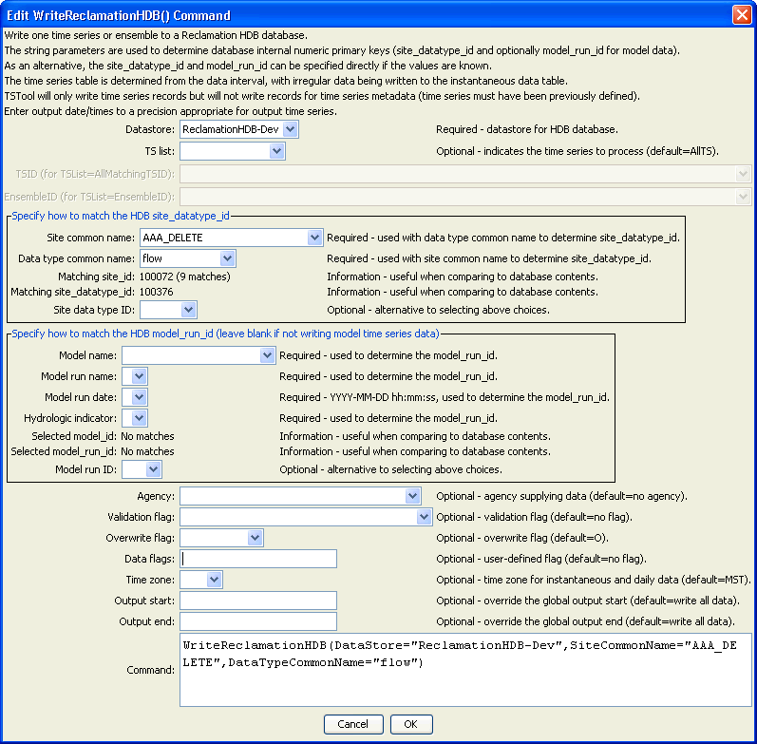
WriteReclamationHDB
WriteReclamationHDB() Command Editor

The command syntax is as follows:

WriteReclamationHDB(Parameter=Value,…)

Command Parameters

Parameter | Description | Default
DataStore | The identifier for the ReclamationHDB data store to use for the database. | None – must be specified.
TSList | Indicates the list of time series to be processed, one of:  - AllMatchingTSID – all time series that match the TSID (single TSID or TSID with wildcards) will be processed.  - AllTS – all time series before the command.  - EnsembleID – all time series in the ensemble will be processed. This is not yet enabled for the new HDB ensemble design.  - FirstMatchingTSID – the first time series that matches the TSID (single TSID or TSID with wildcards) will be processed.  - LastMatchingTSID – the last time series that matches the TSID (single TSID or TSID with wildcards) will be processed.  - SelectedTS – the time series are those selected with the SelectTimeSeries() command. | AllTS
TSID | The time series identifier or alias for the time series to be processed, using the * wildcard character to match multiple time series. | Required if TSList=*TSID.
EnsembleID | The ensemble to be processed, if processing an ensemble. | Required if TSList= EnsembleID.
Site  CommonName | The site common name for the time series location; used with the data type common name to determine the site_datatype_id in the database. | None – must be specified unless SiteDataTypeID is specified.
DataType  CommonName | The data type common name for the time series; used with the site common name to determine the site_datatype_id in the database. | None – must be specified unless SiteDataTypeID is specified.
SiteDataTypeID | The site_datatype_id value to match the time series. If specified, the value will be used instead of the site_datatype_id determined from SiteCommonName and DataTypeCommonName.
ModelName | The model name for the time series; used with the model run name, hydrologic indicator(s), and model run date to determine the model_run_id in the database. | None – must be specified unless ModelRunID is specified.
ModelRunName | The model run name for the time series; used with the model name, hydrologic indicator(s), and model run date to determine the model_run_id in the database. | None – must be specified unless ModelRunID is specified.
ModelRunDate | The model run date (timestamp) to use for the time series; used with the model name, model run name, and hydrologic indicator(s) to determine the model_run_id in the database. | None – must be specified unless ModelRunID is specified.
Hydrologic  Indicator | The hydrologic indicator(s) to use for the time series; used with the model name, model run name, and model run date to determine the model_run_id in the database. | None – must be specified unless ModelRunID is specified.
ModelRunID | The model_run_id value to match the time series. If specified, the value will be used instead of the model_run_id determined from ModelName , ModelRunName, ModelRunDate, and HydrologicIndicator.
Agency | The agency abbreviation (e.g., USBR) for data records written to the database. | No agency is indicated in database.
Validation  Flag | HDB validation flag. Only uppercase characters are supported. | No flag is used.
OverwriteFlag | HDB overwrite flag. | Overwrite (enforced by HDB stored procedure)..
DataFlags | User-defined flags, up to 20 characters. | No flags are used.
TimeZone | Three-letter time zone abbreviation for the data records written to the database. | Default HDB time zone is assumed.
OutputStart | The date/time for the start of the output. | Use the global output period.
OutputEnd | The date/time for the end of the output. | Use the global output period.

