How to Create and Run Regression Tests for TSTool
2007-12-18

This document provides guidelines for creating and running regression tests for TSTool. The following requirements apply:

- Regression test configuration and expected results must be maintained with the product under version control in the repository (dynamic output such as results and log files are not expected to be committed to the repository).
- Individual regression tests should be runnable in an interactive operational mode (e.g., start TSTool, open a command file, run the command file and see expected results or errors). The tests may also serve as simple examples for training, although this needs to be evaluated more.
- Suites of regression tests should be runnable in interactive and batch mode to facilitate daily checks and as part of a release checklist. Creation and management of test suites should be a simple process. Different suites of tests can be created to verify various aspects of the software, for example:
  - General commands (simple tests of all commands).
  - CDSS commands (verify processing of CDSS model files).
  - NWS commands (verify processing of NWS model files).
  - Others to verify processing data in various systems.
- Automated regression tests should allow using CruiseControl, allowing rapid detection of and appropriate response to errors introduced by developers. CruiseControl shall use the “source based build” product configuration.

Answers to common questions are listed below:

Question: Why is this type of testing needed – shouldn’t software developers ensure that the software is working properly?
Answer: The testing described in this document is performed by software developers during development and prior to software release. The number of tests is expected to increase over time. Testing is necessary to detect problems due a change in code resulting in unexpected results. Because software developers may not have defined enough tests to detect all problems in all user environments, this procedure can also be used by users to verify that the tool continues to perform as expected. It is recommended that users submit tests to developers.

Question: Why is testing run by TSTool, the very software that is being tested?
Answer: Although this opens the possibility that a bug in the testing software could cause failures not to be detected, care will be taken to minimize this risk. Doing the testing inside of TSTool allows testing to be done within the tool without distributing a separate test framework. Testing within TSTool also increases the level of code coverage during testing.

Creating a Single Regression Test

A single command file based regression test should be defined to exercise an execution path (combination of parameters) for a command. Ideally, one test for each combination should be defined, and a test for invalid combinations should be defined to test for error detection. At a minimum, a test should be defined to test the most common, basic functionality. The effort to define all combinations is large and therefore basic tests should be defined first with additional test cases defined over time.
The following example illustrates a simple regression test. Such command files are typically saved in the following folder in the development sandbox: TSTool/test/regression/commands/general/CommandName. This reflects the fact that the test is a regression test (not code unit test, and not operational test for interactive testing), is focusing on specific commands (not multi-command files or those used to generate data sets), and the tests are general (not focused on any specific customer or project). The following illustrates other folders in the test structure:

TSTool/test/ operational/ (Files for running operationally, as if installed)
CDSS/ (CDSS environment)
RTi/ (general TSTool environment)
regression/ (all regression tests)
commands/ (tests for commands)
CDSS_RioGrande/ (Verify Rio Grande model file creation)
rih/
Data/ (replacement time series)
ExpectedResults/
Results/
Test_ModelFileName_*.TSTool
general/ (Verify each command)
CommandName/
Data/
ExpectedResults/
Results/
Test_CommandName_*.TSTool
TestSuites/ (groups of tests determined from above folders)
commands_general/ (tests from commands/general)
create/
Create_RunTestSuite_commands_general.TSTool
run/
Run_RunTestSuite_commands_general.TSTool
CDSS_RioGrande/ (tests for CDSS Rio Grande files)
create/
run/
The name of the command file should follow the pattern:
Test_CommandName_1.TSTool
Test_CommandName_SpecificDescriptor.TSTool

The name of log and output files should be consistent with the command file to avoid confusion.
An example test case command file is as follows:

# Start the log file for this specific command file
StartLog(LogFile="Results\Test_Free_FreeOne.TSTool.log")
# Set up the test by removing old output and generating new output
RemoveFile(InputFile="Results\Test_Free_FreeOne_out.dv")
TS Alias1 = NewPatternTimeSeries(NewTSID="MyLoc1..MyData.Day",Description="Test data",
SetStart="1950-01-01",SetEnd="1951-03-12",Units="CFS",PatternValues="5,10,12,13,75")
TS Alias2 = NewPatternTimeSeries(NewTSID="MyLoc2..MyData.Day",Description="Test data",
SetStart="1950-01-01",SetEnd="1951-03-12",Units="CFS",PatternValues="10,20,24,26,150")
Free(TSID="Alias2")
# Uncomment the following command to regenerate the expected results file.
# WriteDateValue(OutputFile="ExpectedResults\Test_Free_FreeOne_out.dv")
WriteDateValue(OutputFile="Results\Test_Free_FreeOne_out.dv")
# Execute the test, generating a SUCCESS (no warning/failures) or WARNING/FAILURE
CompareFiles(InputFile1="Results\Test_Free_FreeOne_out.dv",
InputFile2="ExpectedResults\Test_Free_FreeOne_out.dv",WarnIfDifferent=True)

The above example illustrates the basic steps in each test:

- Configure the local log file (this allows the log to be reviewed after the test if troubleshooting) – note that the log file is created in the Results folder for dynamic content.
- Setup the test:
  - Cleanup old output files that should not be mistaken for current output.
  - Execute the command(s) being tested to generate in-memory values.
  - Generate an output file to compare (DateValue files are convenient). Using output files simplifies troubleshooting. (When generating expected results, uncomment the command(s) that generate/write expected results. In all other cases, comment out the command(s) so that the test in step 3 below uses the current results and expected results that were manually verified when the test was created.)
- Perform the test, typically using the following commands, which can be configured to generate a failure status if results depending on whether the expected and new results should be the same or different:
  - CompareFiles()
  - CompareTimeSeries()

Use the SVN:ignore property for the Subversion repository on the Results folder to NOT commit the dynamic results files to the repository. Yes, this should be done on every Results folder as tests are defined – need to check with Ian as to whether the Results folder is itself committed – otherwise something needs to create so tester does not get warnings.

Running a Single Regression Test

A single regression test can be run by interactively selecting and running the command file in TSTool:

- Start TSTool
- File….Open Command File.
- File… Run Commands.

To run in batch mode, run the command file as follows:

Tstool –commands CommandFile.TSTool

Creating a Test Suite

To create a test suite (a group of test cases), run the a command file similar to the following (in this example named TSTool/test/regression/TestSuites/commands_general/create/
Create_RunTestSuite_commands_general.TSTool):

#
# Create the regression test runner for the
# TSTool/test/regression/commands/general files.
#
# Only command files that start with Test*.TSTool are included in the output.
# Don't append the generated commands, in order to force the old file to be
# overwritten.
#
CreateRegressionTestCommandFile(SearchFolder="..\..\..\commands\general",
OutputFile="..\run\RunRegressionTest_commands_general.TSTool",Append=False)

This will create a command file in a parallel “run” folder called RunRegressionTest_commands_general.TSTool, which has contents similar to:

StartRegressionTestResultsReport(OutputFile="RunRegressionTest_commands_general.TSTool.out.txt")
RunCommands(InputFile="..\..\..\commands\general\addConstant\testDay.TSTool")
RunCommands(InputFile="..\..\..\commands\general\compareTimeSeries\Test_AllDifferent.TSTool")
RunCommands(InputFile="..\..\..\commands\general\compareTimeSeries\Test_AllSame.TSTool")
RunCommands(InputFile="..\..\..\commands\general\free\Test_Free_FreeAll.TSTool")
RunCommands(InputFile="..\..\..\commands\general\free\Test_Free_FreeOne.TSTool")
RunCommands(InputFile="..\..\..\commands\general\free\Test_Free_FreeOneUsingWildcard.TSTool")
RunCommands(InputFile="..\..\..\commands\general\newDayTSFromMonthAndDayTS\testAlgorithm.TSTool")
RunCommands(InputFile="..\..\..\commands\general\newDayTSFromMonthAndDayTS\testMissingDataBoth.TSTool")
RunCommands(InputFile="..\..\..\commands\general\newDayTSFromMonthAndDayTS\testMissingDataDay.TSTool")
RunCommands(InputFile="..\..\..\commands\general\newDayTSFromMonthAndDayTS\testMissingDataMonth.TSTool")
RunCommands(InputFile="..\..\..\commands\general\NewPatternTimeSeries\Test_NewPatternTimeSeries_1.TSTool")
RunCommands(InputFile="..\..\..\commands\general\newTimeSeries\testDay.TSTool")
RunCommands(InputFile="..\..\..\commands\general\newTimeSeries\testHour.TSTool")
RunCommands(InputFile="..\..\..\commands\general\newTimeSeries\testMonth.TSTool")
RunCommands(InputFile="..\..\..\commands\general\OpenHydroBase\Test_OpenHydroBase_1.TSTool")
RunCommands(InputFile="..\..\..\commands\general\ReadStateMod\Test_ReadStateMod_1.TSTool")
RunCommands(InputFile="..\..\..\commands\general\sortTimeSeries\Test_SortTimeSeries_1.TSTool")

Note that the above DOES NOT create a log file. This is because currently with the logging that is in place, a top-level log file would interfere with that for individual command tests. This is an area that can be improved. The first command opens a global test results report file that is used by the RunCommands() command to save its results.

Multiple test suites can be created/run to test general command use, and for specific systems (e.g., CDSS, NWSRFS). The test suites can be distributed to test the software in operational settings, at RTi before software release, and on customer computers for troubleshooting.
Test suites should be regenerated and run before software is released to internal and external customers.

Running a Test Suite

To run a test suite, interactively select the command file shown above and run in TSTool. The output report file will contain information similar to the following:

SUCCESS C:\Develop\TSTool_SourceBuild\TSTool\test\regression\commands\general\add\Test_Add_1.TSTool
SUCCESS C:\Develop\TSTool_SourceBuild\TSTool\test\regression\commands\general\addConstant\Test_AddConstant_1.TSTool
SUCCESS C:\Develop\TSTool_SourceBuild\TSTool\test\regression\commands\general\adjustExtremes\Test_AdjustExtremes_1.TSTool
SUCCESS C:\Develop\TSTool_SourceBuild\TSTool\test\regression\commands\general\analyzePattern\Test_AnalyzePattern_FromMonthDataValues.TSTool
SUCCESS C:\Develop\TSTool_SourceBuild\TSTool\test\regression\commands\general\CreateFromList\Test_CreateFromList_1.TSTool
WARNING C:\Develop\TSTool_SourceBuild\TSTool\test\regression\commands\general\CreateTraces_Alias\Test_CreateTraces_1.TSTool
SUCCESS C:\Develop\TSTool_SourceBuild\TSTool\test\regression\commands\general\cumulate\Test_Cumulate_1.TSTool
SUCCESS C:\Develop\TSTool_SourceBuild\TSTool\test\regression\commands\general\DeselectTimeSeries\Test_DeselectTimeSeries_1.TSTool
SUCCESS C:\Develop\TSTool_SourceBuild\TSTool\test\regression\commands\general\Disaggregate_Alias\Test_Disaggregate_1.TSTool
SUCCESS C:\Develop\TSTool_SourceBuild\TSTool\test\regression\commands\general\divide\Test_Divide_1.TSTool
WARNING C:\Develop\TSTool_SourceBuild\TSTool\test\regression\commands\general\fillCarryForward\Test_FillCarryForward_1.TSTool
SUCCESS C:\Develop\TSTool_SourceBuild\TSTool\test\regression\commands\general\fillConstant\Test_FillConstant_Day.TSTool
SUCCESS C:\Develop\TSTool_SourceBuild\TSTool\test\regression\commands\general\ReadStateModB\Test_ReadStateModB_1.TSTool
FAILURE C:\Develop\TSTool_SourceBuild\TSTool\test\regression\commands\general\ReadTableFromDelimitedFile\Test_ReadTableFromDelimitedFile_1.TSTool
SUCCESS C:\Develop\TSTool_SourceBuild\TSTool\test\regression\commands\general\ReadUsgsNwis\Test_ReadUsgsNwis_1.TSTool
SUCCESS C:\Develop\TSTool_SourceBuild\TSTool\test\regression\commands\general\RelativeDiff_Alias\Test_RelativeDiff_1.TSTool
SUCCESS C:\Develop\TSTool_SourceBuild\TSTool\test\regression\commands\general\replaceValue\Test_ReplaceValue_1.TSTool
FAILURE C:\Develop\TSTool_SourceBuild\TSTool\test\regression\commands\general\ResequenceTimeSeriesData\Test_ResequenceTimeSeriesData_1.TSTool
SUCCESS C:\Develop\TSTool_SourceBuild\TSTool\test\regression\commands\general\RunningAverage\Test_RunningAverage_1.TSTool
SUCCESS C:\Develop\TSTool_SourceBuild\TSTool\test\regression\commands\general\scale\Test_Scale_1.TSTool
SUCCESS C:\Develop\TSTool_SourceBuild\TSTool\test\regression\commands\general\selectTimeSeries\Test_SelectTimeSeries_1.TSTool
SUCCESS C:\Develop\TSTool_SourceBuild\TSTool\test\regression\commands\general\SetAutoExtendPeriod\Test_SetAutoExtendPeriod_1.TSTool
SUCCESS C:\Develop\TSTool_SourceBuild\TSTool\test\regression\commands\general\setAveragePeriod\Test_SetAveragePeriod_1.TSTool
SUCCESS C:\Develop\TSTool_SourceBuild\TSTool\test\regression\commands\general\setConstant\Test_SetConstant_1.TSTool
WARNING C:\Develop\TSTool_SourceBuild\TSTool\test\regression\commands\general\setConstantBefore\Test_SetConstantBefore_1.TSTool
SUCCESS C:\Develop\TSTool_SourceBuild\TSTool\test\regression\commands\general\setDataValue\Test_SetDataValue_Day.TSTool
ry_1.TSTool

The results can be quickly scanned for problems and serve as a record for testing. The TSTool interface will also display command files that had errors (in this case shown after being run on Linux to emphasize errors that occur when a HydroBase database is not properly configured – all other file based commands test out).

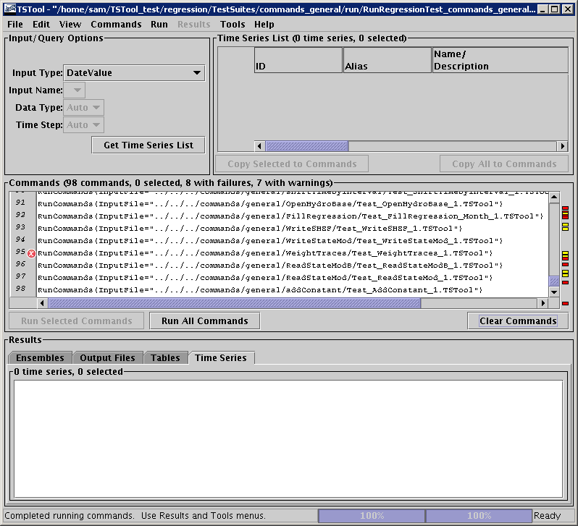

Example TSTool Main Window after Running the General Commands Test Suite

The most severe status from each command file run is used to set the status on each RunCommands() command (in addition to any failure in that command).

The following needs to be done to improve the test process:

- An automated run as described in the next section should be implemented to help detect problems with daily software builds.
- The specific messages generated in a command should be passed to the status information in the RunCommands() command. As it stands, to see the specific problem in a command file, you need to look at the log file for the individual command or rerun the command file to see its feedback.
- There needs to be a way to indicate that a warning is expected, for example to test that warnings are properly generated in specific cases (e.g., obsolete command or actually want to force and detect a failure condition).

Automating Regression Testing Using CruiseControl

CruiseControl software can be used to automate check-out of software from the repository, build the software, and run regression tests. This needs to be implemented to make sure that all code that is checked in by developers is working every night.

Need help from Ian. Questions:

- What computer will be used?
- What configuration is necessary to set up CruiseControl?
- Will it do a full source-build checkout each time?
- How to run?
- What will be the output? And how will it be viewed?
- Are failures notices “pushed” via email? Or do developers need to “pull” the information (e.g., from a web site).

This section will be updated to describe the CruiseControl implementation when it is complete for TSTool.

