3 Getting Started
Version 08.15.00, 2008-04-21

This chapter provides an overview of the TSTool graphical user interface. The TSTool GUI has three main functions:

- Display and analyze time series data. In this capacity, a graph or summary can be created and then TSTool can be closed.
- Format long lists of time series for use with simulation models or other software. In this capacity, information from the previous item can be incorporated into a command file and run the application to generate model files.
- Read time series and produce time series products (e.g., image files), for use on web sites or to facilitate review of database contents or model output. In this capacity TSTool is used to generate data products in a streamlined fashion.
The remainder of this chapter provides an overview of the graphical user interface, in the order of the menus on the menu bar.

3.1 Starting TSTool

TSTool can be started using Start…All Programs…RTi…TSTool (or Start…Programs…RTi…TSTool).

If a commands file has been created, it can be processed in batch mode using the following command line:

tstool –commands commands.TSTool

It is customary to name commands files with a .TSTool file extension.

3.2 Select HydroBase Dialog

If the HydroBase input type is enabled (see the HydroBase Input Type Appendix), the HydroBase login dialog will be automatically shown when TSTool starts in interactive mode. The dialog is used to select a server and database for the State of Colorado’s HydroBase database. A HydroBase database can also be selected from the File...Open…HydroBase... menu.

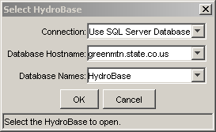
Menu_Open_HydroBase
Select HydroBase Database Dialog

You can also cancel the login, in which case HydroBase features will be disabled but you will be able to work with other input types.

3.3 Main Interface

The following figure illustrates the main TSTool interface during a typical session, immediately after starting (and in this case completing the HydroBase database login). The main interface is divided into three main areas:

- Input/Query Options (top left) and Time Series List area (top right)
- Commands (middle)
- Results (bottom)

Status and progress information is displayed at the bottom of the main window and also in the borders around main panels (e.g., to show how many items are in a list and how many are selected).

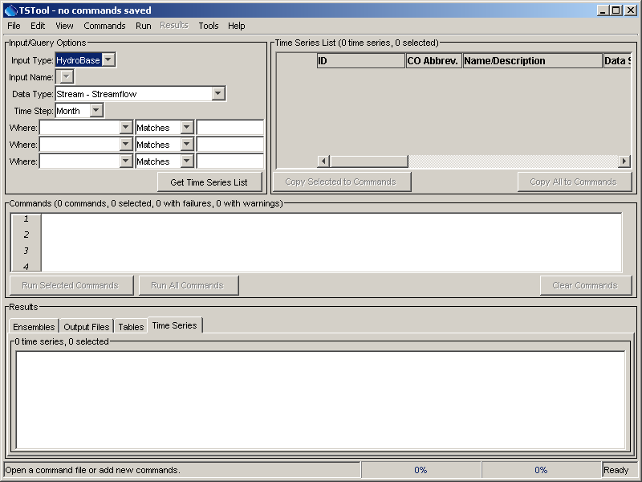
GUI_MainBlank
Initial TSTool Interface

3.3.1 Input/Query Options and Time Series List Area

The upper part of the main window contains the Input/Query Options and Time Series List area. The Input/Query Options choices help select time series information from input types. The interactive interface is useful when searching a database or selecting a time series from a file that includes multiple time series. An alternative to the following interactive approach is to use read commands from the Commands menu (see the Commands chapter), which is appropriate for more complicated analysis. To select time series, execute the following steps:

- Select the Input Type. Input types define the storage format (e.g., database or file) for time series data. The DateValue input type is the default. More specific input types (e.g., the HydroBase database) may be the default if enabled. See the appropriate appendix for a description about supported input types. Depending on the input type, some of the remaining selection choices may be disabled or limited. In most cases, TSTool will assume that you are correctly associating an input type with the actual input that is selected (e.g., that you will select a file that matches the input type when Get Time Series List is pressed – see below). Selecting some input types may prompt for a file, which is then listed in the Input Name choices.

- Select the Data Type (if appropriate for the input type). For example, select Streamflow or Diversion if using a HydroBase input type. For some input types, the data type will be listed as Auto, indicating that the data type automatically will be determined from the input itself.

- Select the Time Step (if appropriate for the input type). The time step, also referred to as the data interval, will generally be limited by the input type. For example, if reading from the HydroBase database, the Streamflow data type will result in Day, Month, and Irregular (real-time) time steps being listed. The time step will be shown as Auto for some input and data types and will be determined as data are read.

- Specify the Where and Is clause(s) for the query (if appropriate for the input type). This information will limit the number of time series that are returned. For some input types, choices will be displayed as choices, whereas for other input types, all time series for the input type will be listed.

- Press the Get Time Series List button in the Input/Query Options area, and TSTool will display a list of matching time series in the Time Series List. If the input type is a file, you may first be prompted to select the file containing the time series. The Time Series List shows a list of matching time series, including standard time series information. As much as possible, the column headings are consistent between different input types. The results are typically sorted by name or identifier if from a database, or if read from a file are listed according to the order in the file. Right-click on the column headings and select Sort Ascending to sort by that column (the other columns will adjust accordingly). The sorts are alphabetical so some numeric fields may not sort as expected due to spaces, etc.

- Move time series to the Commands list in the center of the main interface selecting rows in the Time Series list (must click in column two or greater) and then pressing the Copy Selected to Commands button. Or, if appropriate, press the Copy All to Commands button. The Commands and Time Series Results areas are discussed in the following section and can contain mixed data types and time steps. Analysis commands may require that the units are compatible, but general viewing tools do not require the same units. To mix data types, make multiple queries using the Input/Query Options and Time Series List areas and select from the lists as necessary, accumulating time series identifiers in the Commands list.

After providing selection information, the main interface might look like the following figure:

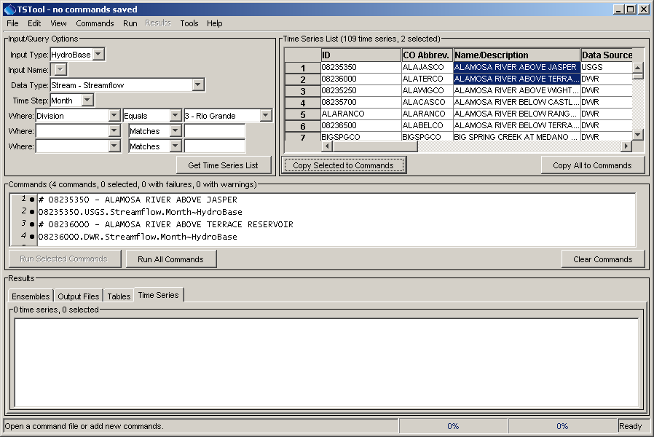
GUI_MainWithCommands
TSTool after Pressing Get Time Series List and selecting from Time Series List

3.3.2 Commands List

The Commands list occupies the middle of the main interface and contains:

- Time series identifiers corresponding to time series selected from the Time Series List, and
- Commands selected from the Commands menu (see Chapter 4 – Commands).

Time series identifiers are added to the Commands list by single clicking on items in the Time Series List and copying the identifiers to the Commands list. Time series identifiers are formatted by transferring information from the appropriate columns in the Time Series List to the Commands list.

An alternative to using the Time Series List to select time series is to use specific read commands from the Commands menu (e.g., use a ReadDateValue() command). Using read commands is useful when performing a more complicated analysis on specific input sources (e.g., specific data files) or when processing large amounts of data. The interactive interface is useful when searching a database or generating a simple graph.

The Commands (and the Time Series Results) lists behave according to Windows conventions:

- Single-click to select one item.
- Ctrl-click to additionally select an item.
- Shift-click to select everything between the previous selection and the current selection.

Right-clicking over the Commands list displays a pop-up menu with useful command manipulation choices, some of which are further described in following sections (e.g., edit menu choices are discussed in Section 3.5 - Edit Menu). A summary of the pop-up menu choices is as follows:

Menu Choice | Description
Show Command Status Success/Warning/Failure | Displays the status of a command for each phase of command processing (more discussion after table).
Edit | Edit the selected command using custom edit dialogs, which provide error checks and format commands. Double-clicking on a command also results in editing the command.
Cut | Cut the selected commands for pasting.
Copy | Copy the selected commands for pasting.
Paste | Paste commands that have been cut/copied, pasted after the selected row.
Delete Command(s) | Delete the selected commands (currently same as Cut).
Find Commands(s) | Find commands in the command list. This displays a dialog. Use the right-click in the found items to go to or select found items.
Select All | Select all the commands.
Deselect All | Deselect all the commands. This is useful because only selected commands are processed (or all if none are selected). It is therefore important not to unknowingly have one or a few commands selected during processing.
Convert Selected Commands to # Comments | Convert selected commands to # comments.
Convert Selected Commands from # Comments | Convert # comments to commands.
Run All Commands (create all output) | Run all commands and create output (e.g., graphs and files).
Run All Commands (ignore output commands) | Run all commands but skip any output commands. This is useful if a batch command file has been read and time series are to be listed in the GUI but output products are not to be generated automatically.
Run Selected Commands (create all output) | Run selected commands and create output (e.g., graphs and files).
Run Selected Commands (ignore output commands) | Run selected commands but skip any output commands. This is useful if a batch command file has been read and time series are to be listed in the GUI but output products are not to be generated automatically.

Initial enhancements to command editing and error handling were implemented in version 7.00.00 and continue to be implemented. Commands are numbered to simplify editing. The command list also includes left and right gutters to display graphics that help with error handling. The following figure illustrates a command with an error (the first time series identifier has been edited to include an x, resulting in an invalid identifier).

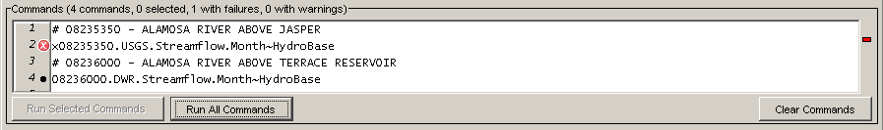
CommandListError
Command List Illustrating Error

The following error handling features are available:

- Clicking on the left gutter will hide and un-hide the gutter.
- The graphic in the left gutter indicates the severity of a problem (see below for full explanation).
- The colored box on the right indicates the severity of a problem and, when clicked on, positions the visible list of commands to display the command corresponding to the problem.
- Commands have three phases: 1) initialization, 2) discovery, 3) run. The discover phase is executed only for commands that generate time series for other commands and provides other commands with identifiers used in command editing.
- Positioning the mouse over a graphic in the left or right gutter will show a popup message with the problem information. The popup is only visible for a few seconds so use the right-click popup menu Show Command Status (Success/Warning/Failure) for a dialog that does not automatically disappear.

The meaning of the gutter symbols is described in the following table. The goal is to display the most severe status to indicate problems; however, some commands are still being enhanced to support this feature and may not display a status until after they are run.

Command List Error Handling Graphics

Command List Left Gutter Graphic | Description
No graphic | Command is successful (a warning or failure has not been detected).
 | The status is unknown, typically because the command has not been updated to fully take advantage of error handling features.
 | The command has a problem that has been classified as non-fatal. For example, a command to fill data may be used but results in no data being filled. In general, commands with warnings need to be fixed unless work is preliminary.
 | The command has failed, meaning that output is likely incomplete. A problem summary and recommendation to fix the problem are available in the status information. Commands with failures generally need to be fixed. Software support should be contacted if the fix is not evident.

Warning and failure messages continue to be enhanced as commands are updated to support the new error handling features.

3.3.3 Time Series Results

The commands in the Commands list are processed by pressing the Run Selected Commands or Run All Commands buttons below the commands list area (or by using the Run menu). The time series that result from processing are listed in the bottom of the main interface, as shown in the following figure:

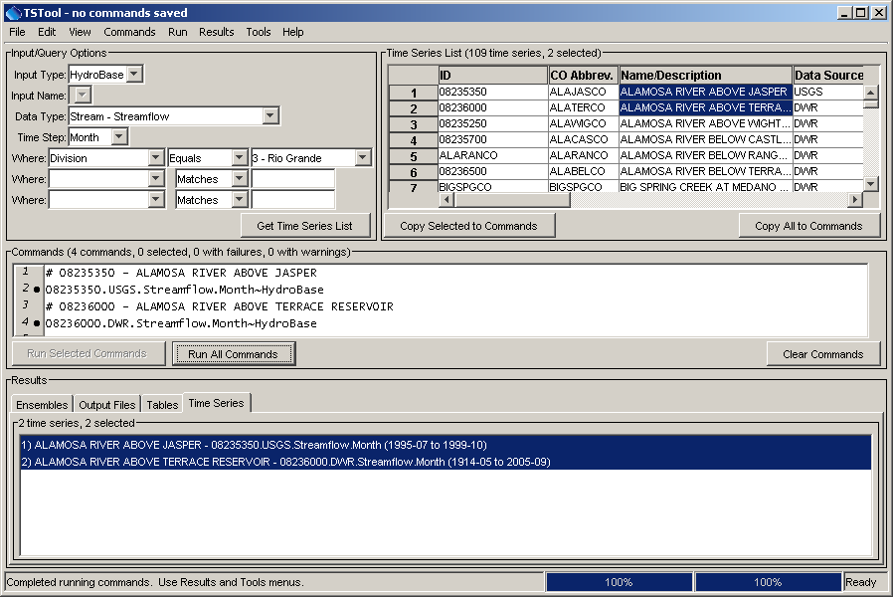
GUI_MainWithTS
TSTool after Running Commands

The time series listed in the Time Series Results list can then viewed using the Results menu, analyzed further using the Tools menu, or output using the File…Save… menus. Only the selected time series will be output (or all if none are selected).

Two progress bars at the bottom of the main window are updated during processing. The left progress bar indicates the overall progress in processing the commands (100% means that all commands have been processed). The right progress bar is used with command that support incremental progress status updating, a feature that will be phased in over time. For example, if a single command processes many time series, this progress bar can be used to indicate progress in the command.

Right-clicking over the Time Series Results list displays a pop-up menu with useful time series viewing choices, including a choice to view the time series properties. The right-click menu choices are summarized below:

Time Series Results List Popup Menu Choices

Menu Choice | Description
Graph - Bar (left of date) | Display bar graph for selected time series, drawing bars to the left of the date.
Graph - Bar (center on date) | Display bar graph for selected time series, drawing bars centered on the date.
Graph - Bar (right of date) | Display bar graph for selected time series, drawing bars to the right of the date.
Graph - Duration | Display a duration graph for the selected time series.
Graph - Line | Display a line graph for selected time series.
Graph - Line (log Y-axis) | Display a line graph for the selected time series, using a log10 y-axis.
Graph - Period of Record | Display a period of record graph for the selected time series.
Graph – Point | Display a graph using symbols but no connecting lines.
Graph – Predicted Value | Display a graph of data and the predicted values from regression.
Graph – Predicted Value Residual | Display a graph of data minus the predicted values from regression.
Graph - XY-Scatter | Display an XY-scatter plot for the selected time series.
Table | Display a scrollable table for the selected time series.
Report - Summary | Display a summary for selected time series.
Find Time Series... | Find time series in the time series list. This displays a dialog. Use the right-click in the found items to go to or select found items.
Select All for Output | Select all time series for output.
Deselect All | Deselect all time series for output.
Time Series Properties | Display the time series properties dialog (see the TSView Time Series Viewing Tools appendix for a complete description of the properties interface).

Viewing capabilities are described further in Section 3.9 - Results Menu and the TSView Time Series Viewing Tools appendix.

The remainder of this chapter summarizes the TSTool menus.

3.4 File Menu - Main Input and Output Control

The File menu provides standard input and output features as described below. Some menus are visible only when certain input types are enabled (see the Installation and Configuration Appendix). Some menus are only enabled when time series have been processed.

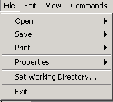
Menu_File
File Menu

3.4.1 File…Open – Open Commands File or Databases

The File…Open menu displays menu items as follows:

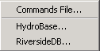
Menu_File_Open
File…Open Menu

The File…Open…Commands File menu item displays a dialog to select an existing commands file. After a file is selected, the file contents replace the contents of the Commands list. If commands already exist in the Commands list and have been modified, you are given the option of saving the existing commands first. Opening a commands file causes the working directory to be set to the directory from which the commands file was read, as if the SetWorkingDir() command was executed. Consequently, SetWorkingDir() commands may not be needed.

The File…Open…HydroBase menu item displays the Select HydroBase dialog discussed in Section 3.2 (see also the HydroBase Input Type Appendix).

The File…Open…RiversideDB menu item displays a dialog to select a RiverTrak® System configuration file, which specifies the location of a RiversideDB database (see the RiversideDB Input Type Appendix).

3.4.2 File…Save – Save Commands File, and Time Series

The File…Save menu displays the following menu choices:

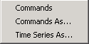
Menu_File_Save
File…Save Menu
The File…Save…Commands and File…Save…Commands As menu items save the contents of the Commands list to a file. The name of the current commands file is shown in the TSTool title bar. All commands are saved, even if only a subset is selected. Saving a commands file causes the working directory to be set to the where the commands file was written, as if the SetWorkingDir() command was executed. Consequently, SetWorkingDir() commands may not be needed.

The File…Save…Time Series As menu item displays a file chooser dialog for saving time series in the Time Series Results list. See the Input Type Appendices for examples of supported file formats. Only the selected time series in the Time Series Results list are saved (or all, if none are selected). Not all formats are supported because in most cases the write commands are used to automate processing of time series.

3.4.3 Print Commands

The File…Print…Commands menu prints the contents of the Commands list. This is useful while editing commands.

3.4.4 Properties for Commands Run, TSTool Session, and Input Types

The File…Properties menu displays the following menu items:

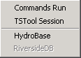
Menu_File_Properties
File…Properties Menu

The File…Properties…Commands Run menu item displays information from the last time that the commands were run, including global properties that impact results:

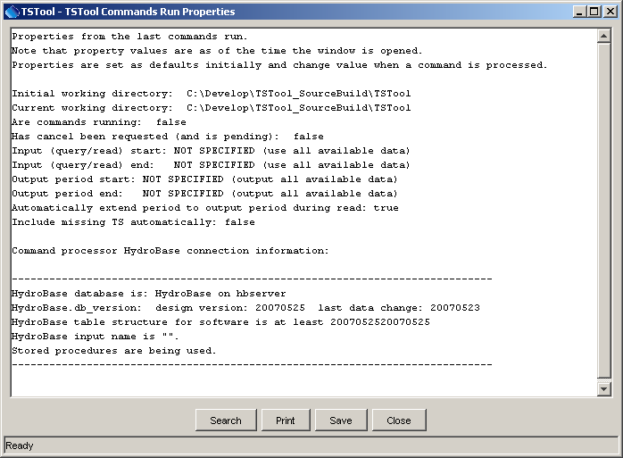
Menu_File_PropertiesRun
Properties of the Last Commands Run

The File…Properties…TSTool Session menu item displays information about the current TSTool session, as follows:

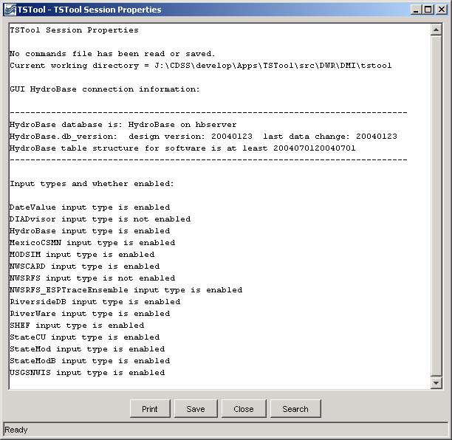
Menu_File_Properties_TSToolSession
TSTool Session Properties

The File…Properties…HydroBase menu item displays HydroBase properties, including the database that is being used, database version, and the water districts that are in the database being queried. The water districts are determined from the structure table in HydroBase. The information that is shown is consistent with that shown by other State of Colorado tools and is useful for troubleshooting.

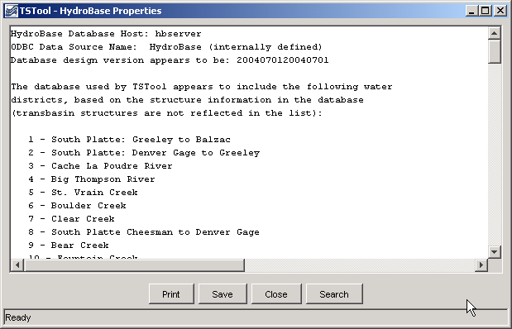
Menu_File_HydroBase
HydroBase Properties Dialog

The File…Properties…RiversideDB menu item displays RiversideDB properties, if a RiversideDB connection is in place.

3.4.5 Set Working Directory

The File…Set Working Directory menu item displays a file chooser dialog that allows you to select the working directory. The working directory, when set properly, can greatly simplify commands files because relative file paths can be used for input and output. The working directory is normally set in one of the following ways, with the current setting being defined by the most recent item that has occurred:

- The startup directory for the TSTool program,
- The directory where a commands file was opened,
- The directory where a commands file was saved,
- The directory specified by a SetWorkingDir() command,
- The directory specified by File…Set Working Directory.

The menu item is provided to allow the working directory to be set before a commands file has been saved (or opened) and it typically eliminates the need for SetWorkingDir() commands in commands files.

3.4.6 Exit

The File…Exit menu exits TSTool. You will be prompted to confirm the exit. If commands have been modified, you will be prompted to save before exiting.

3.5 Edit Menu – Editing Commands

The Edit menu can be used to edit the Commands list. Edit options are enabled and disabled depending on the status of the Commands list. Specific edit features are described below. Right clicking over the Commands list provides a popup menu with many choices described below.

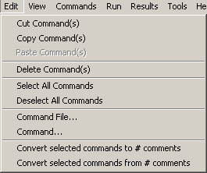
Menu_Edit
Edit Menu

3.5.1 Cut/Copy/Paste/Delete

The Edit…Cut and Edit…Copy menu items are enabled if there are items in the Commands list. Currently, these features do not allow interaction with other applications. Cut deletes the selected item(s) from the Commands list and saves its information in memory. Copy just saves the information in memory. After Cut or Copy is executed, select an item in the Commands list and use Paste (see below).

Paste is enabled if one or more commands from the Commands list has been cut or copied. To paste the command(s), select commands in the Commands list and press Edit…Paste. The commands will be added after the last selected command. To insert at the front of the list, paste after the first command, and then cut and paste the first command to reverse the order.

The Delete choice currently works exactly like the Cut choice. Additionally, after lines in the Commands have been selected, you can press the Clear Commands button below the Commands list to cut/delete.

The Clear Commands button in the Commands area deletes the selected commands or all commands if none are selected. You will be prompted to confirm the clear of no commands are specifically selected.

3.5.2 Select All Commands/Deselect All Commands

The Edit…Select All Commands and Edit…Deselect All Commands menu items are enabled if there are items in the Commands list. Use these menus to facilitate editing. Note that when editing commands it is often useful to deselect all commands so that new commands are added at the end of the commands list.

3.5.3 Edit Commands File

The Edit…Command File menu choice can be used to edit a commands file using Notepad on Windows or nedit on UNIX machines. Currently, there is no way to change the editor. You must re-read the commands file into TSTool after using the editor for TSTool to recognize the time series commands in the commands file. This feature is less useful that in the past because editor dialogs have now been implemented for all commands.

3.5.4 Edit Command

The Edit…Command menu can be used to edit an individual command. TSTool will determine the command that is being edited and will display the editor dialog for that command, performing data checks. Most old commands will be automatically detected and will be converted to new command syntax. This feature is also accessible by right clicking on the Commands list and selecting the Edit menu item.

3.5.5 Convert Selected Commands To/From Comments

The Edit…Convert selected commands to comments menu can be used to toggle selected commands in the Commands list to comments (lines that begin with #). This is useful when temporarily disabling commands, rather than deleting them.

The Edit…Convert selected commands from comments menu can be used to toggle selected commands in the Commands list from comments back to active commands. This is useful when re-enabling commands that were temporarily disabled.

Note that the multi-line /* */ comment notation can be inserted using the Commands…General – Comments menu.

3.6 View Menu – Display Map Interface

The View menu currently has limited choices:

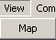
Menu_View
View Menu

The View…Map menu displays a map interface in a separate window. See the Using the Map chapter for more information.

3.7 Commands Menu

The Commands menu provides several menus (as shown in the following figure), which allow time series processing commands to be inserted into the Commands list.

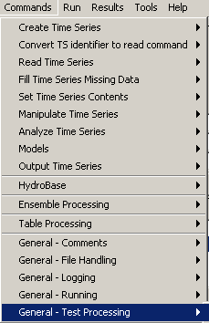
Menu_Commands
Commands Menu

Commands are organized into the following categories:

- Create Time Series - create one or more new time series in memory
- Convert TS identifier to read command – convert a time series identifier in the Commands list area to a read command
- Read Time Series – read time series from a file or database
- Fill Time Series Missing Data - fill missing data
- Set Time Series Contents – set time series data or properties
- Manipulate Time Series - manipulate data by transforming the contents of the time series (e.g., scale a time series’ data values)
- Analyze Time Series – perform analysis on time series, without modifying the time series
- Models – advanced or specific models that operate on time series data
- Output Time Series – write time series results to a file or graph
- HydroBase – commands specific to the HydroBase database
- Ensemble Processing – commands that are specific to ensemble processing
- Table Processing – commands that are specific to table processing
- General – Comments – insert comments
- General – File Handling – commands to manipulate files (e.g., remove)
- General – Logging – commands for logging (e.g., open a log file, set message levels)
- General – Running – commands to control running external programs
- General – Test Processing – commands to process tests, to validate software and procedures

Chapter 4 – Commands discusses commands in more detail and the Command Reference at the back of this documentation provides a reference for each command.

3.8 Run Menu – Run Commands

The Run menu processes the Commands list to generate the Time Series Results for output.

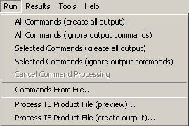
Menu_Run
Run Menu

The Run…All Commands (create all output) menu will process all the commands in the Commands list and create output if appropriate. For example, the WriteStateMod() command will write the time series that are in memory to a StateMod file.

The Run…All Commands (ignore output commands) menu will process the commands in the Commands list, ignoring commands that generate output products. With this option, you can process a commands file prepared for batch mode, but only have the time series available for viewing in the GUI rather than generating the output files. For example, WriteStateMod() commands will not be processed. This increases performance and minimizes creation of files.

The Run…Selected Commands menu items are similar to the above, except that only selected commands are run.

The Run…Cancel Command Processing menu items will be enabled if command processing is active, and allows the processing to be cancelled. Processing may continue until the current command finishes.

The Run…Commands From File choice will run a commands file but not generate any time series for viewing in the GUI. This is equivalent to running in batch mode but initiating the run from the TSTool GUI.

Menu items similar to the above are also available in a popup menu by right clicking on the Commands list.

3.8.1 Process TSProduct

The Run...Process TSProduct File menu items can be used to create time series products by processing time series product definition files. The TSView Time Series Viewing Tools Appendix describes the format of these files. Time series product definition files can be saved from graph views using Save As…Time Series Product. The ProcessTSProduct() command provides equivalent functionality.

3.9 Results Menu – Display Time Series

The Results menu displays time series that are listed in the Time Series Results list. The time series can be viewed multiple times, using the same time series results.

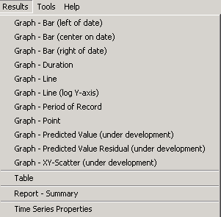
Menu_Results
Results Menu

Graphing time series results in slightly different viewing options being available, depending on the type of graph. In many cases, you will be able to see three views of time series, consisting of a graph, summary, and table. Additionally, you can select the graph properties and choose the colors and symbols to be used for each time series. The TSView Time Series Viewing Tools Appendix describes in detail the graphing tools.

Most of the main Results menu choices are available in a popup menu that is displayed when right-clicking on the Time Series Results list.

3.9.1 Graph - Bar

Bar graphs are generated by selecting time series from the Time Series Results list and pressing Results…Graph - Bar menus. See the TSView Time Series Viewing Tools Appendix for information about bar graphs. The position of the bars relative to the date/time position depends on whether data are instantaneous, mean, or accumulated.

3.9.2 Graph - Duration

Duration graphs are generated by selecting time series in the Time Series Results list and selecting the Results…Graph - Duration menu. See the TSView Time Series Viewing Tools Appendix for information about duration graphs.

3.9.3 Graph - Line

A line graph is generated by selecting time series in the Time Series Results list and then selecting the Results…Graph - Line menu. See the TSView Time Series Viewing Tools Appendix for information about line graphs.

3.9.4 Graph - Line (log Y-axis)

Log Y-axis line graphs are generated by selecting time series in the Time Series Results list and then selecting the Results…Graph - Line (log Y-axis) menu. See the TSView Time Series Viewing Tools Appendix for information about log Y-axis line graphs.

3.9.5 Graph - Period of Record

The period of record graph is useful to display the availability of data over a period. Horizontal lines are drawn for each time series, with breaks in the line indicating missing data. An alternative to this graph type is to use the Tools…Data Coverage by Year report (see Chapter 5 – Tools). See the TSView Time Series Viewing Tools Appendix for information about period of record graphs.

3.9.6 Graph – Point

Point graphs are useful for data that are collected infrequently. For example, the interval of the data may be daily; however, values may only be available once per month, on various days of the months. See the TSView Time Series Viewing Tools Appendix for information about point graphs.

3.9.7 Graph – Predicted Value

The predicted value graph requires as input two time series. First, a regression analysis is performed, similar to the analysis done for the XY-Scatter plot. The original two time series are then plotted, additionally with the time series that would be generated using the regression results. The predicted time series and the original time series will be the same where their periods overlap, with only the predicted time series shown outside of that period.

3.9.8 Graph – Predicted Value Residual

The predicted value residual graph performs the same analysis as the predicted value graph. Where the original and predicted time series overlap, the difference is computed and plotted as a time series. The resulting bar graph therefore shows the relative goodness of fit of the estimated time series.

3.9.9 Graph - XY-Scatter

An XY-scatter graph is generated by selecting two or more time series from the Time Series Results list and then selecting the Results…Graph - XY-Scatter menu. See the TSView Time Series Viewing Tools Appendix for information about XY-Scatter graphs.

3.9.10 Table

A table display is generated by selecting one or more time series from the Time Series Results list and then selecting the Results…Table menu. See the TSView Time Series Viewing Tools Appendix for information about table displays.

3.9.11 Report - Summary

A summary report for time series can be generated by selecting time series in the Time Series Results list and then selecting the Results…Report - Summary menu. See the TSView Time Series Viewing Tools Appendix for information about summary displays.

3.9.12 Time Series Properties

Time series properties include all the information other than the data values. For example, properties include the period of record, data units, processing history, etc

3.10 Tools Menu

The Tools menu lists tools that perform additional analysis on time series that are selected in the Time Series Results list. These features are similar to the Results features in that a level of additional analysis is performed to produce the data product.

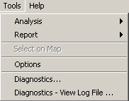
Menu_Tools
Tools Menu

Analysis tools are described in more detail in Chapter 5 – Tools. The following sections describe the Tools…Options and Tools…Diagnostics features.

3.10.1 Options

The Tools…Options menu displays program options, in tabbed panels. The HydroBase tab can be used to specify the total length of water district identifiers (WDIDs), for use with the HydroBase input type.

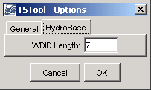
Tools_Options_HydroBase

The WDIDs are used as the location part of the time series identifier. A water district identifier is comprised of a two-digit zero-padded water district (e.g., 01, 20) and a zero-padded identifier for structures within the water district. For example, ditch headgates are typically numbered 500 or greater, within each water district. For modeling purposes, the WDIDs are typically treated as character strings. To allow for distinct and unambiguous identifiers, WDIDs are typically padded with zeros to have consistent overall lengths. In the past, six characters were used for identifiers in model data sets. However, this length is insufficient to handle identifiers in some water districts and therefore the default in TSTool is seven characters. This menu item can be used to set the length if TSTool is being used to create time series and the default length is not compatible with the needed output. The WDID length is enforced when time series are listed. If necessary, the time series identifiers can be edited manually to add or remove padding zeros.

3.10.1 Diagnostics

The Tools…Diagnostics menu displays the diagnostics interface, which is used to set message levels and view messages as TSTool processes data. The Tools…Diagnostics – View Log File menu displays the log file viewer. These tools are useful for troubleshooting problems. Refer to Chapter 5 Tools for more information.

3.11 Help Menu

The help menu displays the version of TSTool.

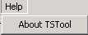
Menu_Help
Help Menu

The Help…About TSTool menu displays the program version number, for use in troubleshooting and support:

