Command Reference: ReadRiversideDB()
Read time series from a RiversideDB database
Version 10.02.00, 2011-12-15

The ReadRiversideDB() command reads one or more time series from a RiversideDB database (see the Riverside Data Store Appendix for more information). It is designed to utilize query criteria to process large numbers of time series. The RiversideDB design is highly consistent with TSTool conventions and therefore time series properties in RiversideDB, including time series identifier information, map closely to TSTool internal data representations.

The following dialog is used to edit the command and illustrates the syntax for the command.

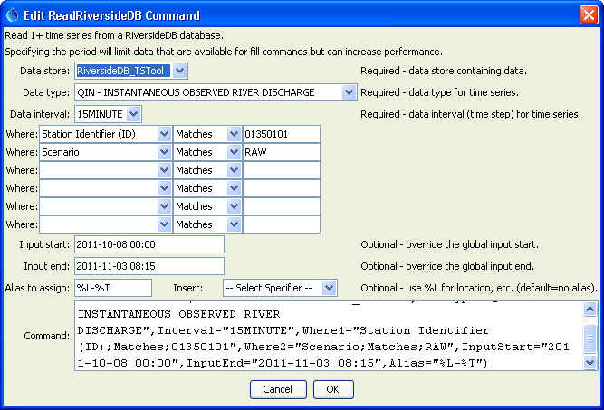
ReadRiversideDB
ReadRiversideDB() Command Editor

The Data type, Data interval, and Where input fields are similar to those from the main TSTool interface. However, whereas the interactive interface first requires a query to find the matching time series list and then an interactive select for specific time series identifiers, the ReadRiversideDB() command reads all matching time series in one step. This can greatly shorten command files and simplify command logic, especially when processing large amounts of data.

The command syntax is as follows:

ReadRiversideDB(Parameter=Value,…)

Command Parameters

Parameter | Description | Default
DataStore | The data store name, indicating the RiversideDB database to query. | None – must be specified.
DataType | The data type to be queried, determined from time series that are available in the database. | None – must be specified.
Interval | The data interval for the time series, determined from time series that are available in the database matching the DataType. | None – must be specified.
WhereN | The “where” clauses to be applied when querying data, matching the values in the Where fields in the command editor dialog and the TSTool main interface. The parameters should be named Where1, Where2, etc., with a gap resulting in the remaining items being ignored. The format of each value is:  “Item;Operator;Value”  Where Item indicates a data field to be filtered on, Operator is the type of constraint, and Value is the value to be checked when querying. | If not specified, the query will not be limited and very large numbers of time series may be queried.
InputStart | Start of the period to query, specified as a date/time with a precision that matches the requested data interval. | Read all available data.
InputEnd | End of the period to query, specified as a date/time with a precision that matches the requested data interval. | Read all available data.
Alias | The alias to assign to the time series, as a literal string or using the special formatting characters listed by the command editor. The alias is a short identifier used by other commands to locate time series for processing, as an alternative to the time series identifier (TSID).

