Command Reference: RunningStatisticTimeSeries()
Create a new time series containing running statistics computed from input
Version 09.10.03, 2011-02-11

The RunningStatisticTimeSeries() command uses a sample of values from a time series to compute a running statistic, resulting in new time series. There are several approaches to determining the sample for the running statistic (as specified by the SampleMethod command parameter):

- The centered running statistic requires that the number intervals on each site of a point be specified (e.g., specifying 1 will use 3 values at each point).
- The previous/future running statistic requires that the number of intervals prior to or after the current point be specified.
- The N-year running statistic is computed by processing the current year and N - 1 values from previous years, for a specific date. A resulting value is produced only if N non-missing values are available. Currently N-year running statistic values for Feb 29 for daily or finer data will always be missing because a sufficient number of values will not be found – an option may be added in the future to allow Feb 29 values to be computed based on fewer than N values.
- A special case of the N-year running statistic (NAllYear) is to use all previous years’ and the current value.

The following dialog is used to edit the command and illustrates the centered running average command syntax.

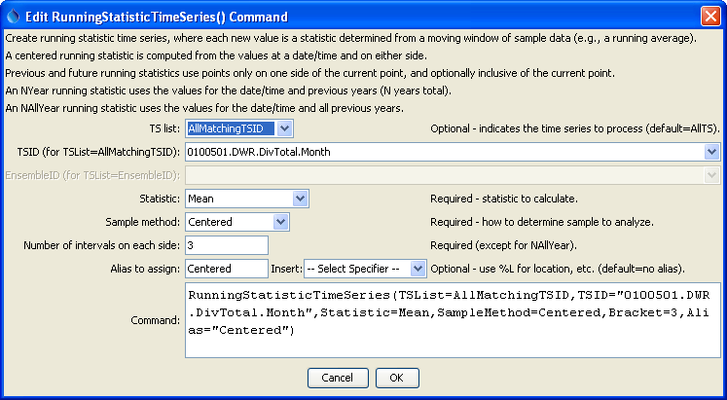
RunningStatisticTimeSeries_centered
RunningStatisticTimeSeries() Command Editor for Centered Running Average

The command syntax is as follows:

RunningStatisticTimeSeries(Parameter=Value,…)

Command Parameters

Parameter | Description | Default
TSList | Indicates the list of time series to be processed, one of:  - AllMatchingTSID – all time series that match the TSID (single TSID or TSID with wildcards)  - AllTS – all time series generated before the command  - EnsembleID – all time series in the ensemble  - FirstMatchingTSID – the first time series that matches the TSID (single TSID or TSID with wildcards)  - LastMatchingTSID – the last time series that matches the TSID (single TSID or TSID with wildcards)  - SelectedTS – the time series selected with the SelectTimeSeries() command | AllTS
TSID | The time series identifier or alias for the time series to be modified, using the * wildcard character to match multiple time series. | Required if TSList=*TSID.
EnsembleID | The ensemble to be modified, if processing an ensemble. | Required if TSList= EnsembleID.
Statistic | The statistic to compute for each point in the created time series, one of:  - Lag-1AutoCorrelation – the autocorrelation between values and the those that follow in the next time step, given by:  r_{k} = Σ_{i=1}^{N-k}(Y_{i} - Y_{mean})(Y_{i + k} - Y_{mean})  Σ_{i=1}^{N}(Y_{i} - Y_{mean})²  - Max – maximum value  - Mean – mean value  - Median – median value  - Min – minimum value  - Skew – skew coefficient, as follows:  Cs = N Σ_{i=1}^{N}(Y_{i} - Y_{mean})³  (n – 1)(n – 2)s³  where s = standard deviation  - StdDev – standard deviation  - Variance – variance | None – must be specified.
SampleMethod | The method used to determine the data sample for each statistic calculation, one of:  - Centered – N (bracket) values on each side of a date/time and the center value  - Future – average the next N (bracket) values but do not include the current value  - FutureInclusive – average the next N (bracket) values and also include the current value  - NYear – values for the current year and (N – 1) preceding years, for the same date/time in each year  - NAllYear – values for the current year and all preceding years, for the same date/time in each year (missing values are allowed)  - Previous – the previous N (bracket) values but do not include the current value  - PreviousInclusive – the previous N (bracket) values and also include the current value | None – must be specified.
Bracket | For centered SampleMethod, the bracket is the number of points on each side of the current point (therefore a value of 1 will average 3 data values). For future and previous SampleMethod, the bracket is the number of previous or future values. For N-year SampleMethod, the bracket is the total number of years to process, including the current year. | None – must be specified.

A sample command file to convert State of Colorado HydroBase diversion time series to running averages is as follows:

# SetInputPeriod(InputStart="1993-01",InputEnd="2000-12")
# 0100501 - EMPIRE DITCH
0100501.DWR.DivTotal.Month~HydroBase
RunningStatisticTimeSeries(TSList=AllMatchingTSID,
TSID="0100501.DWR.DivTotal.Month",Statistic=Mean,SampleMethod=Centered,
Bracket=3,Alias="Centered")
RunningStatisticTimeSeries(TSList=AllMatchingTSID,
TSID="0100501.DWR.DivTotal.Month",Statistic=Mean,SampleMethod=NYear,
Bracket=5,Alias="NYear")
ProcessTSProduct(TSProductFile="Test_RunningStatisticTimeSeries_Example.tsp")

The resulting graph is as follows:

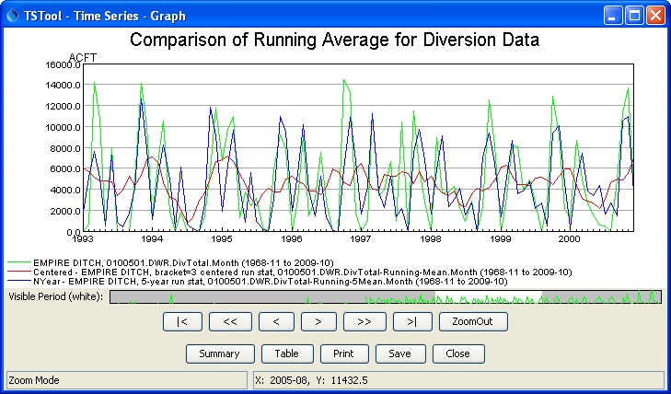
RunningStatisticTimeSeries_graph
Results from RunningStatisticTimeSeries() Commands

