Command Reference: SetInputPeriod()
Set the period for reading time series from files and querying from databases
Version 08.15.00, 2008-05-11

The SetInputPeriod() command sets the period used for reading time series data from files and querying data from databases. The default is to read/query all available data so that all data are available for analysis and data filling. However, a shorter period may be desirable to increase performance (e.g., when processing real-time data) or to force matching a historical period. This command replaces the SetQueryPeriod() command. See also the SetOutputPeriod() command.

The following dialog is used to edit the command and illustrates the command syntax.

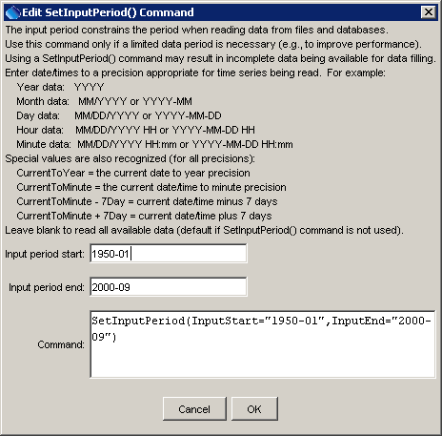
SetInputPeriod
SetInputPeriod() Command Editor

The command syntax is as follows:

SetInputPeriod(Parameter=Value,…)

Command Parameters

Parameter | Description | Default
InputStart | The date/time to start reading/querying time series data, one of:  - A date/time string (see dialog above for examples).  - CurrentToYear, CurrentToMonth, CurrentToDay, CurrentToHour, CurrentToMinute, indicating the current date/time to the specified precision.  - A Current* value +- an interval, for example: CurrentToMinute – 7Day | None – must be specified.
InputEnd | The date/time to end reading/querying time series data, one of:  - A date/time string (see dialog above for examples).  - CurrentToYear, CurrentToMonth, CurrentToDay, CurrentToHour, CurrentToMinute, indicating the current date/time to the specified precision.  - A Current* value +- an interval, for example: CurrentToMinute – 7Day  - An expression involving InputStart, used similar to the Current* values. | None – must be specified.

A sample commands file for historical data from the State of Colorado’s HydroBase is as follows:

SetInputPeriod(InputStart="1950-01",InputEnd="2000-09")
# 06754000 - SOUTH PLATTE RIVER NEAR KERSEY
06754000.DWR.Streamflow.Month~HydroBase

A sample commands file for real-time data is as follows:

SetInputPeriod(InputStart="CurrentToMinute - 14Day",
InputEnd="CurrentToMinute + 1Hour")
# 06754000 - SOUTH PLATTE RIVER NEAR KERSEY
06754000.DWR.Streamflow-DISCHRG.Irregular~HydroBase

