Command Reference: TS Alias = ReadHydroBase()
Read a single time series from a HydroBase Database
Version 08.16.03, 2008-08-20

The TS Alias = ReadHydroBase() command reads a single time series from a HydroBase database (see the HydroBase Input Type Appendix) and assigns an alias to the result. This command should not be confused with the ReadHydroBase() command that does not use the alias, which reads one or more matching time series from a HydroBase database.

The following special actions occur, depending on data type:

- Daily diversion (DivTotal and DivClass) and reservoir release (RelTotal and RelClass) time series have their values automatically carried forward to fill data within irrigation years (Nov to Oct). HydroBase only stores full months of data when non-zero observations or non-zero filled values occur in a month. Therefore, this filling action should only provide additional zero values. Irrigation years with no observations remain as missing after the read. See the FillHistMonthAverage() command, which is often used to fill completely missing years.
- Daily, monthly, and yearly diversion and reservoir release time series can optionally be filled using diversion comments, which indicate when irritation years should be treated as missing. See the FillUsingDivComments parameter below. Note that diversion comments should not conflict with more detailed records but and provide additional information. The older FillUsingDivComments() command is also available for filling.

The following dialog is used to edit the command and illustrates the syntax.

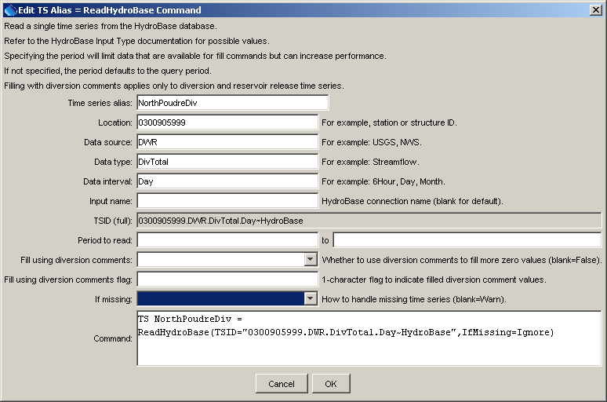
ReadHydroBase_Alias
TS Alias = ReadHydroBase() Command Editor

The command syntax is as follows:

TS Alias = ReadHydroBase(Parameter=Value…)

Command Parameters

Parameter | Description | Default
Alias | Alias for the new time series that is read from the file. | None – must be specified.
TSID | A time series identifier to read – see the HydroBase Input Type Appendix. | Required – specify the time series identifier to read.
InputName | The HydroBase database connection input name to use for the connection, as initialized in OpenHydroBase(), which allows reading from more than one HydroBase in the same commands file. | Use the default HydroBase connection.
InputStart | The start of the period to read data – specify if the period should be different from the global input period. | Use the global input period.
InputEnd | The end of the period to read data – specify if the period should be different from the global input period. | Use the global input period.
FillUsingDivComments | Indicate whether to fill diversion and reservoir release time series using diversion comments. | False
FillUsingDivCommentsFlag | If specified as a single character, data flags will be enabled for the time series and each filled value will be tagged with the specified character. The flag can then be used later to label graphs, etc. The flag will be appended to existing flags if necessary. | No flag is assigned.
IfMissing | Indicate the action to be taken if the requested time series is missing, one of:  - Ignore – ignore the time series (do not warn and the time series will not be available)  - Warn – generate a failure for the command | Warn

A sample command file to read a diversion time series is as follows:

TS NorthPoudreDiv = ReadHydroBase(TSID="0300905.DWR.DivTotal.Day~HydroBase")

This page is intentionally blank.

