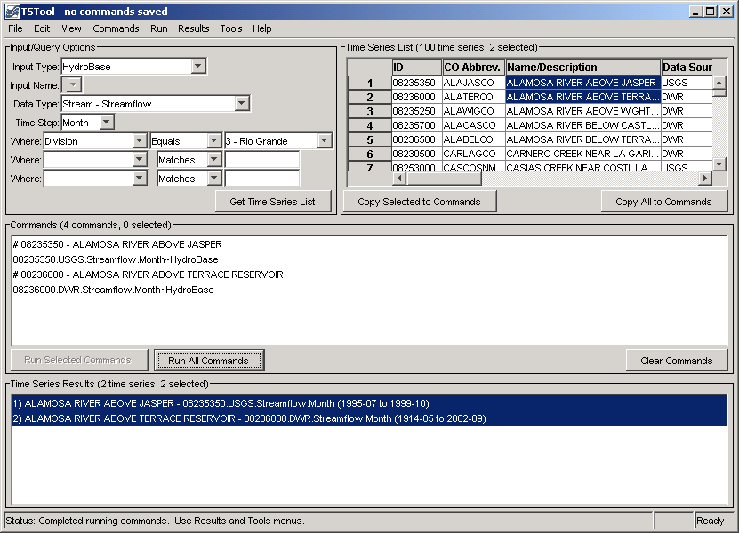
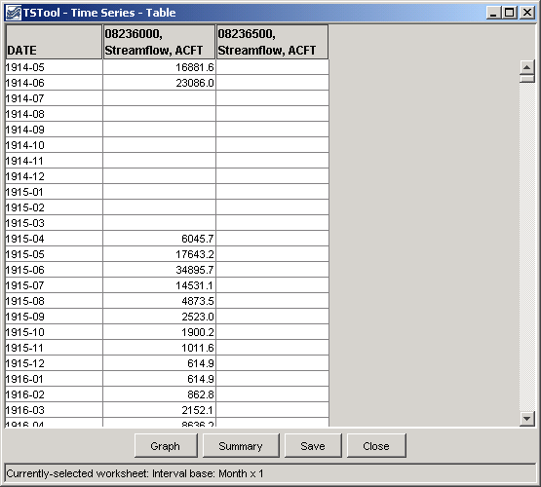
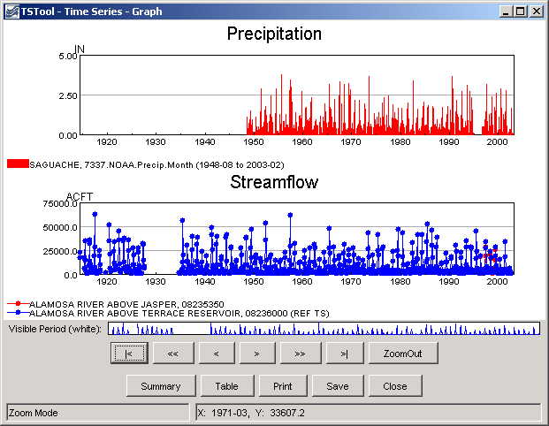
TSTool - Time Series Tool

Developed by:

 | Riverside Technology, inc.

http://www.riverside.com
support@riverside.com

Version 8.15.03, 2008-06-11

This page is intentionally blank.

This document is formatted for double-sided printing.

