Command Reference: TS Alias = Copy()
Create a new time series as a copy of a time series
Version 08.15.03, 2008-05-29

The TS Alias = Copy() command creates a copy of an existing time series, assigning an alias to the result. The copy is an exact copy except that the alias is different (the TSID should also specified to be unique). The alias can then be used for further time series manipulation. A copy of a time series is useful when data filling or other manipulation will occur and the original time series needs to be maintained for graphing or other purpose.

The following dialog is used to edit the command and illustrates the syntax for the command.

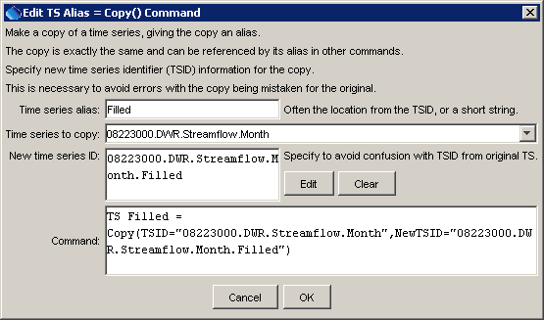
Copy
TS Alias = Copy() Command Editor

The command syntax is as follows:

TS Alias = Copy(Parameter=Value,…)

Command Parameters

Parameter | Description | Default
Alias | The alias to assign to the new copy, which can be used instead of the TSID by other commands. | None – must be specified.
TSID | The time series identifier or alias of the time series to copy. The time series will be found by searching backwards from the copy command. | None – must be specified.
NewTSID | A new time series identifier to assign to the copy. This is useful to avoid confusion with the original time series. Use the Edit button to edit the time series identifier parts. The data interval must match that of the original time series. | Copy the original time series TSID. If NewTSID is specified but does not have a valid interval, copy the interval from TSID. The default cannot be determined if an alias is used for the input time series.

A sample commands file is as follows:

# 08223000 - RIO GRANDE RIVER AT ALAMOSA
08223000.DWR.Streamflow.Month~HydroBase
TS Filled = Copy(TSID="08223000.DWR.Streamflow.Month",
NewTSID="08223000.DWR.Streamflow.Month.Filled")

