Command Reference: SetPatternFile()
Set the pattern file to be used with FillPattern() commands
Version 08.16.04, 2008-09-19

This command has been replaced with ReadPatternFile() – TSTool will automatically convert the command.

The SetPatternFile() command specifies a pattern file to be used with FillPattern() commands (see the FillPattern() command for more information ).

The following dialog is used to edit the command and illustrates the command syntax.

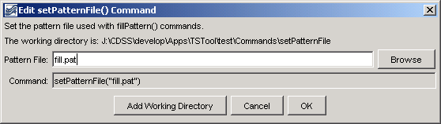
SetPatternFile
SetPatternFile() Command Editor

The command syntax is as follows:

SetPatternFile(PatternFile)

Command Parameters

Parameter | Description | Default
PatternFile | The path to the pattern file, which can be absolute or relative to the working directory. The Browse button can be used to select the pattern file (if a relative path is desired, remove the leading path after the select). | None – must be specified.

A sample commands file is as follows:

SetPatternFile("fill.pat")

This page is intentionally blank.

