Command Reference: SetIncludeMissingTS()
Indicate whether missing time series should automatically be added as blank time series
Version 08.16.00, 2008-07-16

The SetIncludeMissingTS() command sets the global property that indicates whether time series that cannot be found should automatically be added as a time series with missing data. By default, time series that cannot be found generate a warning. This command is useful when processing large amounts of data, to guarantee a placeholder time series even if time series are not found. For example, use the command in the early stages of work to evaluate command sequence logic without addressing every data issue, and then remove the command when focusing on data.

The following dialog is used to edit this command and illustrates the syntax of the command.

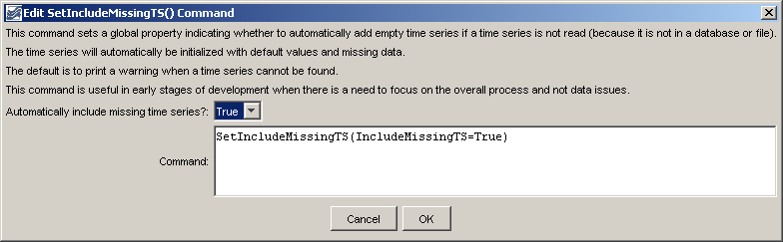
SetIncludeMissingTS
SetIncludeMissingTS() Command Editor

The command syntax is as follows:

SetIncludeMissingTS(Parameter=Value,…)

Command Parameters

Parameter | Description | Default
IncludeMissingTS | Indicates whether time series that are not found with read commands should automatically be added with missing data. | If this command is not used, the default is False.

A sample command file is as follows:

SetIncludeMissingTS(IncludeMissingTS=True)

This page is intentionally blank.

