Command Reference: ReadNwsrfsEspTraceEnsemble()
Read all time series traces from an NWSRFS ESP trace ensemble file
Version 10.00.02, 2011-05-23

The ReadNwsrfsEspTraceEnsemble() command reads all the time series traces in a National Weather Service River Forecast System (NWSRFS) ESP Trace Ensemble file (see the NWSRFS ESP Trace Ensemble Input Type Appendix). Currently, only conditional (CS) files may be read. Each trace is converted to a separate time series, with each having the same header information. The sequence number in the time series is set to the historical year for the start of the trace and the alias can be set dynamically to uniquely identify each trace.

The following dialog is used to edit the command and illustrates the syntax for the command.

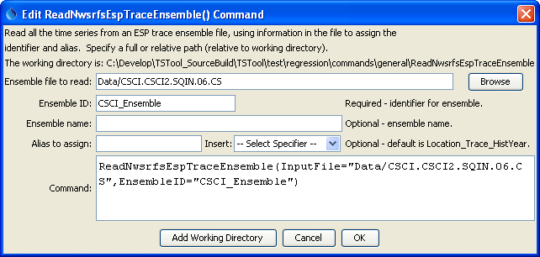
ReadNWSRFSESPTraceEnsemble
ReadNWSRFSESPTraceEnsemble() Command Editor

The command syntax is as follows:

ReadNwsrfsEspTraceEnsemble(Parameter=Value,…)

Command Parameters

Parameter | Description | Default
InputFile | The name of the ensemble file to read, surrounded by double quotes. | None – must be specified.
EnsembleID | The identifier for the ensemble that is read. This identifier is used by other commands that process ensembles. | None – must be specified.
EnsembleName | The descriptive name of the ensemble that is read. | Blank.
Alias | The alias to be assigned to each trace in the ensemble. The string can include:  - % specifiers from the LegendFormat property (see the TSView Time Series Viewing Tools appendix).  - ${Property} strings, where Property is a value set internally by the command processor (more documentation will be provided in the future) or with the SetProperty() command. This approach is useful if the TSTool command file is dynamically created with a script.  - Any literal characters. | Location_Trace_Year, where Location is the location identifier and Year is the starting historical year for each trace.

A sample command file is as follows, which will use the location identifier and sequence number (historical year) in the alias:

ReadNwsrfsEspTraceEnsemble(InputFile="Data\CSCI.CSCI2.SQIN.06.CS",
EnsembleID="Ensemble_CSCI2",EnsembleName="test ensemble",
Alias="%L_%z_Baseline")

