Command Reference: Divide()
Divide the data values in one time series by data values in another time series
Version 08.16.04, 2008-09-24

The Divide()command divides one time series by another. This is useful for comparing the relative size of time series values (see also RelativeDiff()). If the divisor is zero or missing, the result is set to missing. Use the Scale() command to divide by a numerical value.

The following dialog is used to edit the command and illustrates the syntax of the command.

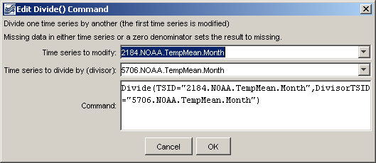
Divide
Divide() Command Editor

The command syntax is as follows:

Divide(Parameter=Value,…)

Command Parameters

Parameter | Description | Default
TSID | The time series identifier or alias for the time series to be modified. | None – must be specified.
DivisorTSID | The time series identifier or alias for the time series that is the divisor. | None – must be specified.

A sample command file to process data from the State of Colorado’s HydroBase database is as follows:

# 2184 - DEL NORTE 2 E
2184.NOAA.TempMean.Month~HydroBase
# 5706 - MONTE VISTA 2 W
5706.NOAA.TempMean.Month~HydroBase
Divide(TSID="2184.NOAA.TempMean.Month",
DivisorTSID="5706.NOAA.TempMean.Month")

The resulting graph is as follows:

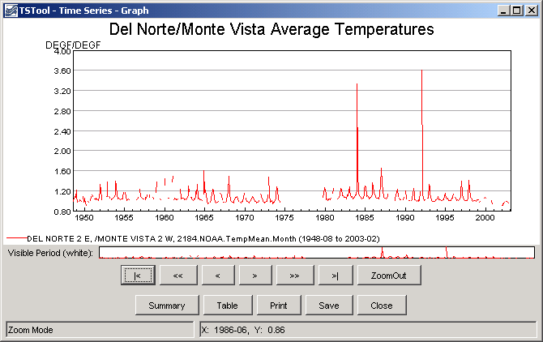
divide_graph
Results from Divide() Command

