Command Reference: ReadReclamationHDB()
Read time series from a Reclamation HDB database
Version 10.06.00, 2012-03-29

The ReadReclamationHDB() command reads one or more time series from a Reclamation HDB database (see the Reclamation HDB Data Store Appendix for more information). It provides query criteria to filter the list of time series.

The following dialog is used to edit the command and illustrates the syntax for the command. Where criteria should be specified in sequential order without intervening blank selections.

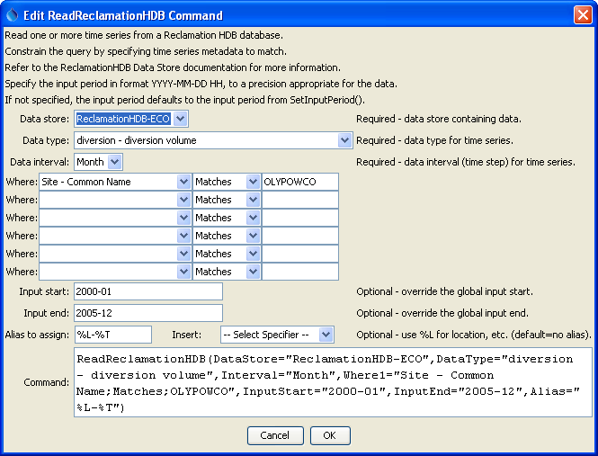
ReadReclamationHDB
ReadReclamationHDB() Command Editor

The command syntax is as follows:

ReadReclamationHDB(Parameter=Value,…)

Command Parameters

Parameter | Description | Default
DataStore | Reclamation HDB data store name indicating database from which to read time series. | None – must be specified.
DataType | The data type to read as ObjectType – DataTypeCommonName. The object type is shown to help with selections. * can be specified to read all data types. | None – must be specified.
Interval | The data interval to read (Hour, Day, Month, Year, Irregular). Irregular is used for instantaneous data and internally results in data with date/times to minute precision. | None – must be specified.
WhereN | The “where” clauses to be applied when querying data, which match the values in the Where fields in the TSTool main interface. The parameters should be specified as Where1, Where2, etc., with no intervening gaps in numbering. All clauses are joined as “and” and are therefore cumulative in limiting the query. The format of each parameter value is:  “Item;Operator;Value”  Where Item indicates a data field to be filtered on, Operator is the type of constraint, and Value is the value to be checked when querying. | If not specified, the query will not be limited and very large numbers of time series may result from the query (which may require a long time to perform the query).
InputStart | Start of the period to query, specified in format YYYY-MM-DD HH, with a precision appropriate for the interval. | Read all available data.
InputEnd | End of the period to query, specified in format YYYY-MM-DD HH, with a precision appropriate for the interval. | Read all available data.
Alias | Indicate an alias to assign to time series, which can result in shorter identifiers for time series when referenced with other commands. | No alias is assigned.

