Command Reference: WriteWaterML()
Write time series to a WaterML XML format file
Version 10.05.00, 2012-03-06

This command is under development. In particular, an evaluation is determining how best to map internal time series properties to the WaterML specification, including selecting reasonable defaults while allowing override of defaults.

The WriteWaterML() command writes time series to a WaterML XML format file. See the WaterML Input Type Appendix for more information about the file format.

The following dialog is used to edit the command and illustrates the syntax of the command.

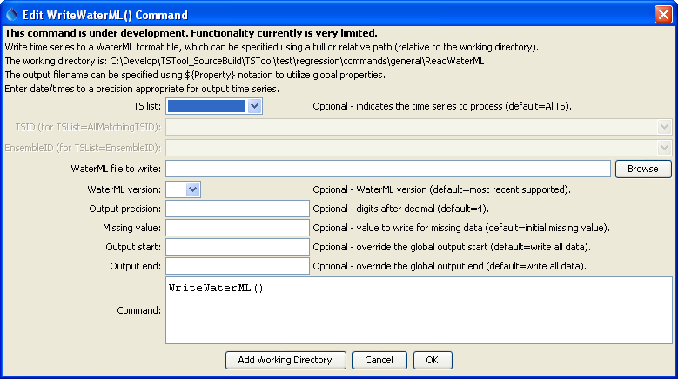
WriteDateValue
WriteDateValue() Command Editor

The command syntax is as follows:

WriteWaterML(Parameter=Value,…)

Command Parameters

Parameter | Description | Default
TSList | Indicates the list of time series to be processed, one of:  - AllMatchingTSID – all time series that match the TSID (single TSID or TSID with wildcards) will be processed.  - AllTS – all time series before the command.  - EnsembleID – all time series in the ensemble will be processed.  - FirstMatchingTSID – the first time series that matches the TSID (single TSID or TSID with wildcards) will be processed.  - LastMatchingTSID – the last time series that matches the TSID (single TSID or TSID with wildcards) will be processed.  - SelectedTS – the time series are those selected with the SelectTimeSeries() command. | AllTS
TSID | The time series identifier or alias for the time series to be processed, using the * wildcard character to match multiple time series. | Required if TSList=*TSID.
EnsembleID | The ensemble to be processed, if processing an ensemble. | Required if TSList= EnsembleID.
OutputFile | TheWaterML output file. The path to the file can be absolute or relative to the working directory (command file location). Global properties can be used to specify the filename, using the ${Property} syntax. | None – must be specified.
Version | The WaterML version to write. Currenly only version 1.1 is supported. | 1.1
Precision | The number of digits after the decimal for numerical output. | 4 (in the future may default based on data type)
MissingValue | The value to write to the file to indicate a missing value in the time series. | As initialized when reading the time series or creating a new time series, typically -999, NaN, or another value that is not expected in data.
OutputStart | The date/time for the start of the output. | Use the global output period.
OutputEnd | The date/time for the end of the output. | Use the global output period.

