Command Reference: SetFromTS()
Set time series data using another time series
Version 10.00.01, 2011-05-11

The SetFromTS() command sets data in a dependent time series by transferring values from an independent time series. A period can be specified to limit the period that is processed. See also the FillFromTS() command, which will transfer values only when the dependent time series has missing data. Only data values are transferred – time series header information (e.g., data type, alias) will not be modified. If multiple time series or an ensemble is being processed, the number of independent time series must be one or the same number as the time series being filled.

The following dialog is used to edit the command and illustrates the command syntax.

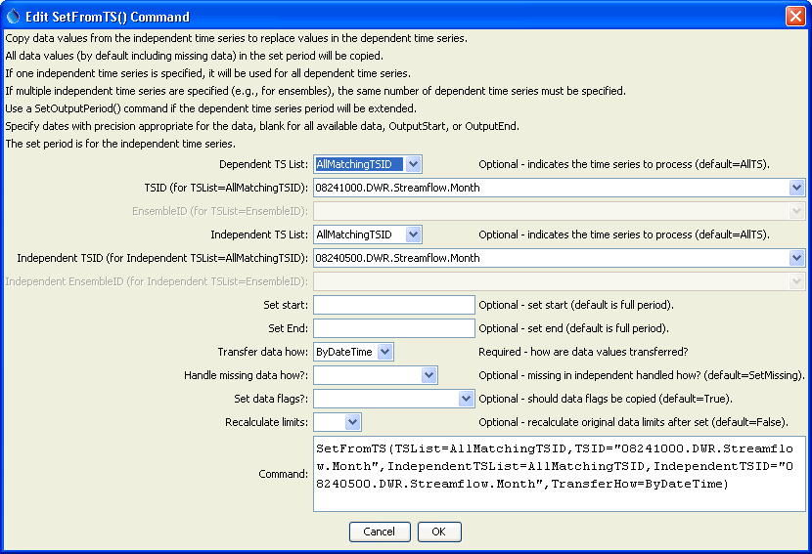
SetFromTS
SetFromTS() Command Editor

The command syntax is as follows:

SetFromTS(Parameter=Value,…)

Command Parameters

Parameter | Description | Default
TSList | Indicates the list of time series to be processed, one of:  - AllMatchingTSID – all time series that match the TSID (single TSID or TSID with wildcards) will be modified.  - AllTS – all time series before the command.  - EnsembleID – all time series in the ensemble will be modified.  - FirstMatchingTSID – the first time series that matches the TSID (single TSID or TSID with wildcards) will be modified.  - LastMatchingTSID – the last time series that matches the TSID (single TSID or TSID with wildcards) will be modified.  - SelectedTS – the time series are those selected with the SelectTimeSeries() command. | AllTS
TSID | The time series identifier or alias for the time series to be modified, using the * wildcard character to match multiple time series. | Required when TSList=*TSID
EnsembleID | The ensemble to be modified, if processing an ensemble. | Required when TSList=EnsembleID.
Independent  TSList | Indicates how to determine the list of independent time series (see the explanation of TSList). | AllTS
Independent  TSID | The time series identifier or alias for the independent time series (see the explanation of TSID). | Required when a IndependentTSList=  *TSID
Independent  EnsembleID | The ensemble identifier for the independent time series (see the explanation of EnsembleID). | Required when IndepndentTSList=  EnsembleID.
SetStart | The date/time to start setting data, if other than the full time series period. | Full period if * is specified.
SetEnd | The date/time to end setting data, if other than the full time series period. | Full period if * is specified.
TransferHow | Indicates how to transfer data:  - ByDateTime – a date/time in one time series will be lined up with the other time series.  - Sequentially – data from the independent will be transferred sequentially, even if the date/time does not align (used when transferring continuous data over Feb 28/29, without gaps). | None – must be specified.
HandleMissingHow | Indicates how to handle missing data in the independent time series:  - IgnoreMissing – missing values in the independent time series WILL NOT be transferred to the dependent time series.  - SetMissing – missing values in the independent time series WILL be transferred to the dependent time series.  - SetOnlyMissingValues – only the missing values in the independent time series will be transferred, useful when a separate time series has been used to insert additional missing values. | SetMissing
SetDataFlags | Indicates if data flags should also be transferred. | True
RecalcLimits | Available only for monthly time series. Indicate whether the original data limits for the time series should be recalculated after the setting the time series values. Setting to True is appropriate if the independent time series provides observations consistent with the original data. | False (only the values in the initial time series will be used for historical data).

A sample command file to process data from the State of Colorado’s HydroBase is as follows:

# 08241000 - TRINCHERA CREEK ABOVE MOUNTAIN HOME RESERVOIR
08241000.DWR.Streamflow.Month~HydroBase
# 08240500 - TRINCHERA CREEK ABOVE TURNER'S RANCH
08240500.DWR.Streamflow.Month~HydroBase
SetFromTS(TSList=AllMatchingTSID,TSID="08241000.DWR.Streamflow.Month",
IndependentTSList=AllMatchingTSID,
IndependentTSID="08240500.DWR.Streamflow.Month",
TransferHow=ByDateTime)

This page is intentionally blank.

