Command Reference: TS Alias = ReadTimeSeries()
Read a single time series using a full time series identifier
Version 08.16.04, 2008-09-23

The TS Alias = ReadTimeSeries()reads a single time series from any input type. This generalized command is useful for converting time series identifiers from the TSTool interface into read commands that assign an alias to a time series. Because the command is generic, it does not offer specific parameters that may be found in read commands for specific input types. Use the specific read commands where available for additional functionality and more specific error handling.

The following dialog is used to edit the command and illustrates the syntax of the command.

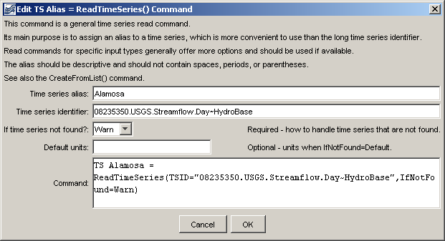
ReadTimeSeies_Alias
ReadTimeSeries() Command Editor

The command syntax is as follows:

TS Alias = ReadTimeSeries(Parameter=Value,…)

Command Parameters

Parameter | Description | Default
Alias | The alias assigned to the time series. | None – must be specified.
TSID | The time series identifier of the time series to read. The identifier should include the input type (and input name, if required). See the input type appendices for examples of time series identifiers for various input types. | None – must be specified.
IfNotFound | Indicates how to handle missing time series, one of:  - Warn – generate fatal warnings and do not include in output.  - Ignore – generate non-fatal warnings and do not include in output.  - Default – generate non-fatal warnings and create empty time series for those that could not be found. This requires that a SetOutputPeriod() command be used before the command to define the period for default time series. | Warn
DefaultUnits | Default units when IfNotFound=Default. | Blank – no units.

A sample command file to read data from the State of Colorado’s HydroBase is as follows:

TS Alamosa =
ReadTimeSeries(TSID="08235350.USGS.Streamflow.Day~HydroBase")

