Command Reference: SetTimeSeriesPropertiesFromTable()
Set time series properties using values in a table
Version 10.23.00, 2013-09-10

The SetTimeSeriesPropertiesFromTable() command sets time series properties using values in a table. This is useful, for example, when additional attributes are available for locations associated with time series. The time series can then be selected for processing by matching properties with the SelectTimeSeries() command.

The following dialog is used to edit the command and illustrates the command syntax (in this case the location part of the time series identifier is used to match the contents of the “loc” column in the table).

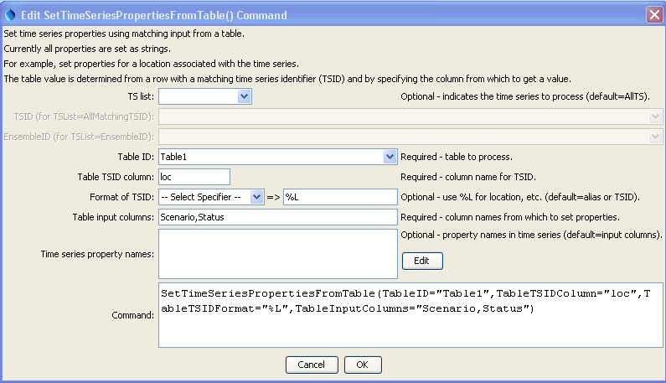
SetTimeSeriesPropertiesFromTable
SetTimeSeriesPropertiesFromTable() Command Editor

The command syntax is as follows:

SetTimeSeriesPropertiesFromTable(Parameter=Value,…)

Command Parameters

Parameter | Description | Default
TSList | Indicates the list of time series to be processed, one of:  - AllMatchingTSID – all time series that match the TSID (single TSID or TSID with wildcards) will be modified.  - AllTS – all time series before the command.  - EnsembleID – all time series in the ensemble will be modified (see the EnsembleID parameter).  - FirstMatchingTSID – the first time series that matches the TSID (single TSID or TSID with wildcards) will be modified.  - LastMatchingTSID – the last time series that matches the TSID (single TSID or TSID with wildcards) will be modified. | AllTS
TSID | The time series identifier or alias for the time series to be modified, using the * wildcard character to match multiple time series. | Required if TSList=*TSID
EnsembleID | The ensemble to be modified, if processing an ensemble. | Required if TSList=EnsembleID
TableID | The identifier for the table that contains properties. | None – must be specified.
TableTSIDColumn | Table column name that is used to match the time series identifier for processing. | None – must be specified.
TableTSIDFormat | The specification to format the time series identifier to match the TSID column. Use the format choices and other characters to define a unique identifier. | Time series alias if available, or otherwise the time series identifier.
TableInputColumns | The name(s) of the column(s) to supply properties for the matching time series. Separate column names with commas. | None – must be specified.
TSPropertyNames | Indicate property names that should be different from table column names using syntax:  ColumnName1:TableProperty1,  ColumnName2:TableProperty2  The special property name ${TS:Description} will set the time series description. | Same as TableInputColumns.

