Command Reference: createTraces()
Create One or More Traces from a Time Series
Version 06.08.02, 2004-07-29, Color, Acrobat Distiller

A createTraces() command can be inserted to convert a time series into a series of traces, which can then be manipulated as independent time series. This command has been implemented on a limited basis will be enhanced in the future. For example, shifts currently ensure that data are sequential; however, there is no option to create traces and make sure that February 29 is always February 29 (currently the reference date controls whether the trace will have leap year or not).

New traces are created using the time series identifier information from the original time series. The original time series is not modified. To avoid confusion, the original time series may need to be discarded after processing or use a temporary time series.

The following dialog is used to edit the command and illustrates the syntax of the command:

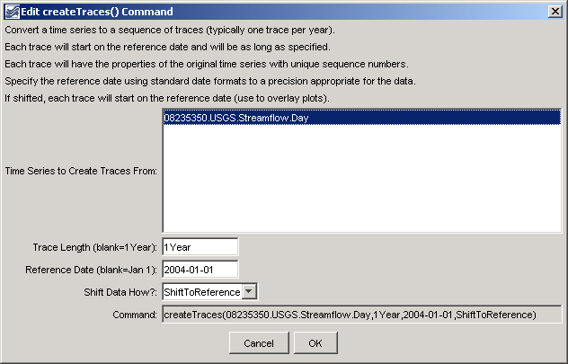
createTraces
createTraces() Command Editor

The command syntax is as follows:

createTraces(TSID,Length,ReferenceDate,ShiftDataHow)

Command Parameters

Parameter | Description | Default
TSID | The time series identifier or alias for the time series to split into traces. The original time series to process can be selected explicitly or can be identified as a TEMPTS. | None – must be specified.
Length | The length of each trace to be created (e.g., 1Year, #Month or, #Day). The starting (reference) date will be incremented by this interval to determine the trace end point. | 1Year.
ReferenceDate | The reference date indicates the starting date for each trace and should be left blank (resulting in a default of January 1 of the current year), or set to January 1 of a year of interest (use the format 01/01/YYYY or YYYY-MM-DD). Each trace can optionally be shifted (see ShiftDataHow). | January 1.
ShiftDataHow | Indicates whether the traces should be shifted. Possible values are:  - ShiftToReference – each trace will be shifted to the reference date, resulting in overlapping time series.  - NoShift – plotting the traces will result in a total line that matches the original time series, except that each trace can be manipulated individually. | NoShift

A sample commands file is as follows:

#
# Create annual traces from a time series shifted to current year
#
# (1995-1998) ALAMOSA RIVER ABOVE JASPER, CO USGS Streamflow Day
08235350.USGS.Streamflow.Day~HydroBase
createTraces(08235350.USGS.Streamflow.Day,1Year,2004-01-01,ShiftToReference)

Results from processing the command are as follows:

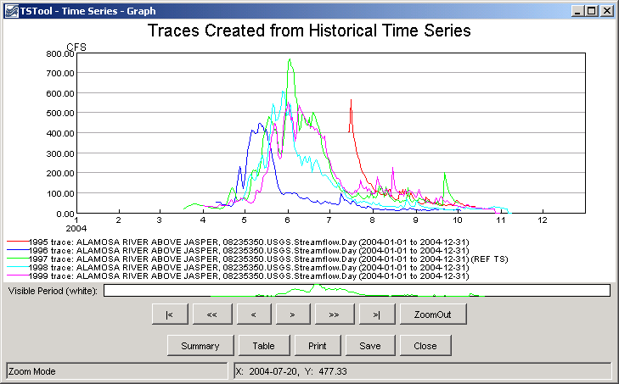
createTraces_Graph
Results from the createTraces() Command

This page is intentionally blank.

