Command Reference: FreeTable()
Free a table
Version 10.16.01, 2013-02-14

The FreeTable() command frees a table. The table will not be available for subsequent commands, although a new table with the same name can be created and used with subsequent commands. This command is useful, for example, when looping through blocks of commands where logic is repeated and the table contents are recreated.

The following dialog is used to edit the command and illustrates the syntax of the command.

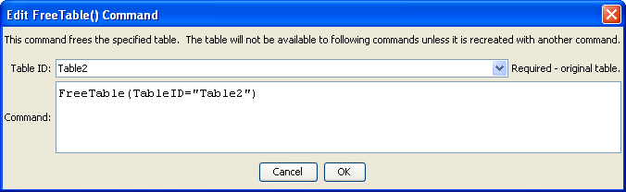
FreeTable
FreeTable() Command Editor

The command syntax is as follows:

FreeTable(Parameter=Value,…)

Command Parameters

Parameter | Description | Default
TableID | The identifier for the original table. | None – must be specified.

This page is intentionally blank.

