Command Reference: ProfileCommands()
Profile the commands that have executed, to evaluate performance
Version 10.16.01, 2013-02-14

The ProfileCommands() command summarizes run times for each command in the command list (by command type), and outputs the summary to a new table. This command is useful for evaluating which commands are slow in a command workflow, so that software and command file logic improvements can occur.

The following dialog is used to edit the command and illustrates the syntax of the command.

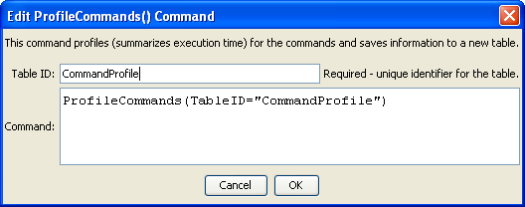
ProfilkeCommands
ProfileCommands() Command Editor

The following figure illustrates the output table. Because command execution may be very fast, times are shown in milliseconds (1-1000th of a second). The table can be output to a file with other commands.

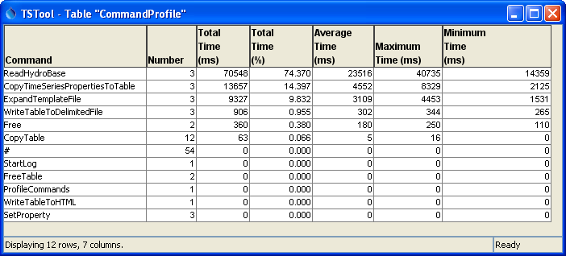
ProfilkeCommands_Table
ProfileCommands() Command Editor
The command syntax is as follows:

ProfileCommand(Parameter=Value,…)

Command Parameters

Parameter | Description | Default
TableID | The identifier for the original table. | None – must be specified.

