Command Reference: ReadDateValue()
Read all time series from a DateValue File
Version 08.15.00, 2008-05-08

The ReadDateValue() command reads all the time series in a DateValue file into memory (see the DateValue Input Type Appendix).

The following dialog is used to edit the command and illustrates the syntax for the command. The path to the file can be absolute or relative to the working directory. The Browse button can be used to select the file to read (if a relative path is desired, delete the leading path after the select). Use the TS Alias = ReadDateValue() command to read a single time series from a DateValue file. Note that reading a DateValue file that was created for time series that have aliases will result in the aliases being assigned to the result.

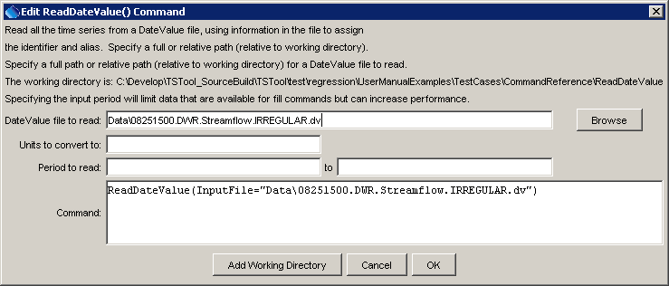
ReadDateValue
ReadDateValue() Command Editor

The command syntax is as follows:

ReadDateValue(Parameter=Value,…)

Command Parameters

Parameter | Description | Default
InputFile | The name of the DateValue input file to read, surrounded by double quotes to protect whitespace and special characters. | None – must be specified.
NewUnits | Units to convert data to (must be in the DATAUNIT configuration file). | Use the data units from the file.
InputStart | Starting date/time to read data, in precision consistent with data. | Read all data.
InputEnd | Ending date/time to read data, in precision consistent with data. | Read all data.

A sample command file is as follows:

ReadDateValue(InputFile="Data\08251500.DWR.Streamflow.IRREGULAR.dv")

