Command Reference: SetToMin()
Set data values to the minimum of values from one or more time series
Version 08.16.04, 2008-09-25

The SetToMin() command sets a time series to contain, for each time step, the minimum of its own values and those of one or more additional (independent) time series.

The following dialog is used to edit the command and illustrates the command syntax.

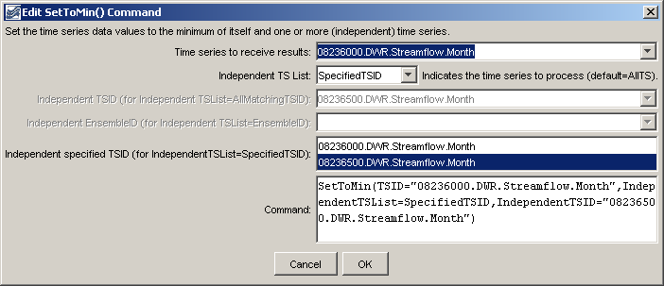
SetToMin
SetToMin() Command Editor

The command syntax is as follows:

SetToMin(Parameter=Value,…)

Command Parameters

Parameter | Description | Default
TSID | The time series identifier or alias for the time series to be modified. | None – must be specified.
IndependentTSList | Indicates how the list of time series is specified, one of:  - AllTS – all time series before the command.  - AllMatchingTSID – all time series that match the IndependentTSID (single TSID or TSID with wildcards).  - EnsembleID – the time series from the specified ensemble will be processed.  - FirstMatchingTSID – the first time series that matches the TSID (single TSID or TSID with wildcards) will be processed.  - LastMatchingTSID – the last time series that matches the TSID (single TSID or TSID with wildcards) will be processed.  - SelectedTS – the time series are those selected with the SelectTimeSeries() command.  - SpecifiedTSID – the specified list of time series given by the IndependentTSID parameter. | AllTS (the time series receiving the result will not be checked)
IndependentTSID | If the IndependentTSList= SpecifiedTSID, provide the list of time series identifiers (or alias) to process, separated by commas. If the IndependentTSList parameter is AllMatchingTSID, FirstMatchingTSID, or LastMatchingTSID, specify a single TSID or a TSID with wildcards. | Required if TSList=*TSID.
Independent  EnsembleID | Ensemble identifier. | Required if TSList=EnsembleID.

A sample command file to process data from the State of Colorado’s HydroBase database is as follows:

# 08236000 - ALAMOSA RIVER ABOVE TERRACE RESERVOIR
08236000.DWR.Streamflow.Month~HydroBase
# 08236500 - ALAMOSA RIVER BELOW TERRACE RESERVOIR
08236500.DWR.Streamflow.Month~HydroBase
SetToMin(TSID="08236000.DWR.Streamflow.Month",
IndependentTSList=SpecifiedTSID,
IndependentTSID="08236500.DWR.Streamflow.Month")

