Command Reference: ReadStateCU()
Read time series from a StateCU time series or report File
Version 08.15.00, 2008-05-09

The ReadStateCU() command reads all the time series in a StateCU time series file (e.g., frost dates) or report file (e.g., IWR, WSL) (see the StateCU Input Type Appendix).

The following dialog is used to edit the command and illustrates the syntax for the command.

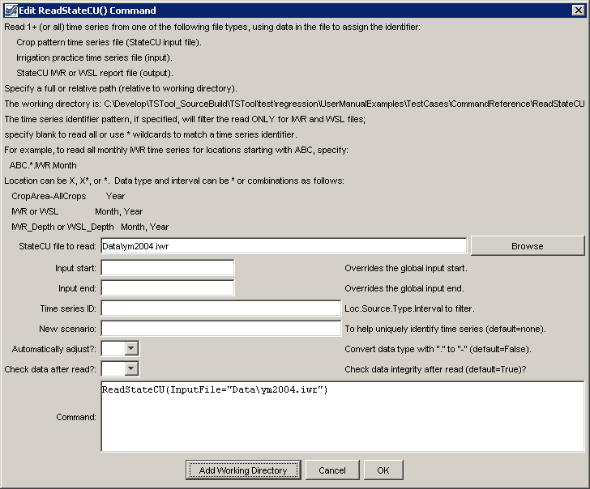
ReadStateCU
ReadStateCU() Command Editor

The command syntax is as follows:

ReadStateCU(Parameter=Value,…)

Command Parameters

Parameter | Description | Default
InputFile | The name of the StateCU time series or report file to read, surrounded by double quotes. | None – must be specified.
InputStart | The starting date/time to read, specified to a precision (month or year) that matches the data file. | Read all the data.
InputEnd | The ending date/time to read, specified to a precision (month or year) that matches the data file. | Read all the data.
TSID | A time series identifier pattern that will be used to filter the list of time series that are read. See the figure above for examples. | Read all time series.
NewScenario | A new scenario to use for the TSID. This is useful when reading data from multiple model runs that otherwise would have the same TSIDs. | No scenario.
AutoAdjust | Indiate whether to automatically adjust time series identifiers to use a dash “-” instead of period “.” in the data type, necessary because StateCU data types (e.g., crop types that include CU method) have a period that interferes with the normal TSID convention. This may be made the default in the future. | False
CheckData | Indicate whether to check the data for integrity after reading. Currently only the irrigation practice time series can be checked, to verify that the acreage totals are the sum of the parts. | True

A sample commands file is as follows:

ReadStateCU(InputFile="Data\ym2004.iwr")

