Command Reference: FillFromTS()
Fill missing time series data using data from another time series (or ensemble)
Version 09.08.01, 2010-09-14

The FillFromTS() command fills missing data in a time series (or ensemble) by transferring non-missing values from another time series (or ensemble). This is useful when two time series typically have very similar values. The filled time series is not automatically extended. A period can be specified to limit the period that is checked for missing data. See also the SetFromTS() command, which will transfer all values. If multiple time series or an ensemble is being processed, the number of independent time series must be one or the same number as the time series being filled.

Data transfer occurs by date/time, not sequentially. This may be a problem if trying to fill from a time series that has been shifted and leap years have caused an offset – an enhancement may be made in the future to address this issue.

The following dialog is used to edit the command and illustrates the command syntax.

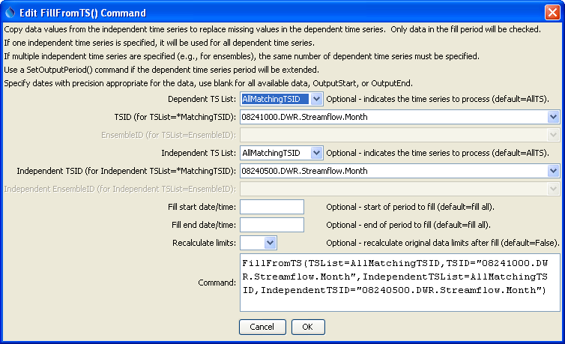
FillFromTS
FillFromTS() Command Editor

The command syntax is as follows:

FillFromTS(Parameter=Value,…)

Command Parameters

Parameter | Description | Default
TSList | Indicates the list of time series to be processed, one of:  - AllMatchingTSID – all time series that match the TSID (single TSID or TSID with wildcards) will be modified.  - AllTS – all time series before the command.  - EnsembleID – all time series in the ensemble will be modified.  - FirstMatchingTSID – the first time series that matches the TSID (single TSID or TSID with wildcards) will be modified.  - LastMatchingTSID – the last time series that matches the TSID (single TSID or TSID with wildcards) will be modified.  - SelectedTS – the time series are those selected with the SelectTimeSeries() command. | AllTS
TSID | The time series identifier or alias for the time series to be modified, using the * wildcard character to match multiple time series. | Required when a TSList=*TSID
EnsembleID | The ensemble to be modified, if processing an ensemble. | Required when TSList=EnsembleID.
Independent  TSList | Indicates how to determine the list of independent time series (see the explanation of TSList). | AllTS
Independent  TSID | The time series identifier or alias for the independent time series (see the explanation of TSID). | Required when a IndependentTSList=  *TSID
Independent  EnsembleID | The ensemble identifier for the independent time series (see the explanation of EnsembleID). | Required when IndependentTSList=  EnsembleID.
FillStart | The date/time to start filling, if other than the full time series period. | Fill the entire period.
FillEnd | The date/time to end filling, if other than the full time series period. | Fill the entire period.
RecalcLimits | Available only for monthly time series. Indicate whether the original data limits for the time series should be recalculated after the filling the time series. Setting to True is appropriate if the independent time series provides observations consistent with the original data. | False (only the values in the initial time series will be used for historical data).

A sample command file to fill data from the State of Colorado’s HydroBase is as follows:

#
# 08241000 - TRINCHERA CREEK ABOVE MOUNTAIN HOME RESERVOIR
08241000.DWR.Streamflow.Month~HydroBase
# 08240500 - TRINCHERA CREEK ABOVE TURNER'S RANCH
08240500.DWR.Streamflow.Month~HydroBase
FillFromTS(TSList=AllMatchingTSID,TSID="08241000.DWR.Streamflow.Month",
IndependentTSList=AllMatchingTSID,
IndependentTSID="08240500.DWR.Streamflow.Month")

