Command Reference: TS Alias = NewTimeSeries()
Create a new time series
Version 09.08.01, 2010-09-15

The NewTimeSeries() command creates a new time series in memory and assigns it an alias. This time series can then be manipulated (e.g., added to, filled). This command is useful, for example, to create a new time series to receive the results of a series of manipulations, rather than having the results accumulate in the first time series.

The following dialog is used to edit the command and illustrates the syntax for the command. The new time series identifier is edited by pressing the Edit button.

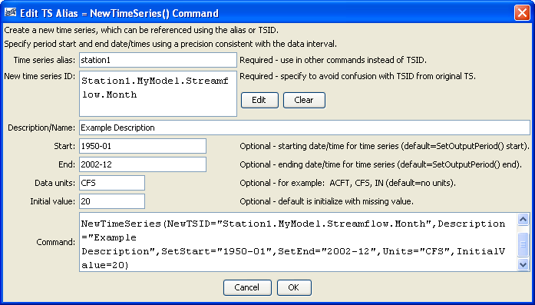
NewTimeSeries
NewTimeSeries() Command Editor

The command syntax is as follows:

TS Alias = NewTimeSeries(Parameter=Value,…)

Command Parameters

Parameter | Description | Default
Alias | The alias of the new time series, which can be used in place of the TSID in other commands. | None – must be specified.
NewTSID | The time series identifier of the new time series. The editor dialog formats the identifier from its parts. | None – must be specified with at least minimal information (location, data type, interval).
Description | The description for the time series, used in output. | Blank.
SetStart | The start of the time series data period, or blank to use the output period defined with the SetOutputPeriod() command. | Use the start from SetOutputPeriod().
SetEnd | The end of the time series data period, or blank to use the output period defined with the SetOutputPeriod() command. | Use the end from SetOutputPeriod().
Units | Data units for the time series. | Blank.
InitialValue | The initial value to populate the time series. | Initialize the time series to missing data.

The example commands file shown below creates a new time series and initializes it to a constant of 20 CFS. Uncommenting the first command would allow the SetStart and SetEnd parameters to be removed from the NewTimeSeries() command. The interval (Month below) must match a recognized type but the other parts of the identifier are not standardized.

SetOutputPeriod(OutputStart="1950-01",OutputEnd="2002-12")
TS station1 = NewTimeSeries(NewTSID="Station1.MyModel.Streamflow.Month",
Description="Example Description",SetStart="1950-01",
SetEnd="2002-12",Units="CFS",InitialValue=20)

