Command Reference: NewTreeView()
Create a new tree view using a definition file
Version 09.07.00, 2010-07-20

The NewTreeView() command creates a tree view, which is a hierarchical listing of time series. The resulting view is dispayed in the Views section of the TSTool Results area and provides interactive access to data. The view is defined using a simple text file, as shown in the following example:

# Test data for displaying a tree view of time series results
Label: Top-level label
TS: ts1*
Label: Second-level label
TS: ts2*
Label: Another second-level label
TS: ts3*

Tree view definition files have the following characteristics:

- Comments are indicated by lines starting with #.
- Indentations indicate the level (branch) in the tree:
  - Use the tab character to indicate indentation
  - The indentation on one row cannot be more than 1 greater than the previous row
- The content for the tree is indicated by keywords:
  - Label: indicates that the string following the colon will be used to label a branch.
    - A single top-level label is required
  - TS: indicates that a time series identifier pattern will be used to identify time series in the tree. Wildcard conventions follow rules consistent with the TSList=AllMatchingTSID ,TSID=… command parameters.

The following figure illustrates the resulting view that is displayed in TSTool for the above example, using contrived data. The time series in the tree view can be selected and a pop-up menu can be used to generate graphs. Consequently, the view allows the results of processing to be presented in a way that is more customized than a simple list. It is envisioned that additional functionality will be implemented, for example to output the view as HTML with navigation links.

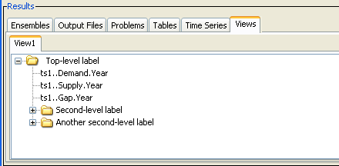
NewTreeView_Results
Example of Tree View in TSTool Results

The following dialog is used to edit the command and illustrates the syntax of the command.

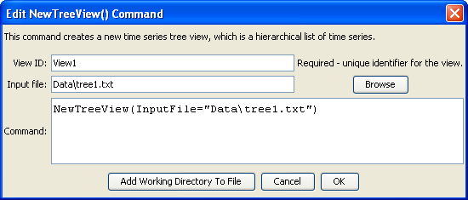
NewTreeView
NewTreeView() Command Editor

The command syntax is as follows:

NewTreeView(Parameter=Value,…)

Command Parameters

Parameter | Description | Default
ViewID | Identifier to assign to the view, which allows the view to be used with other commands. | None – must be specified.
InputFile | The name of the view definition file to read, as an absolute path or relative to the command file location. | None – must be specified.

