Command Reference: Normalize()
Create a normalized time series
Version 10.00.00, 2011-03-25

A Normalize() command can be inserted to create a new normalized time series from an existing time series, assigning an alias to the result. Normalized time series are useful for analyzing trends and relationships and for allowing time series with different units to be plotted or analyzed together. For example, the range of data values can be normalized to the range 0 to 1. The alias that is assigned to the time series can be referenced by other commands.

The following dialog is used to edit the command and illustrates the syntax of the command.

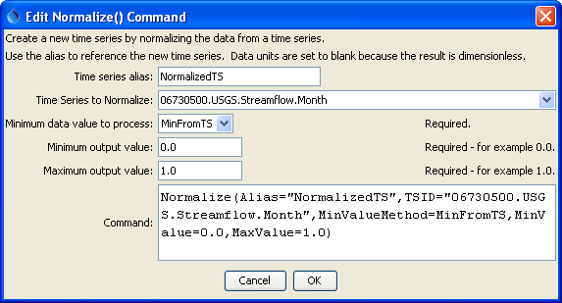
Normalize
Normalize() Command Editor

The command syntax is as follows:

Normalize(Parameter=Value,…)

The following older command syntax is updated to the above syntax when a command file is read:

TS Alias = Normalize(Parameter=Value,…)

Command Parameters

Parameter | Description | Default
Alias | The alias to assign to the time series, as a literal string or using the special formatting characters listed by the command editor. The alias is a short identifier used by other commands to locate time series for processing, as an alternative to the time series identifier (TSID). | None – must be specified.
TSID | The time series identifier or alias for the time series to be normalized. | None – must be specified.
MinValue  Method | Indicates how to determine the minimum data value to process, one of:  - MinFromTS – get the minimum value from the time series (typical)  - MinZero – use zero (e.g., if negative values are to be ignored) | None – must be specified.
MinValue | The minimum normalized value (e.g., 0). | None – must be specified.
MaxValue | The maximum normalized value (e.g., 1). | None – must be specified.

A sample command file to process data from the State of Colorado’s HydroBase database is as follows:

# 06730500 - BOULDER CREEK AT MOUTH, NEAR LONGMONT, CO.
06730500.USGS.Streamflow.Month~HydroBase
Normalize(Alias=” NormalizedTS”,TSID="06730500.USGS.Streamflow.Month",
MinValueMethod=MinFromTS,MinValue=0.0,MaxValue=1.0)

The results are as follows:

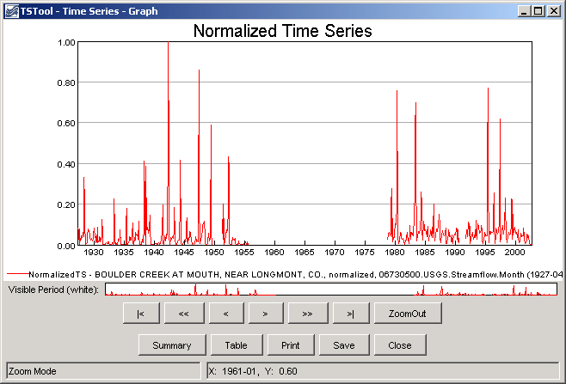
Normalize_Graph
Results of Normalize() Command

