Command Reference: ReadUsgsNwisRdb()
Read a single time series from a USGS NWIS RDB file
Version 10.05.00, 2012-02-27

The ReadUsgsNwisRdb() command reads a single time series from a USGS NWIS RDB file (see the UsgsNwisRdb Input Type Appendix) and assigns an alias to the result. This command replaces the older ReadUsgsNwis() command – legacy ReadUsgsNwis() commands are automatically translated to ReadUsgsNwisRdb() commands. Currently only the daily streamflow format is supported and the file being read must contain only one time series. The data type is assigned as Streamflow, with units CFS. See also the WebGet() command, which can be used to retrieve data files from the USGS website. See also the ReadUsgsNwisDaily() and ReadWaterML() commands.

The following dialog is used to edit the command and illustrates the syntax.

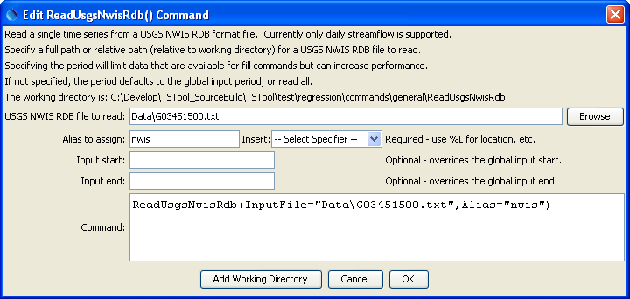
ReadUsgsNwisRdb
ReadUsgsNwisRdb() Command Editor

The command syntax is as follows:

ReadUsgsNwisRdb(Parameter=Value,…)

The following legacy command syntax is updated to the above syntax when a command file is read:

TS Alias = ReadUsgsNwis (Parameter=Value,…)

Command Parameters

Parameter | Description | Default
InputFile | The name of the USGS NWIS RDB file to read, surrounded by double quotes. The path to the file can be absolute or relative to the working directory. | None – must be specified.
Alias | The alias to assign to the time series, as a literal string or using the special formatting characters listed by the command editor. The alias is a short identifier used by other commands to locate time series for processing, as an alternative to the time series identifier (TSID). | None – must be specified.
InputStart | The start of the period to read data – specify if the period should be different from the global query period. | Use the global query period.
InputEnd | The end of the period to read data – specify if the period should be different from the global query period. | Use the global query period.

A sample command file is as follows:

ReadUsgsNwisRdb(Alias=”ts1”,InputFile="G03451500.txt")

