Command Reference: WriteSummary()
Write time series to a summary format file
Version 08.15.00, 2008-05-12

The WriteSummary() command writes time series to a summary report file. The format of the file is a default for the data interval. The total/average column in reports is based on the units. AF, ACFT, FT, FEET, FOOT, IN, INCH all result in totals with others resulting in averages – a parameter may be added in the future to allow more flexibility.

The following dialog is used to edit the command and illustrates the syntax of the command.

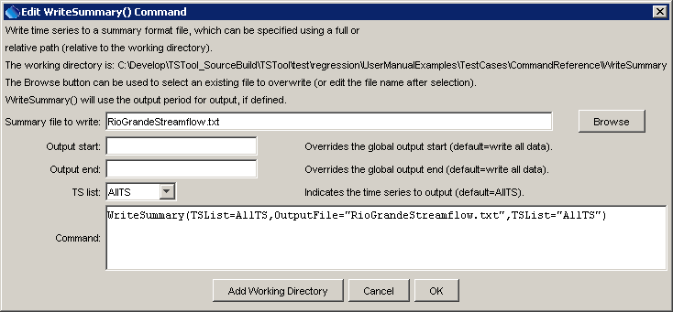
WriteSummary
WriteSummary() Command Editor

The command syntax is as follows:

WriteSummary(Parameter=Value,…)

Command Parameters

Parameter | Description | Default
OutputFile | The summary file. The path to the file can be absolute or relative to the working directory (command file location). | None – must be specified.
OutputStart | The date/time for the start of the output. | Use the global output period.
OutputEnd | The date/time for the end of the output. | Use the global output period.
TSList | Indicate how to determine the list of time series to process, one of:  - AllTS – process all the time series.  - SelectedTS – process the time series that are selected (see SelectTimeSeries()). | None – must be specified.

A sample command file to process data from the State of Colorado’s HydroBase is as follows:

SetOutputPeriod(OutputStart="1950-01",OutputEnd="2002-12")
# 08213500 - RIO GRANDE RIVER AT THIRTY MILE BRIDGE NEAR CREEDE
08213500.DWR.Streamflow.Month~HydroBase
# 08217000 - RIO GRANDE AT WASON, BELOW CREEDE, CO.
08217000.USGS.Streamflow.Month~HydroBase
WriteSummary(TSList=AllTS,OutputFile="RioGrandeStreamflow.txt",TSList="AllTS")

