Command Reference: WriteHecDss()
Write time series to a HEC-DSS File
Version 09.00.03, 2000-01-15

The WriteHecDss() command writes time series to a HEC-DSS file. See the HEC-DSS Input Type Appendix for information about how time series properties are output to HEC-DSS files. Current limitations on the command are:

- Irregular time series may not be properly handled – the focus of initial development has been regular interval time series.
- HEC-DSS uses times through 2400. However, TSTool will convert this to 0000 of the next day. Year, month, and day data are not impacted.

The A-F parts of the HEC-DSS time series pathname are taken from the time series properties, as follows:

- The A and B parts are taken from the time series identifier location, where location should be defined as A:B.
- The C part is taken from the time series data type.
- The D part is taken from the time series period in memory or as defined by the output period.
- The E part is taken from the time series interval.
- The F part is taken from the time series identifier scenario.

The following dialog is used to edit the command and illustrates the syntax for the command.

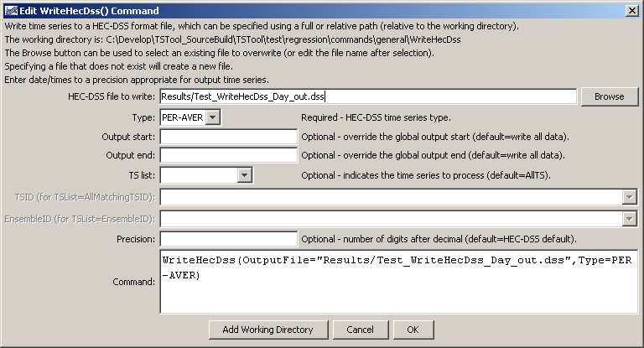
WriteHecDss
WriteHecDss() Command Editor

The command syntax is as follows:

WriteHecDss(Parameter=Value,…)

Command Parameters

Parameter | Description | Default
OutputFile | The name of the HEC-DSS file to write, surrounded by double quotes to protect whitespace and special characters. If the file does not exist it will be created. | None – must be specified.
Type | The HEC-DSS time series type, indicating whether the time series is instantaneous, mean, or accumulated. | None – must be specified.
OutputStart | The date/time for the start of the output. | Use the global output period or write all available data.
OutputEnd | The date/time for the end of the output. | Use the global output period or write all available data.
TSList | Indicates the list of time series to be processed, one of:  - AllMatchingTSID – all time series that match the TSID (single TSID or TSID with wildcards) will be processed.  - AllTS – all time series before the command will be processed.  - EnsembleID – all time series in the ensemble will be processed.  - FirstMatchingTSID – the first time series that matches the TSID (single TSID or TSID with wildcards) will be processed.  - LastMatchingTSID – the last time series that matches the TSID (single TSID or TSID with wildcards) will be processed.  - SelectedTS – the time selected with the SelectTimeSeries() command will be processed. | AllTS
TSID | The time series identifier or alias for the time series to be processed, using the * wildcard character to match multiple time series. | Required if TSList=*TSID.
EnsembleID | The ensemble to be processed, if processing an ensemble. | Required if TSList= EnsembleID.
Precision | The number of digits after the decimal for numerical output. | HEC-DSS default.

A sample command file is as follows:

ReadHecDss(InputFile="sample.dss",InputStart="1992-01-01",
InputEnd="1992-12-31",Alias="%L_%T_%Z")

