Command Reference: CreateRegressionTestCommandFile()
Create a command file to run software regression tests
Version 09.03.00, 2009-04-12

The CreateRegressionTestCommandFile() command is used for software testing (or certification of processes used in operations) and creates a command file that includes a StartRegressionTestResultsReport() and multiple RunCommands() commands. A starting search folder is provided and all files that match the given pattern (by convention Test_*.TSTool) are assumed to be command files that can be run to test the software. The resulting command file is a test suite comprised of all the individual tests and can be used to verify software before release. The goal is to have all tests pass before software release.

The following table lists tags that can be placed in # comments in command files to provide information for testing, for example:

#@expectedStatus Failure

Command # Comment Tags

Parameter | Description
@expectedStatus Failure  @expectedStatus Warning | The RunCommands() command ExpectedStatus parameter is by default Success. However, a different status can be specified if it is expected that a command file will result in Warning or Failure and still be a successful test. For example, if a command is obsolete and should generate a failure, the expected status can be specified as Failure and the test will pass. Another example is to test that the software properly treats a missing file as a failure.
@os Windows  @os UNIX | The test is designed to work only on the specified platform and will be included in the test suite only if the IncludeOS parameter includes the corresponding operating system (OS) type. This is primarily used to test specific features of the OS and similar but separate test cases should be implemented for both OS types. If the OS type is not specified as a tag in a command file, the test is always included (see also the handling of included test suites).
@testSuite ABC | Indicate that the command file should be considered part of the specified test suite, as specified with the IncludeTestSuite parameter. The test is included in all test collections if the tag is not specified; therefore, for general tests, do not specify a test suite. This tag is useful if a group of tests require special setup, for example connecting to a database. The suite names should be decided upon by the test developer.

The following dialog is used to edit the command and illustrates the syntax for the command.

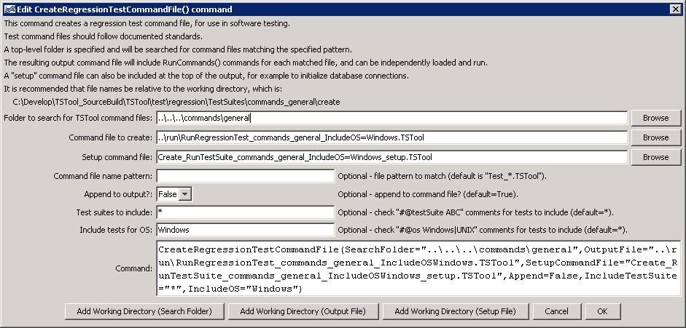
CreateRegressionTestCommandFile
CreateRegressionTestCommandFile() Command Editor

The command syntax is as follows:

CreateRegressionTestCommandFile(Parameter=Value,…)

Command Parameters

Parameter | Description | Default
SearchFolder | The folder to search for regression test command files. All subfolders will also be searched. | None – must be specified.
OutputFile | The name of the command file to create, enclosed in double quotes if the file contains spaces or other special characters. A path relative to the command file containing this command can be specified. | None – must be specified.
SetupCommandFile | The name of a TSTool command file that supplies setup commands, and which will be prepended to output. Use such a file to open database connections and set other global settings that apply to the entire test run. | Do not include setup commands.
FilenamePattern | Pattern for TSTool command files, using wildcards. | Test_*.TStool
Append | Indicate whether to append to the output file (True) or overwrite (False). This allows multiple directory trees to be searched for tests, where the first command typically specifies False and additional commands specify True. | True
IncludeTestSuite | If *, all tests that match FilenamePattern and IncludeOS are included. If a test suite is specified, only include tests that have @testSuite tag values that match a value in IncludeTestSuite. One or more tags can be specified, separated by commas. | * – include all test cases.
IncludeOS | If *, all tests that match FilenamePattern and IncludeTestSuite are included. If an OS is specified, only include tests that have @os tag values that match a value in IncludeTestSuite. This tag is typically specified once or not at all. | * – include all test cases.

See the RunCommands() documentation for how to set up a regression test. The following command file illustrates how to create a regression test suite.

CreateRegressionTestCommandFile(SearchFolder="..\..\..\commands\general",
OutputFile="..\run\RunRegressionTest_commands_general.TSTool",Append=False)

An example of the output file from running the tests is:

# The test status below may be PASS or FAIL.
# A test can pass even if the commands file actual status is FAILURE, if failure is expected.
# Test Commands Commands
# Pass/ Expected Actual
# Num Fail Status Status Command File
#---------------------------------------------------------------------
1 PASS SUCCESS SUCCESS C:\Develop\TSTool_SourceBuild\TSTool\test\regression\commands\general\add\Test_Add_1.TSTool
2 PASS SUCCESS SUCCESS C:\Develop\TSTool_SourceBuild\TSTool\test\regression\commands\general\add\Test_Add_Ensemble_1.TSTool
3 PASS SUCCESS SUCCESS C:\Develop\TSTool_SourceBuild\TSTool\test\regression\commands\general\addConstant\Test_AddConstant_1.TSTool
4 PASS SUCCESS SUCCESS C:\Develop\TSTool_SourceBuild\TSTool\test\regression\commands\general\adjustExtremes\Test_AdjustExtremes_1.TSTool
…
11 PASS SUCCESS SUCCESS C:\Develop\TSTool_SourceBuild\TSTool\test\regression\commands\general\ChangeInterval\Test_ChangeInterval_IrregINST_To_3HourINST.TSTool
12 PASS SUCCESS SUCCESS C:\Develop\TSTool_SourceBuild\TSTool\test\regression\commands\general\ChangePeriod\Test_ChangePeriod_1.TSTool
13 PASS SUCCESS SUCCESS C:\Develop\TSTool_SourceBuild\TSTool\test\regression\commands\general\compareTimeSeries\Test_AllDifferent.TSTool
14 PASS SUCCESS SUCCESS C:\Develop\TSTool_SourceBuild\TSTool\test\regression\commands\general\compareTimeSeries\Test_AllSame.TSTool
15 PASS SUCCESS SUCCESS C:\Develop\TSTool_SourceBuild\TSTool\test\regression\commands\general\ComputeErrorTimeSeries\Test_ComputeErrorTimeSeries_1.TSTool
16 PASS SUCCESS SUCCESS C:\Develop\TSTool_SourceBuild\TSTool\test\regression\commands\general\convertDataUnits\Test_ConvertDataUnits_1.TSTool
17 PASS SUCCESS SUCCESS C:\Develop\TSTool_SourceBuild\TSTool\test\regression\commands\general\Copy\Test_Copy_1.TSTool
18 PASS SUCCESS SUCCESS C:\Develop\TSTool_SourceBuild\TSTool\test\regression\commands\general\CopyEnsemble\Test_CopyEnsemble_1.TSTool
19 PASS SUCCESS SUCCESS C:\Develop\TSTool_SourceBuild\TSTool\test\regression\commands\general\CreateEnsemble\Test_CreateEnsemble_1.TSTool
20 *FAIL* SUCCESS WARNING C:\Develop\TSTool_SourceBuild\TSTool\test\regression\commands\general\CreateFromList\Test_CreateFromList_1.TSTool
21 PASS Failure FAILURE C:\Develop\TSTool_SourceBuild\TSTool\test\regression\commands\general\CreateTraces_Alias\Test_CreateTraces_Legacy_1.TSTool
22 PASS SUCCESS SUCCESS C:\Develop\TSTool_SourceBuild\TSTool\test\regression\commands\general\cumulate\Test_Cumulate_1.TSTool

This page is intentionally blank.

