Command Reference: RunDSSUTL()
Run the DSSUTL program from the US Army Corps of Engineers
Version 09.03.00, 2009-04-10

The RunDSSUTL() command runs the Army Corps of Engineers’ DSSUTL program, which is used with HEC-DSS files. See also the HEC-DSS Input Type appendix. This command formats the command line for the program, runs the program, and checks the exit value. A non-zero exit value will result in a failure status for the command.

TSTool internally maintains a working directory that is used to convert relative paths to absolute paths in order to locate files. The working directory is by default the location of the last command file that was opened. The location of the DSSUTL.EXE file is determined by the operating system using the PATH environment variable; therefore, use the ${WorkingDir} property in the command line if the program location is not in PATH. Use \” in the command line or arguments to surround whitespace.

It is not clear whether DSSUTL has limits on path or filename length, but if this appears to be the case, use shorter names. If DSSUTL is not provided with correct input, it may go into interactive mode, in which case TSTool may appear to stop when running the command. Currently there is no way to kill the DSSUTL process and TSTool must be restarted.

The following dialog is used to edit the command and illustrates the command syntax. Note that the DSSUTL.EXE location is in this case not included in the PATH environment variable and is specified with the DssutlProgram parameter, using ${WorkingDir}. The HEC-DSS and input files are relative to the working directory.

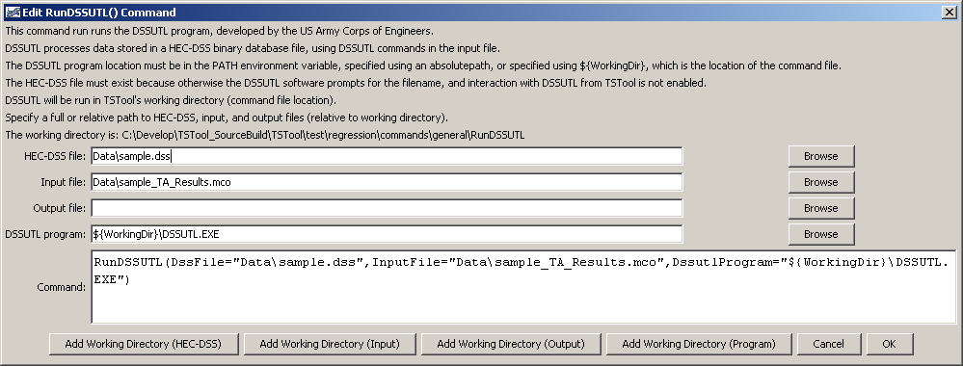
RunDSSUTL
RunDSSUTL() Command Editor when Specifying Command Line

The command syntax is as follows:

RunDSSUTL(Parameter=Value…)

Command Parameters

Parameter | Description | Default
DssFile | The HEC-DSS filename as an absolute path or relative to the working directory. The file must exist because TSTool does not interface with the DSSUTL interactive mode prompts. The parameter is passed to DSSUTL using the DSSFILE= command line argument. | None – must be specified.
InputFile | The DSSUTL command file to run. The file must exist because TSTool does not interface with the DSSUTL interactive mode prompts. This is passed to DSSUTL using the INPUT= command line argument. | None – must be specified.
OutputFile | The DSSUTL output file, which contains logging information. This is passed to DSSUTL using the OUTPUT= command line argument. Specifying the argument will cause output to be printed to the file and not the screen. Note that some DSSUTL commands write to other output files, which should not be confused with the output file for this argument. | Not required by DSSUTL.
DssutlProgram | The DSSUTL program to run. | If not specified, DSSUTL.EXE must be located in a directory listed in the PATH environment variable.

