Command Reference: VariableLagK()
Lag and attenuate (route) a time series with parameters that vary by rate
Version 09.03.00, 2009-04-10

The VariableLagK() command can be used to lag and attenuate an input time series, resulting in a new time series. The command is commonly used to route an instantaneous flow time series through a stretch of river (reach). Lag and K routing is a common routing method that combines the concepts of:

- Lagging the inflow to simulate travel time in a reach and,
- Attenuating the wave to simulate the storage-outflow relationship for the reach (see Figure 1).

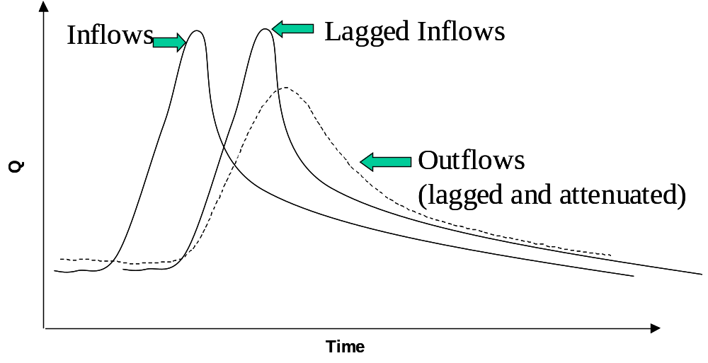
Figure 1: Lag and K Routing
At its fundamental level, the method solves the continuity equation using an approach similar to Muskingum routing (assuming that the Muskingum parameter representing wave storage is negligible). The governing equation for this routing method is given as:

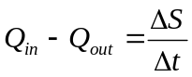

where:

Q_{in} = instantaneous inflow [rate] lagged appropriately,
Q_{out} = instantaneous outflow [rate] lagged appropriately,
ΔS = change in storage in the reach [volume],
Δt = time difference.

The relationship assumes an outflow-storage relationship of the form:
S = k ⋅ Q_{out,}
where:

k = attenuation for the outflow [time].

To ensure accurate results, k should be larger or equal to Δt/2. For discrete time steps these relationships translate into:
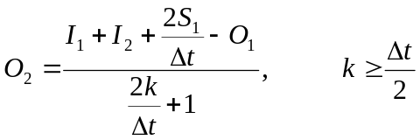
where: I₁ and I₂ are the lagged inflows into the reach at the previous and current time step, respectively,
O₁ and O₂ are the outflows out of the reach at the previous and current time step, respectively,
S₁ is the storage within the reach at the previous time step, defined as S₁ = k⋅O₁, and
Δt is the time difference between the two time steps.

Values for Lag and K can usually be established by comparing routed flows to downstream observations. Alternatively, the Lag can be estimated using the reach length and wave speed in the reach. Without any other information, K can be set to Lag/2.

The above discussion applies where the Lag and K parameters are single values (as implemented in the LagK() command). However, there are cases where the values vary by flow, which is handled by this command. The approach that is implemented is an adaptation of that described in National Weather Service River Forecast System LAG/K documentation: http://www.nws.noaa.gov/oh/hrl/nwsrfs/users_manual/part2/_pdf/24lagk.pdf.

The following dialog is used to edit the command and illustrates the syntax for the command:

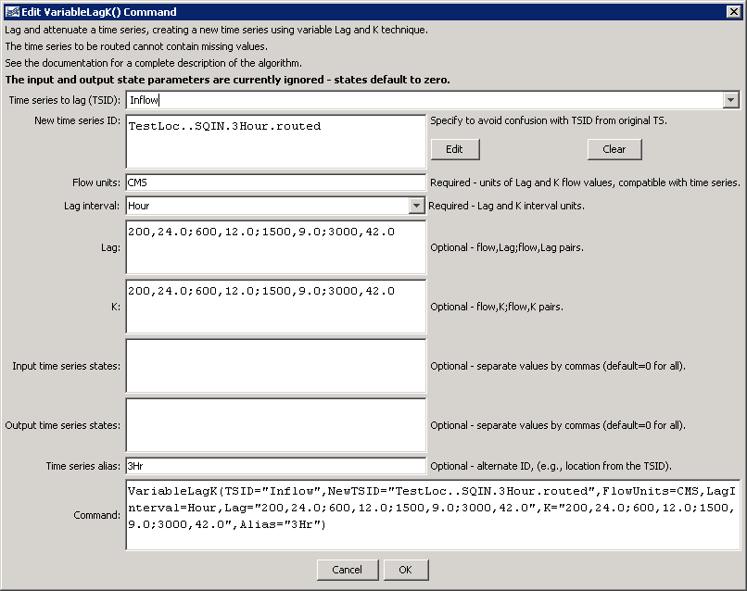
ViriableLagK
VariableLagK() Command Editor

The command syntax is as follows:

VariableLagK(Parameter=Value,…)

Command Parameters

Parameter | Description | Default
TSID | Identifier or alias for the time series to be routed. It is assumed that this series describes an instantaneous flow. Due to the lagging, the first data values required for the computation of O₂ are not available within this time series and are therefore set to values set in the InflowStates parameter. | None – must be specified.
NewTSID | Identifier for the new (routed) time series. This is required to ensure that the internal identifier for the time series is unique and accurate for the data. The interval of the identifier must be the same as for the time series specified by TSID. | None – must be specified.
FlowUnits | The units of the flow data specified in the Lag and K tables. These units must be compatible with the time series units. The table values will be converted to the time series units if the units are not the same. | None – must be specified.
LagInterval | The base interval for the time data specified in the Lag and K tables. The interval must be compatible with the time series base interval. The table values will be converted to the time series time interval if the intervals are not the same. For example, table data specified in Hour base interval will be converted to Minute if the time series being routed contains NMinute data. | None – must be specified.
Lag | Flow value and lag time pairs to control routing. The units of the data values are as specified by the FlowUnits parameter (see above). The units of the lag are time as specified by the LagInterval parameter. The Lag value is not required to be evenly divisible by the time step interval; values in the time series between time steps will be linearly interpolated. Use commas and semi-colons to separate values, for example:  100.0,10;200.0,20 | None – must be specified.
K | Flow value and K time pairs to control routing. The attenuation factor K is applied to the wave. The units of K are time as specified by the LagInterval parameter. Use commas and semi-colons to separate values, for example:  100.0,5;200.0,10 | None – must be specified.
InputStates | Comma-delimited list of default inflow values prior to the start of the time series. The order of the values is earliest to latest. The array must specify (Lag/multiplier) + 1 values; i.e., a 10 minute interval with a LAG of 30 must be provided with 30/10 + 1 = 4 inflow carryover values. Note: Specifying values that are not consistent with the Lag and K parameters will result in oscillation! | 0 for each value  ALWAYS DEFAULT FOR NOW
OutputStates | Comma-delimited list of default outflow values prior to the start of the time series. See InflowStates for details. | 0 for each value  ALWAYS DEFAULT FOR NOW
Alias | The alias that will be assigned to the new time series. | No alias will be assigned.

A sample command file is as follows (commands to read time series are omitted):

# Test routing at 3 hour interval
StartLog(LogFile="Results/Test_VariableLagK_3hr.TSTool.log")#
# Read NWSCard input file
TS Inflow = ReadNwsCard(InputFile="Data\3HR_INPUT.SQIN")
#
# Route using the same routing parameters used in the mcp3 input deck
# (metric units: Lag(hrs) K(hrs) Q(cms)
# Lag
# K
# 24.0 200.0 12.0 600.00 9.0 1500.0 42.0 3000.0
# 24.0 200.0 12.0 600.00 9.0 1500.0 42.0 3000.0
#
VariableLagK(TSID="Inflow",NewTSID="TestLoc..SQIN.3Hour.routed",DataUnits=CMS,
LagInterval=Hour,Lag="200,24.0;600,12.0;1500,9.0;3000,42.0",
K="200,24.0;600,12.0;1500,9.0;3000,42.0",Alias="3Hr")

This page is intentionally blank.

