Command Reference: SetTimeSeriesProperty()
Set time series properties
Version 10.26.00, 2013-10-22

The SetTimeSeriesProperty() command sets the value of one or more time series properties. Properties that are used to uniquely identify the time series cannot be set because other commands need to utilize this information to reference the time series; therefore, properties that cannot be changed include the location identifier, data source, data type, interval, and scenario. Built-in properties are those that are part of the internal time series data object. User-defined properties are handled as a list of properties that can be referenced by other commands using the ${ts:Property} notation. See also the SetTimeSeriesPropertiesFromTable()and SelectTimeSeries() commands.

The following dialog is used to edit this command and illustrates the syntax of the command for built-in properties.

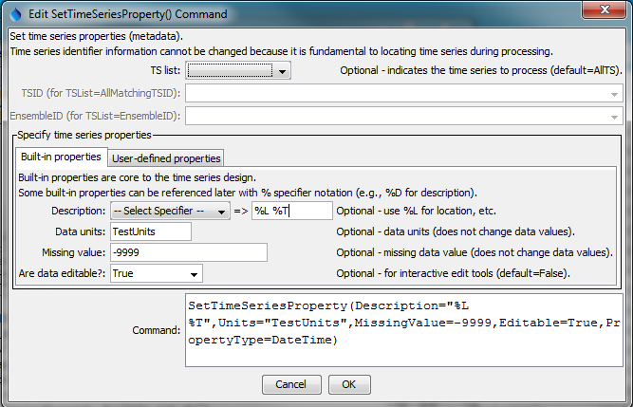
SetTimeSeriesProperty
SetTimeSeriesProperty() Command Editor for Built-in Properties

The following dialog is used to edit this command and illustrates the syntax of the command for user-defined properties.

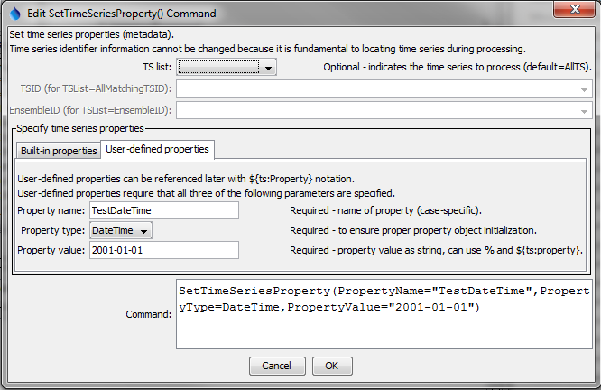
SetTimeSeriesProperty_User
SetTimeSeriesProperty() Command Editor for Built-in Properties

The command syntax is as follows:

SetTimeSeriesProperty(Parameter=Value,…)

Command Parameters

Parameter | Description | Default
TSList | Indicates the list of time series to be processed, one of:  - AllMatchingTSID – all time series that match the TSID (single TSID or TSID with wildcards) will be modified.  - AllTS – all time series before the command.  - EnsembleID – all time series in the ensemble will be modified.  - FirstMatchingTSID – the last time series that matches the TSID (single TSID or TSID with wildcards) will be modified.  - LastMatchingTSID – the last time series that matches the TSID (single TSID or TSID with wildcards) will be modified.  - SelectedTS – the time series are those selected with the SelectTimeSeries() command. | AllTS
TSID | The time series identifier or alias for the time series to be modified, using the * wildcard character to match multiple time series. | Required if TSList=*TSID.
EnsembleID | The ensemble to be modified, if processing an ensemble. | Required if TSList=EnsembleID.
Description | The description to assign to the time series. Use the format choices and other characters to define a unique alias. | None.
Units | The data units to assign to the time series. The units should agree with the time series data values. | None.
Editable | If set to True, then graphing the time series will enable interactive editing features, including the ability to save the edited time series. | False
PropertyName | Name of user-defined property.
PropertyType | Property type, to ensure proper initialization and data check. | Required if PropertyName is specified.
PropertyValue | Value for property as a string but adhering to the property type requirements (e.g., date as a string must match format that can be parsed). Specify % formatter to access a built-in time series property, ${ts:Property} to access a user-defined time series property, and ${Property} to access a processor property. | Required if PropertyName is specified.

A sample command file to set a property for time series read from a StateMod file is as follows:

ReadStateMod(InputFile="Data\ym2004.ddh")
SetTimeSeriesProperty(Units="AF/M")

