Command Reference: InsertTimeSeriesIntoEnsemble ()
Insert 1+ time series into an existing ensemble
Version 10.13.00, 2012-10-25

The InsertTimeSeriesIntoEnsemble() command inserts 1+ time series into an ensemble. The time series must have the same interval and data units as the time series in the ensemble. For example, use the command to insert scenario time series into an ensemble.

The following dialog is used to edit the command and illustrates the syntax for the command.

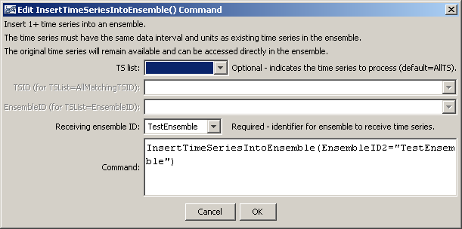
InsertTimeSeriesIntoEnsemble
InsertTimeSeriesIntoEnsemble () Command Editor

The command syntax is as follows:

InsertTimeSeriesIntoEnsemble (Parameter=Value,…)

Command Parameters

Parameter | Description | Default
TSList | Indicates the list of time series to be added to the ensemble, one of:  - AllMatchingTSID – all time series that match the TSID (single TSID or TSID with wildcards).  - AllTS – all time series before the command.  - EnsembleID – all time series in the ensemble.  - FirstMatchingTSID – the first time series that matches the TSID (single TSID or TSID with wildcards).  - LastMatchingTSID – the last time series that matches the TSID (single TSID or TSID with wildcards).  - SelectedTS – the time series are those selected with the SelectTimeSeries() command. | AllTS
TSID | The time series identifier or alias for the time series to be processed, using the * wildcard character to match multiple time series. | Required when TSList=*TSID
EnsembleID | The ensemble from which to retrieve time series, if inserting time series from an ensemble. | Required when TSList=EnsembleID.
EnsembleID2 | The identifier for the ensemble that is receiving the time series. | None – must be specified.

A sample command file to create an ensemble from user-defined time series is as follows:

# Test inserting time series into an ensemble from year interval time series
NewPatternTimeSeries(Alias="ts1",NewTSID="ts1..Flow.Year",
SetStart="1960",SetEnd="2000",Units="ACFT",
PatternValues="1,2,5,8,,20")
NewPatternTimeSeries(Alias="ts2",NewTSID="ts2..Flow.Year",
SetStart="1950",SetEnd="2005",Units="ACFT",
PatternValues="2,4,10,16,,40")
NewEnsemble(TSList=AllTS,
NewEnsembleID="TestEnsemble",NewEnsembleName="Test Ensemble")
InsertTimeSeriesIntoEnsemble(Ensemble2=”TestEnsemble”)

