Command Reference: ReplaceValue()
Replace a range of data values with a constant Value
Version 08.16.04, 2008-09-11

The ReplaceValue() command replaces a range of values in a time series with a constant value. If the missing value indicator is a number in the range, missing values also will be replaced.

The following dialog is used to edit the command and illustrates the syntax of the command:

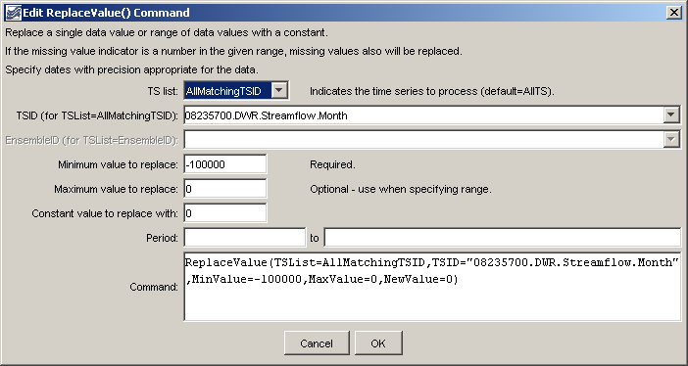
ReplaceValue
ReplaceValue() Command Editor

The command syntax is as follows:

ReplaceValue(Parameter=Value,…)

Command Parameters

Parameter | Description | Default
TSList | Indicates the list of time series to be processed, one of:  - AllMatchingTSID – all time series that match the TSID (single TSID or TSID with wildcards) will be modified.  - AllTS – all time series before the command.  - EnsembleID – all time series in the ensemble will be modified.  - LastMatchingTSID – the last time series that matches the TSID (single TSID or TSID with wildcards) will be modified.  - SelectedTS – the time series are those selected with the SelectTimeSeries() command. | AllTS
TSID | The time series identifier or alias for the time series to be modified, using the * wildcard character to match multiple time series. | Required if TSList=*TSID.
EnsembleID | The ensemble to be modified, if processing an ensemble. | Required if TSList=EnsembleID.
MinValue | The minimum value to replace. | None – must be specified.
MaxValue | The maximum value to replace. | If not specified, only data values that exactly match the minimum value will be replaced.
NewValue | The new data value. | None – must be specified.
SetStart | The date/time to start filling, if other than the full time series period. | Check the full period.
SetEnd | The date/time to end filling, if other than the full time series period. | Check the full period.

A sample command file to process from the State of Colorado’s HydroBase database is as follows:

# 08235700 - ALAMOSA RIVER BELOW CASTLEMAN GULCH NEAR JASPER
08235700.DWR.Streamflow.Month~HydroBase
ReplaceValue(TSList=AllTS,MinValue=-100000,MaxValue=0,NewValue=0)

