Command Reference: ReadRccAcis()
Read time series from the RCC ACIS web services
Version 10.11.00, 2012-06-27

The ReadRccAcis() command reads one or more time series from the Regional Climate Center (RCC) Applied Climate Information System (ACIS) web services, in particular to provide access to daily historical and real-time values from the National Climatic Data Center (NCDC). Features and limitations of ACIS are described in the RCC ACIS Data Store appendix. Because web services are used to access a remote database, there may be some delay in retrieving data. For data intensive processes, it may be advisable to mine the data, save to a local file or database, and then perform additional processing using the local data.

The following dialog is used to edit the command and illustrates the syntax for the command when reading a single time series. This is appropriate when a specific site is being processed.

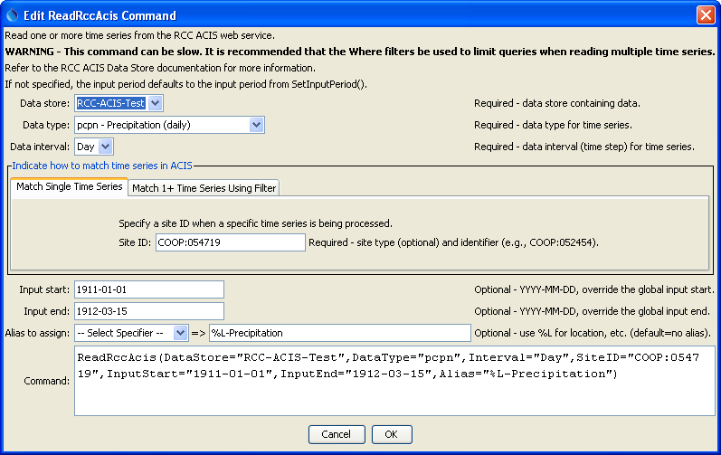
ReadRccAcis_Single
ReadRccAcis() Command Editor for Reading Single Time Series

The following dialog is used to edit the command and illustrates the syntax for the command when reading multiple time series. This is appropriate when performing bulk processing. Mouse over the Where data entry fields to see information about choices.

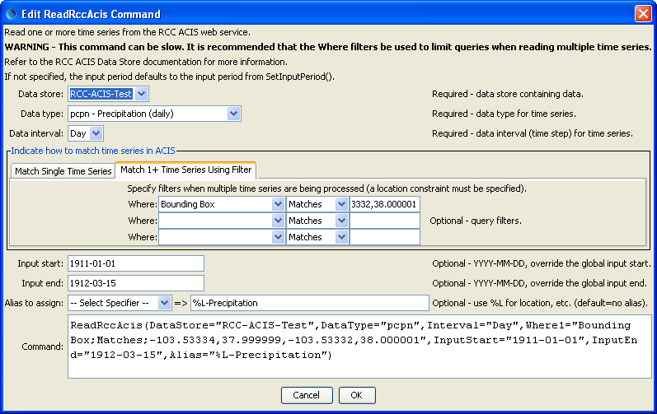
ReadRccAcis
ReadRccAcis() Command Editor for Reading Multiple Time Series

The command syntax is as follows:

ReadRccAcis(Parameter=Value,…)

Command Parameters

Parameter | Description | Default
DataStore | The name of the RCC ACIS data store from which to read. | None – must be specified.
DataType | The data type to be queried, as documented in the RCC ACIS Data Store appendix. The “Variable Major”, which is a unique number, is used as the data type in the command parameter. | None – must be specified.
Interval | The data interval for the time series. Currently only daily time series is supported. | None – must be specified.
SiteID | Used when reading a single time series. The site ID should be specified using the station type and site identifier (e.g., COOP:052454). The station type can be determined by first querying the time series using the TSTool main interface or using the WhereN parameter and reviewing the resulting time series identifiers in returned time series. Omitting the station type will assume the ACIS identifier, which is internal to the ACIS system and not typically used by users. Specifying the SiteID will override the WhereN parameter. | If not specified, the WhereN filters are used.
WhereN | Used when reading 1+ time series. The “where” clauses to be applied to filter the list of stations, matching the values in the Where fields in the command editor dialog and the TSTool main interface. The parameters should be named Where1, Where2, etc., and a gap in numbering will result in the remaining items being ignored. The format of each value is:  “Item;Operator;Value”  Where Item indicates a data field to be filtered on, Operator is the type of constraint, and Value is the value to be checked when querying. | If not specified, the query will not be limited and very large numbers of time series may be queried.
InputStart | Start of the period to query, specified as a date/time with a precision that matches the requested data interval. | Read all available data.
InputEnd | End of the period to query, specified as a date/time with a precision that matches the requested data interval. | Read all available data.
Alias | The alias to assign to the time series, as a literal string or using the special formatting characters listed by the command editor. The alias is a short identifier used by other commands to locate time series for processing, as an alternative to the time series identifier (TSID). | None – must be specified.

This page is intentionally blank.

