Command Reference: SetWarningLevel()
Set level for warning messages
Version 08.16.00, 2008-08-24

The SetWarningLevel() command sets the warning levels for the screen and log file. Higher warning levels are useful for troubleshooting commands. The higher the level, the more messages will be generated. This command can be used multiple times, for example to isolate a problem. Currently the warning level applies to all components. In the future logging control may be grouped by component. Levels are not completely consistent but the following guidelines can be followed:

0 = no messages
1 = important messages generated in applications
2 = important messages generated in commands
3+ = messages generated in commands that may explain other problems
10+ = messages in processing code that may still be useful to end users
30+ = low-level messages, for example generated while reading from files or databases

The following dialog is used to edit this command and illustrates the command syntax.

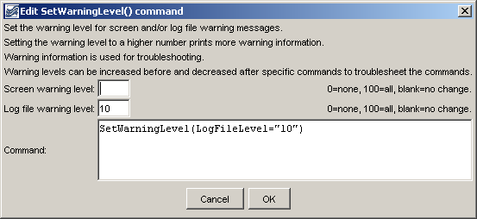
SetWarningLevel
SetWarningLevel() Command Editor

The command syntax is as follows:

SetWarningLevel(Parameter=Value,…)

Command Parameters

Parameter | Description | Default
ScreenLevel | The warning level for the screen (0+). | Keep previous setting.
LogFileLevel | The warning level for the log file (0+). | Keep previous setting

A sample commands file is as follows:

SetWarningLevel(ScreenLevel=1,LogFileLevel=10)

