Command Reference: FillPrincipalComponent
Analysis()
Fill Principal Component Analysis
Version 08.15.00, 2008-05-04

The FillPrincipalComponentAnalysis() command creates a list of potential regression equations for a single dependent time series and multiple independent time series and uses the best fit to fill the dependent time series. Both the regression analysis and filled time series are written to output files.

The following dialog is used to create and utilize principal component analysis.

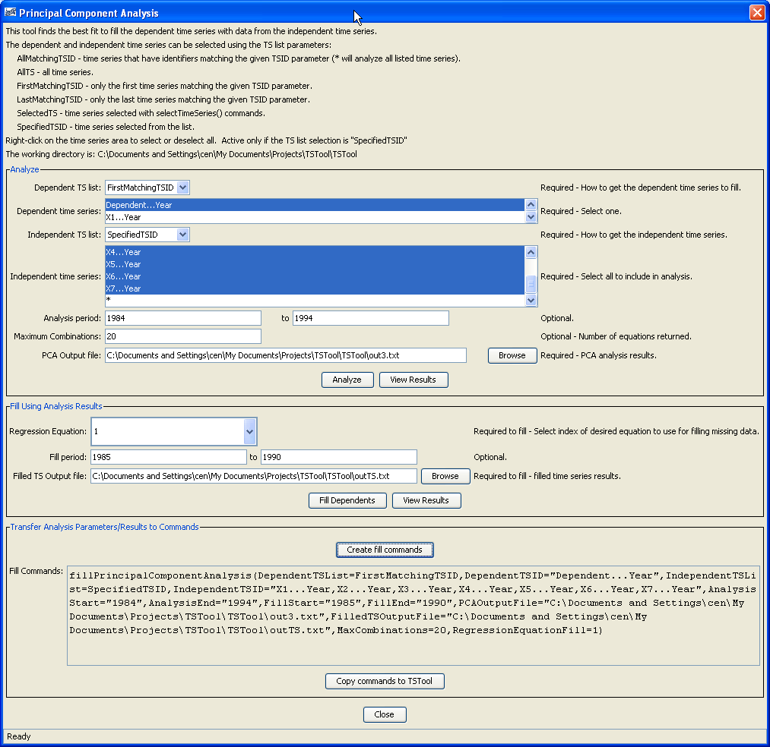
This dialog is divided into 3 main sections. Analysis tools are located in the first section which assists the user in creating a principal component analysis. A single dependent time series and multiple independent time series can be specified. An analysis period can be specified if only a portion of the time series should be used. The number of regression equations the user wishes to create to choose from by specifying Maximum Combinations. Finally, an output file must be specified where the results will be written. Once the user has created an analysis by clicking the Analyze button, the View Results button becomes enabled to view the results file contents.

Once the analysis has been completed, the Fill Using Analysis Results section becomes enabled for the next step when utilizing this dialog. The regression equations are numbered starting with 1, as seen in the output file from the analysis. These numbers correspond with the Regression Equation selection. When filling the dependent time series, all missing data from the entire period of record will be filled unless otherwise specified. The results are written to the file specified in Filled TS Output file and can be viewed by clicking the View Results button.

Finally, a command which can be run within TSTool can be created and copied to the main TSTool commands area by using the final section, Transfer Analysis Parameters/Results to Commands.

The command syntax is as follows:

PrincipalComponentAnalysis(Parameter=Value,…)

Command Parameters

Parameter | Description | Default
DependentTSList |  | None – must be specified.
Dependent  TSID | Dependent time series identifier or alias. | None – must be specified.
IndependentTSList | Indicate how the list of time series to process should be determined, one of:  - AllTS – all time series  - AllMatchingTSID – all time series that have identifiers matching the given TSID parameter.  - FirstMatchingTSID – First time series in list that has identifier matching the given TSID parameter.  - LastMatchingTSID – Last time series in list that has identifier matching the given TSID parameter.  - SelectedTS – all time series that have been selected with SelectTimeSeries() commands. | None – must be specified.
IndependentTSID | Independent time series identifier or alias. | None – must be specified.
AnalysisStart | The date/time to start the analysis – use to focus on only a period appropriate from analysis. For example specify the unregulated period for streamflow. | Analyze the full period.
AnalysisEnd | The date/time to end the analysis – use to focus on only a period appropriate from analysis. | Analyze the full period.
FillStart | The date/time to start the filling functionality. | Fill the full period.
FillEnd | The date/time to end the filling functionality. | Fill the full period.
FilledTSOutputFile | Output file in which to write filled time series. | None – must be specified.
PCAOutputFile | Output file in which to write regression equations. | None – must be specified.
RegressionEquationFill | Index of regression equation to use for filling (1 is the top fit determined by PCA) | 1
MaxCombinations | Number of regression equations to return. | 20

A sample command file to fill time series is as follows:

# Test Fill TS using Principal Component Analysis
# First create time series
TS Y = NewPatternTimeSeries(NewTSID="Dependent...Year",SetStart="1983",SetEnd="1993",
PatternValues="15.95,16.78,26.39,19.07,19.10,13.10,17.05,20.23,37.02,-999,15.04")
TS X1 = NewPatternTimeSeries(NewTSID="X1...Year",SetStart="1983",SetEnd="1993",
PatternValues="6.11,5.83,2.18,10.65,10.9,8.2,12.84,17.52,29.41,13.62,8.54")
TS X2 = NewPatternTimeSeries(NewTSID="X2...Year",SetStart="1983",SetEnd="1993",
PatternValues="9.44,4.59,10.28,8.53,7.25,5.30,6.58,6.14,11.77,7.87,4.72")
TS X3 = NewPatternTimeSeries(NewTSID="X3...Year",SetStart="1983",SetEnd="1993",
PatternValues="18.43,10.55,30.37,18.67,21.46,13.41,15.59,23.15,35.51,23.55,13.66")
TS X4 = NewPatternTimeSeries(NewTSID="X4...Year",SetStart="1983",SetEnd="1993",
PatternValues="9.02,4.61,15.39,6.06,11.26,5.67,7.24,10.24,13.27,12.44,7.01")
TS X5 = NewPatternTimeSeries(NewTSID="X5...Year",SetStart="1983",SetEnd="1993",
PatternValues="13.15,13.82,25.91,25.16,21.18,16.10,19.96,29.29,48.35,24.21,14.29")
TS X6 = NewPatternTimeSeries(NewTSID="X6...Year",SetStart="1983",SetEnd="1993",
PatternValues="32.87,13.75,23.74,26.65,18.82,15.47,19.02,26.10,41.93,23.15,13.78")
TS X7 = NewPatternTimeSeries(NewTSID="X7...Year",SetStart="1983",SetEnd="1993",
PatternValues="5.32,2.72,4.09,4.47,3.83,2.81,2.91,3.90,8.46,5.12,2.76")
#
# Write PCA Analysis
#
# Fill dependent ts using PCA Analysis
#
fillPrincipalComponentAnalysis(
DependentTSList=AllMatchingTSID,DependentTSID="Dependent...Year",
IndependentTSList=AllMatchingTSID,IndependentTSID="X*",
PCAOutputFile="Data\PCA_fillDependentTS.txt",
FilledTSOutputFile="Results\PCA_fillDependentTS.txt",
RegressionEquationFill=1")

