Command Reference: WriteSHEF()
Write time series to a SHEF format file
Version 08.17.00, 2008-10-03

The WriteSHEF() command write time series to the specified SHEF format file. See the SHEF Input Type appendix for more information about the file format. The SHEF physical element (PE) codes are similar to time series data type codes. The PE code is looked up based on data type information that is available for the execution environment. Currently there is no default PE information on Windows; however, this information is available on Linux when working with National Weather Service River Forecast System files (the SHEF data types are read using NWSRFS app default configuration information). The PE code can be supplied using the DataTypePELookup parameter in environments where the information is not available by default.

The following dialog is used to edit the command and illustrates the syntax of the command.

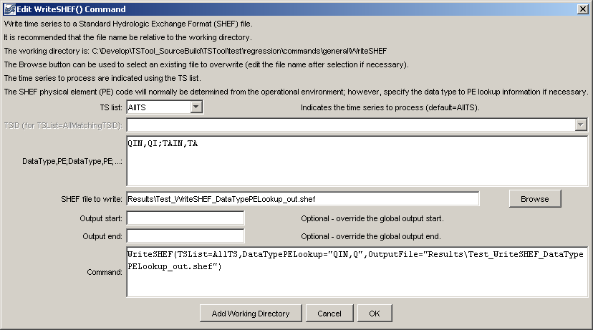
WriteSHEF
WriteSHEF() Command Editor

The command syntax is as follows:

WriteSHEF(Parameter=Value,…)

Command Parameters

Parameter | Description | Default
TSList | Indicates the list of time series to be processed, one of:  - AllMatchingTSID – all time series that match the TSID (single TSID or TSID with wildcards) will be processed.  - AllTS – all time series before the command.  - EnsembleID – all time series in the ensemble will be processed.  - FirstMatchingTSID – the first time series that matches the TSID (single TSID or TSID with wildcards) will be processed.  - LastMatchingTSID – the last time series that matches the TSID (single TSID or TSID with wildcards) will be processed.  - SelectedTS – the time series are those selected with the SelectTimeSeries() command. | AllTS
TSID | The time series identifier or alias for the time series to be processed, using the * wildcard character to match multiple time series. | Required if TSList=*TSID
DataTypePELookup | Pairs of data type and SHEF physical element (PE) codes. The pairs should be separated by semicolons and the data type/PE strings by commas. For example, the data values for instantaneous streamflow and air temperature might be: QIN,QI;TAIN,TA | Use information determined for operational environment, if available.
OutputFile | The SHEF output file. The path to the file can be absolute or relative to the working directory (command file location). | None – must be specified.
OutputStart | The date/time for the start of the output. | Use the global output period.
OutputEnd | The date/time for the end of the output. | Use the global output period.

A sample command file to write data from a streamflow forecast system is as follows:

WriteSHEF(TSList=AllTS,DataTypePELookup="QIN,QI;TAIN,TA",
OutputFile="Results\Test_WriteSHEF_DataTypePELookup_out.shef")

